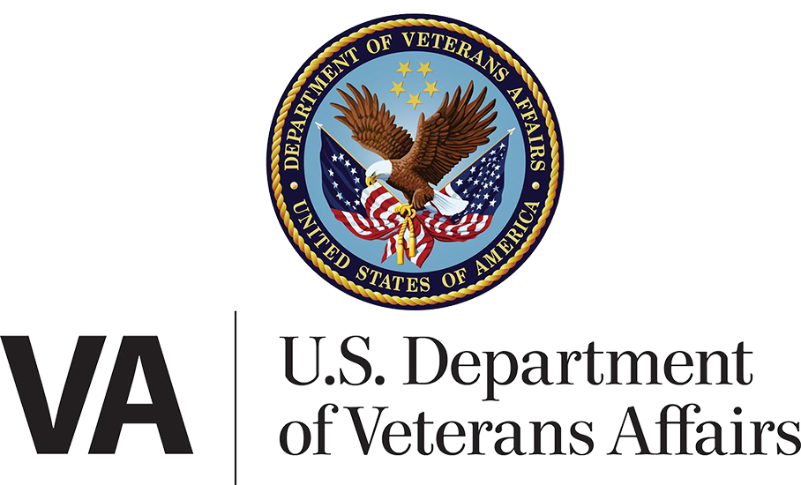

**VA.gov Profile**

Version 7.0

December, 2023

Table of Contents

Revision History 6

Product Overview: VA.gov Profile 7

User Access 7

The Master Person Index (MPI) 7

Users who have not verified their identity (LOA1) 7

Users who have verified their identity (LOA3) 9

Users who have a blocked account 10

Navigation 11

Section Overview: Profile Hub 12

User Access 14

Users who have not verified their identity (LOA1) 14

Users who have verified their identity (LOA3) 14

Users who have a blocked account 14

Navigation 14

Major Issues and Error Messages 14

Bad address indicator: 14

Generic System Maintenance / Outage Alert: 15

Section Overview: Personal Information 16

User Access 16

Users who have not verified their identity (LOA1) 16

Users who have verified their identity (LOA3) 16

Users who have a blocked account 16

Navigation 16

Functionality 17

Non-editable personal information: 17

Legal name 18

Collapsed Alert FAQ for Editing your Legal Name 18

Expanded Alert FAQ for Editing your Legal Name 18

Date of birth 18

Collapsed Alert FAQ for Editing Your Date of Birth 18

Expanded Alert FAQ for Editing Your Date of Birth 19

Details from the expanded FAQ: 19

Disability rating 19

If a user has a disability rating: 20

If a user does not have a disability rating: 20

Editing personal information: Preferred name 20

Editing personal information: Gender identity 21

Section Overview: Contact Information 24

User Access 26

Users who have not verified their identity (LOA1) 26

Users who have verified their identity (LOA3) 26

Users who have a blocked account 26

Navigation 26

Functionality 27

Editing Contact Information: Addresses 27

How to edit mailing addresses 27

How to edit home addresses 30

Address validation 33

A prompt to confirm the address, with potential address suggestions: 33

A prompt to confirm the address, with no suggestions: 34

A prompt to add a unit number: 34

A prompt to edit a unit number: 35

Editing Contact Information: Phone numbers 42

Editing contact information: Contact email address 44

Editing Contact Information: Sign in email address 45

Major Issues and Error Messages 46

Editing errors 46

Invalid phone numbers 46

Finish editing section before moving to another 47

Canceling 48

Trying to leave a page without saving 49

Saving error 49

Update is delayed 50

General errors 51

Can’t access personal information 51

Multiple accounts 51

To find out if this is about an account on MyHealtheVet 51

To find out if this is about an account with Department of Defense 52

User information doesn’t match our Veteran records 52

User Account is Blocked: 53

Section Overview: Military Information 55

User Access 56

Users who have not verified their identity (LOA1) 56

Users who have verified their identity (LOA3) 56

Users who have a blocked account 56

Navigation 56

Functionality 57

Editing Military Information 57

Major Issues and Error Messages 59

Can’t access military information 59

Can’t show military information 60

Section Overview: Direct Deposit 61

User Access 61

Users who have not verified their identity (LOA1) 61

Users who have verified their identity (LOA3) 62

Users who have a blocked account 63

Navigation 63

Functionality 63

Direct deposit information for disability compensation and pension (C&P) payments 63

How to add direct deposit information for compensation and pension 63

How to edit direct deposit information for disability and compensation payments 66

Direct Deposit for Education Benefits 68

How to edit direct deposit information for Education payments 68

How to view payment history 70

Major Issues and Error Messages 71

User needs to verify their identity with Login.gov or ID.me 71

Direct Deposit Form Validation Errors 71

Required Field Errors 71

Routing number can’t be found 73

Backend system is down/generic error 74

Backend System Error - information fails to load 75

Fraud Alert Error 76

Mailing address errors 76

Phone number errors 79

Additional Information 82

Additional Information on Direct Deposit 82

Switching from paper checks and direct deposit 82

Section Overview: Notification Settings 83

User Access 83

Users who have not verified their identity (LOA1) 83

Users who have verified their identity (LOA3) 83

Users who have a blocked account 83

Navigation 83

Functionality 84

Selecting notification options 84

Editing-as-a-subtask: Adding mobile phone number 85

Major Issues and Error Messages 87

Notification settings feature is unavailable 88

Save failure 89

Section Overview: Account Security 90

User Access 90

Users who have not verified their identity (LOA1) 90

Users who have verified their identity (LOA3) 91

Users who have a block on their account: 92

Navigation 92

Functionality 94

Verifying identity 94

2-factor authentication (2FA) 96

Sign in email address 97

Major Issues and Error Messages 99

User has not verified their identity (LOA1) 99

User information doesn’t match our Veteran records 99

User information cannot be accessed 100

Section Overview: Connected Apps 101

User Access 101

Users who have not verified their identity (LOA1) 101

Users who have verified their identity (LOA3) 101

Users who have a blocked account 101

Navigation 101

Functionality 102

Connecting and disconnecting an app 102

How to connect an app to your VA.gov profile 103

How to disconnect an app from your VA.gov profile 104

How to find additional information on connected apps 106

Major Issues and Error Messages 107

Can’t retrieve connected apps: 107

Can’t disconnect an app: 108

Table of Figures 109

# Revision History

| Date | Version | Description | Author |
| --- | --- | --- | --- |
| 11/1/2021 | 4.0 | Added Notification Settings feature | Anastasia Jakabcin |
| 4/1/2022 | 5.0 | Added Personal Info feature | Marci McGuire |
| 4/6/2022 | 5.0 | Minor edits; Removed redundant content | Samara Strauss |
| 4/28/2022 | 5.0 | Updated images; Minor content changes | Christina Gednalske |
| 5/4/2022 | 5.0 | Updates to Direct Deposit section | Liz Lantz |
| 9/01/2022 | 5.1 | Addition of “Review your mailing address” alert | Sharon Kasimow |
| 9/23/2022 | 5.2 | Updated screens for “Review your mailing address” alert | Sharon Kasimow |
| 10/31/2022 | 5.2.1 | Account Security—Updates to section for Major Issues and Error Messages | Sharon Kasimow |
| 12/14/22 | 5.2.2 | Misc: updates to alerts and Notif Settings page including:  Contact info major errors alert: update to alert when user doesn’t complete editing before moving to a new section of page  Update to Notification settings screen to improve accessibility  Update to Account Security page | Sharon Kasimow |
| 08/2023 | 6 | Notification Settings:  Updated Checkbox UI  Editing mobile phone number workflow | Travis Cahill |
| 12/2023 | 7 | Added the profile hub  Started to add in a table of figures, future tickets have been created to expand on this.  Updated every section to have corrected navigation information.  Updated every section to have corrected user access information. | Travis Cahill |

# Product Overview: VA.gov Profile

From the VA.gov Profile, users can update or view the following:

* Personal information
* Contact information
* Military information
* Direct deposit information
* Notification settings
* Account security and preferences
* Connected apps

What is available within each section of the Profile is dependent upon each user’s own benefits and status.

## User Access

For a user to view the VA.gov User Profile, they must meet the following criteria:

* Be logged in to VA.gov
* Be found in the Master Person Index (MPI)
* Have verified their identity on VA.gov
* Not have a block on their account

### The Master Person Index (MPI)

Veterans found in the Master Person Index (MPI) will have access to their VA.gov profile if they are logged in and have verified their identity (see below). To be in the MPI, a person must have had some sort of interaction with the VA where they had data entered into the MPI system. This could be online or offline. In most cases, a person contacting a call center will have already had some interaction with the VA and be in the MPI.

### Users who have not verified their identity (LOA1)

If someone is logged in and is in the MPI but has not verified their identity on VA.gov, they will only see the **Account security** section of the VA.gov profile when they go to [www.va.gov/profile/account-security](http://www.va.gov/profile/account-security). From here, they can add additional security to their account by verifying their identity or adding 2-factor authentication (2FA).

To view any other sections of the profile, users must verify their identity at [https://va.gov/verify/](https://staging.va.gov/verify/). Note that the link for changing the sign in email address will conditionally populate based on the method used to sign in (Login.gov, ID.me, MyHealtheVet, DS Logon).

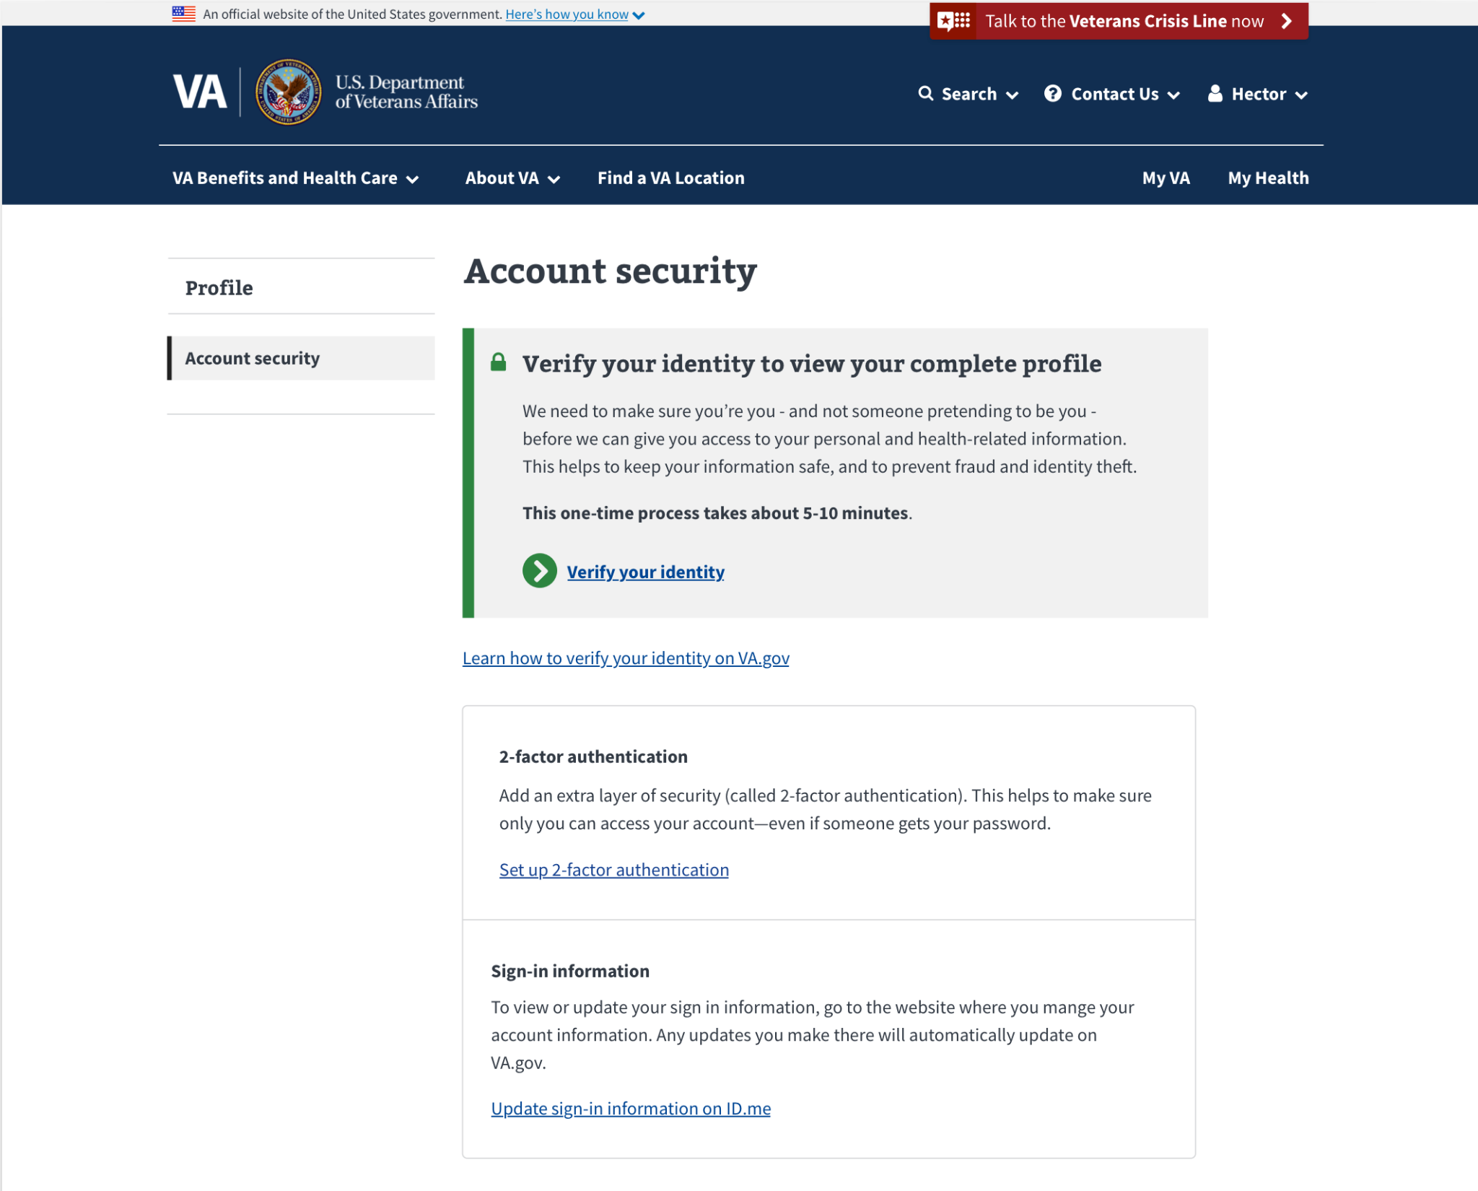

Figure 1 profile account security page for LOA1 User

### Users who have verified their identity (LOA3)

Users who are logged in, have data in the MPI, and have verified their identity (LOA3) will be able to view their full profile on VA.gov.

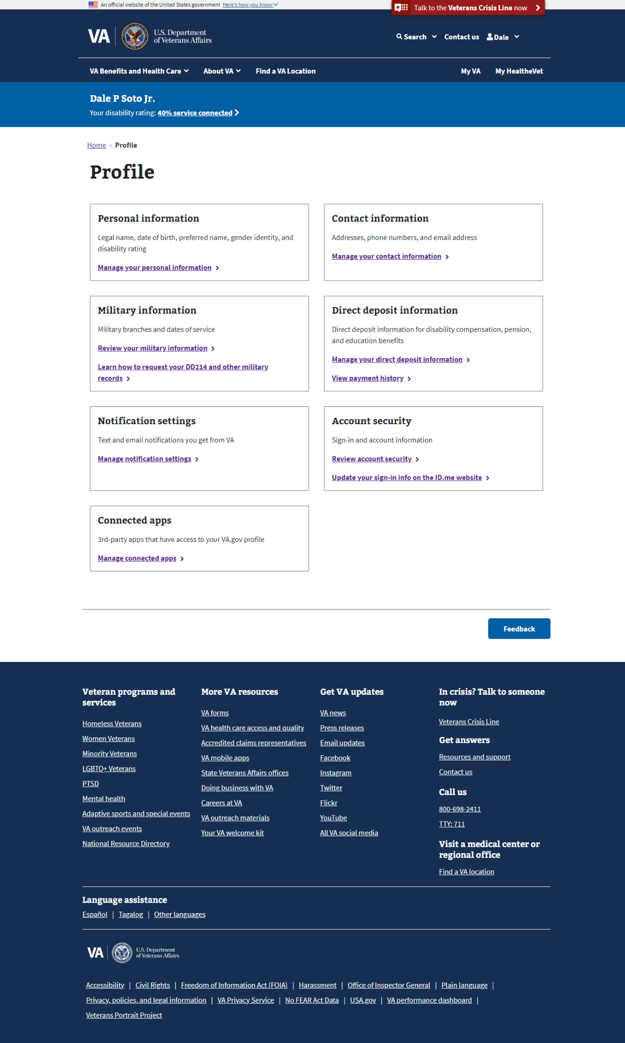

Figure 2 profile hub, main landing page for most users

### Users who have a blocked account

Blocked users will only see the Account Security page; no other pages in profile are available from the profile navigation menu.

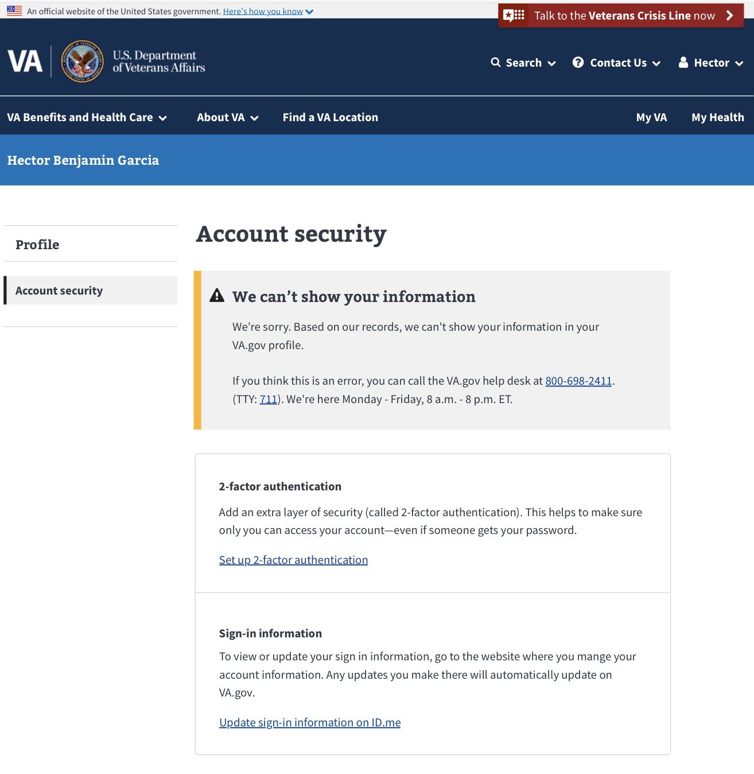

Figure 3 account security page for blocked users

## Navigation

To navigate to the VA.gov User Profile, a person must:

1. Sign into VA.gov (<https://www.va.gov/>).  
     
   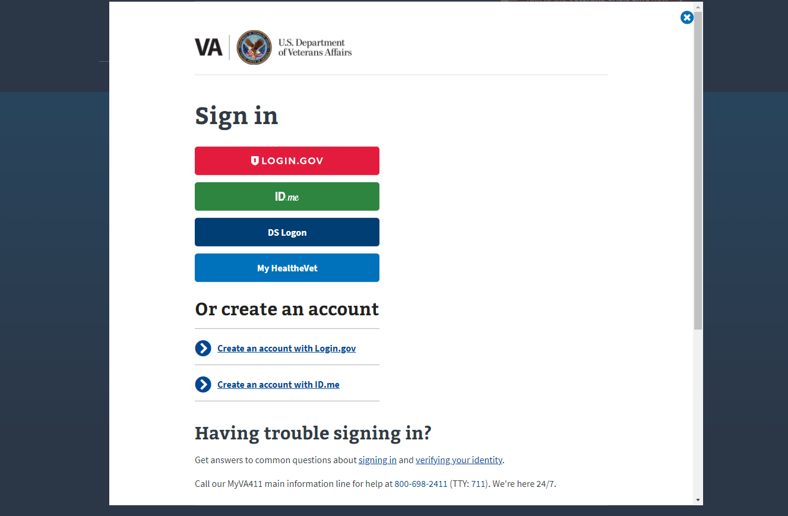

Figure 4 sign in modal

1. Open the authenticated menu in the upper right corner of the screen (a dropdown menu with the user’s name) and select **Profile**. This will take logged in users to the VA.gov profile. If a user is LOA3 then the **Profile Hub** section will be the first screen that they will see in the profile.  
   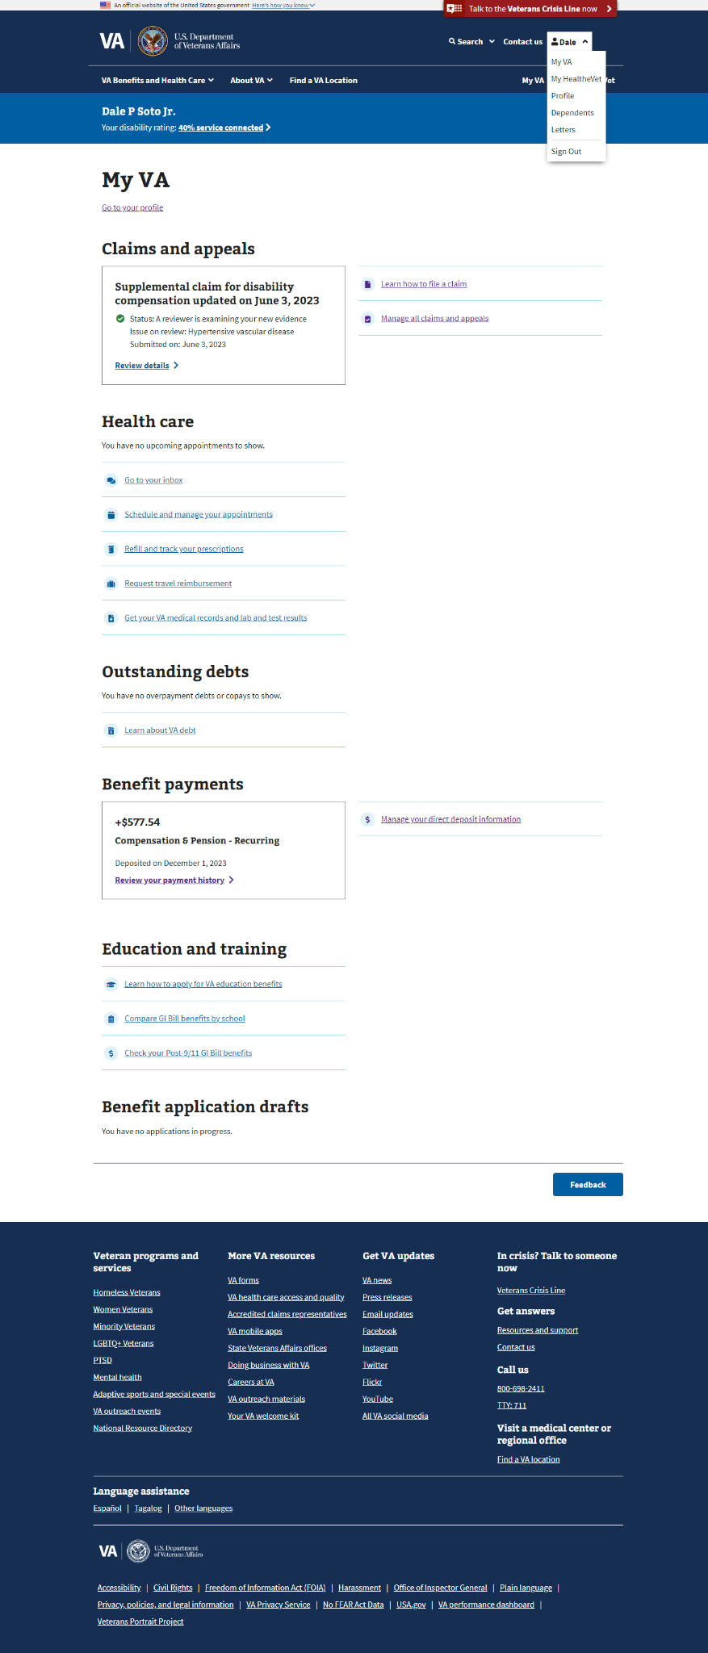

Figure 5 the My VA logged in landing page with the Authenticated Menu expanded.

* 1. Alternatively, if a user is logged in to the My VA dashboard, there is a link just below the My VA heading that says “Go to your profile.”

# Section Overview: Profile Hub

For users who have verified their identities (LOA3), the **Profile Hub** will be the first page that a user lands on when accessing their Profile. This section links a user to all other parts of the Profile.



Figure 6 the Profile Hub

## User Access

### Users who have not verified their identity (LOA1)

As a reminder, users who have not verified their identity on VA.gov, or users who have a block on their account will only see the **Account security** section of the VA.gov profile when they go to www.va.gov/profile. They will not see the **Profile Hub**.

### Users who have verified their identity (LOA3)

Users who have verified their identities on VA.gov will be able to see **Profile Hub** and all the sections of the profile.

### Users who have a blocked account

Users who have verified their identities on VA.gov but have a flagged account (eg. have a fiduciary, are deceased, flagged as incompetent) will not be able to use the **Profile Hub**, they will only see the **Account security** page. If they attempt to navigate to [www.va.gov/profile/profile](http://www.va.gov/profile/profile) it will redirect them to [www.va.gov/profile/account-security](http://www.va.gov/profile/account-security).

## Navigation

To access to the VA.gov User Profile via the authenticated menu, a person must:

1. Sign into VA.gov (<https://www.va.gov/>).
2. A user should open the authenticated menu in the upper right corner of the screen (the user’s name) and select **Profile**. This will take logged in users to the VA.gov profile. If a user is LOA3 then the **Profile Hub** section will be the first screen that they will see in the profile. (see screenshots here)
   1. Alternatively, if a user is logged in to the My VA dashboard, there is a link just below the My VA heading that says “Go to your profile.”

## Major Issues and Error Messages

### Bad address indicator:

If the system detects a potential issue with the address provided in the user’s **Contact Information** an alert appears on the **Profile Hub** advising users to review their address

This results when mail has been sent to a Veteran and then returned to the VA; the VA marks the address as "bad," and the user is then notified in the form of the alert.

The address may be a real, valid address, but the returned mail implies that it is no longer the correct address for the Veteran for whom the mail was intended.

Clicking the link within the alert box will take the user to the **Contact info** page where they can update their mailing address.

: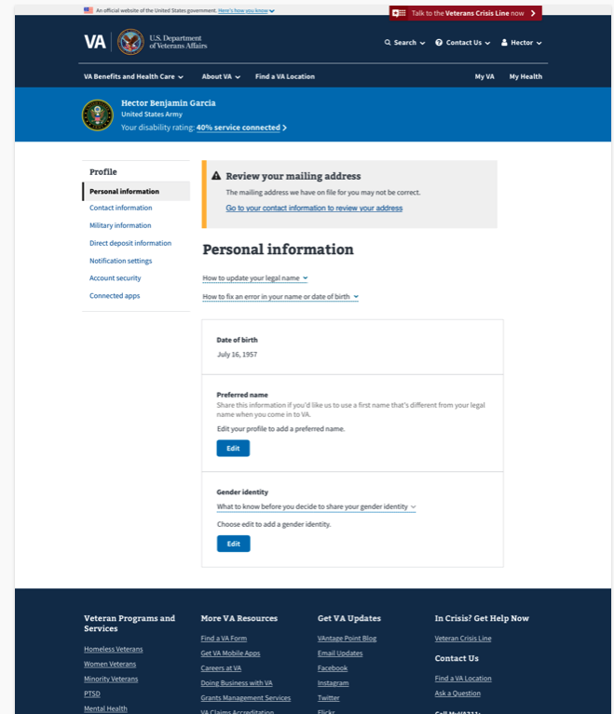

### Generic System Maintenance / Outage Alert:

# Section Overview: Personal Information

For users who have verified their identities (LOA3), the **Personal information** section will give an overview of the personal information that the VA has on file for them. The **Personal information** section will show:

* Legal name
* Date of birth
* Preferred name
* Gender identity
* Disability rating

## User Access

### Users who have not verified their identity (LOA1)

As a reminder, users who have not verified their identity on VA.gov, or users who have a block on their account will only see the **Account security** section of the VA.gov profile when they go to [www.va.gov/profile/personal-information](http://www.va.gov/profile/personal-information). They will not see **Personal information**.

### Users who have verified their identity (LOA3)

Users who have verified their identities on VA.gov will be able to see **Personal Information** and all the sections of the profile.

### Users who have a blocked account

Users who have verified their identities on VA.gov but have a flagged account (eg. have a fiduciary, are deceased, flagged as incompetent) will not be able to use the **Personal Information** section of the profile, they will only see the **Account security** page. If they attempt to navigate to [www.va.gov/profile/personal-information](http://www.va.gov/profile/personal-information) it will redirect them to [www.va.gov/profile/account-security](http://www.va.gov/profile/account-security).

## Navigation

To access the **Personal information** section of the profile via the authenticated menu:

1. Sign into VA.gov (<https://www.va.gov/>).
2. Click the authenticated menu in the upper right corner of the screen (the user’s name) and select **Profile**. This will land the user on the **Profile Hub**
3. Users then need to follow the link on the **Personal information** card from the **Profile Hub**.

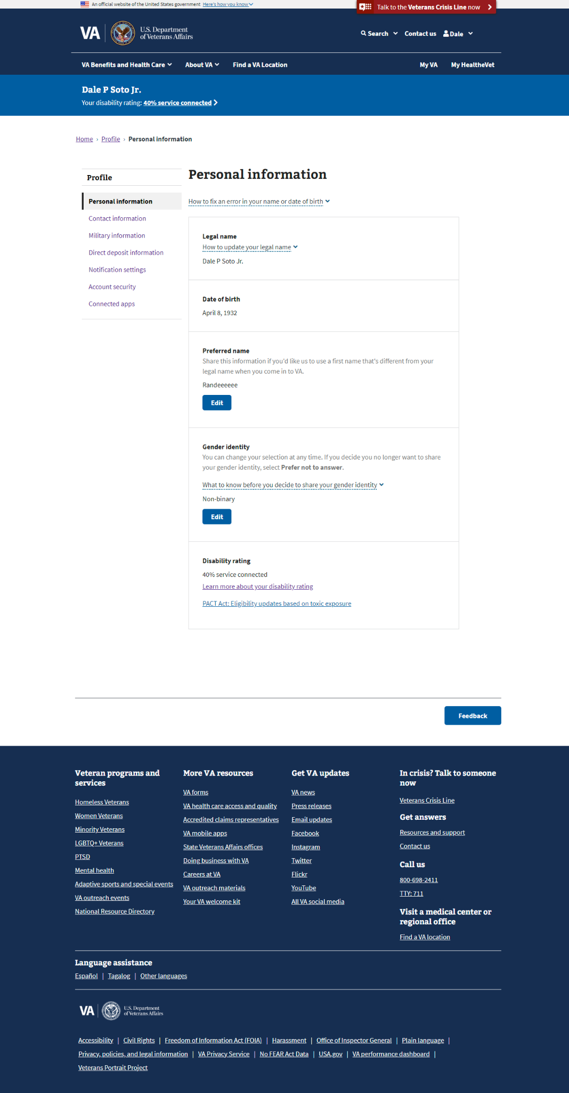

## Functionality

### Non-editable personal information:

Some personal information is not directly editable on VA.gov. Those fields are:

#### Legal name

If a user would like to change this information, they need to follow the process linked from within the profile

##### Collapsed Alert FAQ for Editing your Legal Name

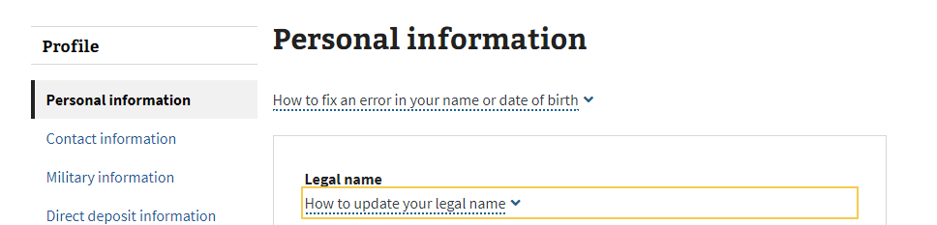

##### Expanded Alert FAQ for Editing your Legal Name

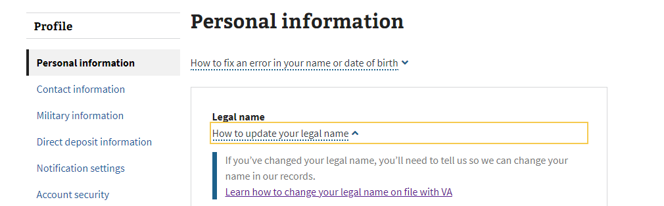

#### Date of birth

If a user would like to change their date of birth, they need to follow the process linked from within the profile. There is a collapsed FAQ alert that contains additional details:

##### Collapsed Alert FAQ for Editing Your Date of Birth

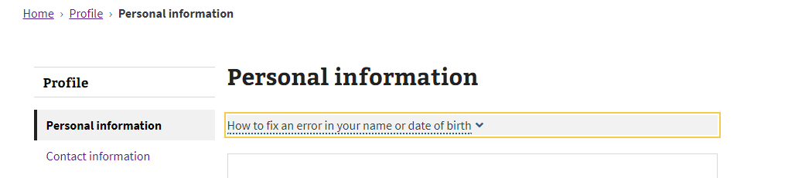

##### Expanded Alert FAQ for Editing Your Date of Birth

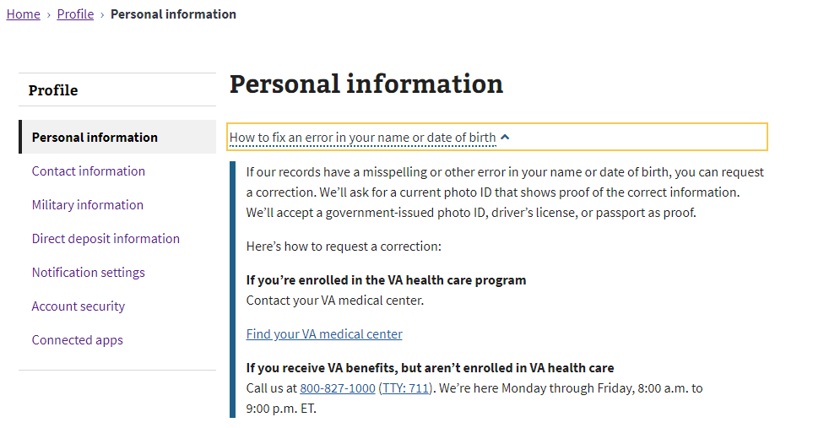

###### Details from the expanded FAQ:

1. If the user is enrolled in the VA health care program, they will need to contact the nearest VA medical center. This can be done by clicking on the **Find your nearest VA medical center** link provided in the dropdown FAQ (<https://va.gov/find-locations/?facilityType=health>).
2. If a user receives VA benefits but is not enrolled in the VA health care program, they will need to contact their nearest VA regional office. This can be done by clicking on the **Find your nearest VA regional office** link provided in the dropdown FAQ (<https://va.gov/find-locations/?facilityType=benefits>).

#### Disability rating

This is the last section of the **Personal information** page and is automatically populated based on the veteran’s disability rating status.

##### If a user has a disability rating:

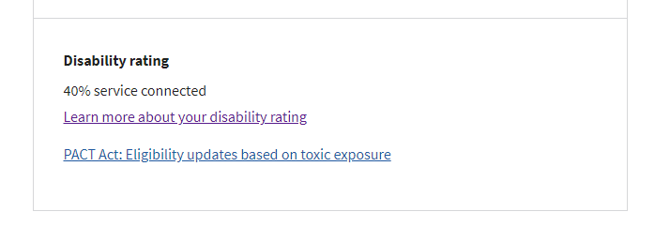

##### If a user does not have a disability rating:

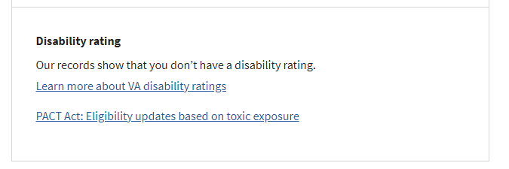

### Editing personal information: Preferred name

**From the Personal information section of the profile:**

1. Go to the **Preferred name** box.
2. Select **Edit**.

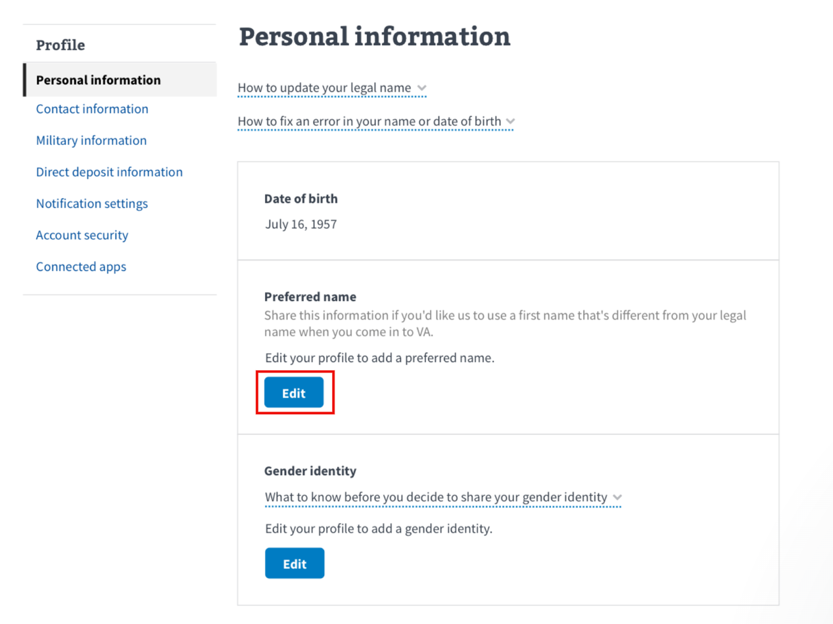

1. Enter preferred name.
2. Click **Save**.

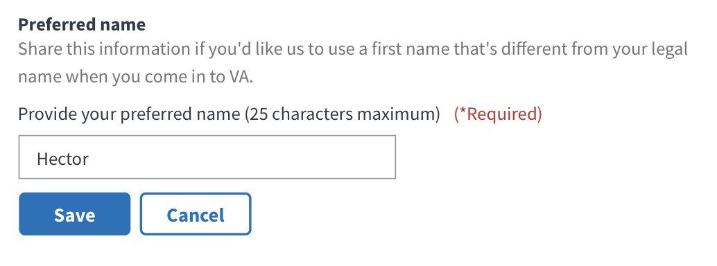

### Editing personal information: Gender identity

**From the Personal information section of the profile:**

1. Go to the **Gender identity** box.
2. Select **Edit**.

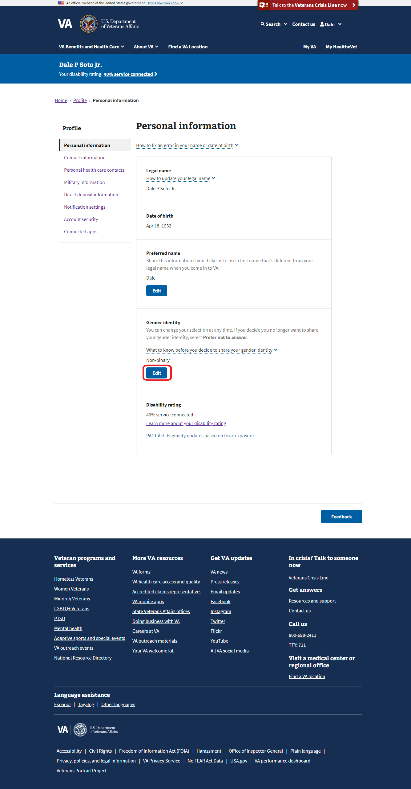

1. Select a desired gender identity from the options provided.
2. Click **Save**.

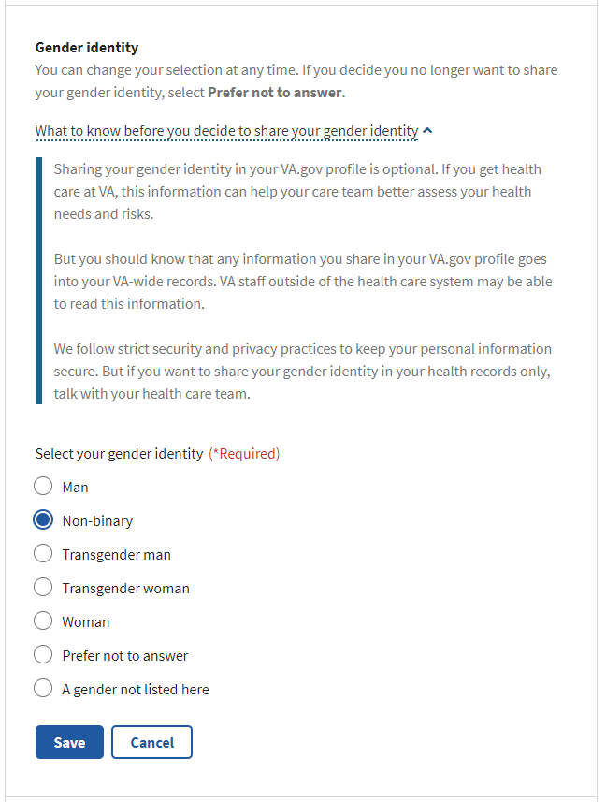

# Section Overview: Contact Information

This section will give an overview of the contact information that the VA has on file for them. The contact information section will show:

* Addresses
* Phone numbers
* Email address

For users who have verified their identities (LOA3), and don’t have any blocks on their account, the **Contact information** section is accessible from the **Profile Hub.**

Alternatively, if the user has already opened another page of the profile, they’ll see the left-side navigation and can access the contact information page from there:

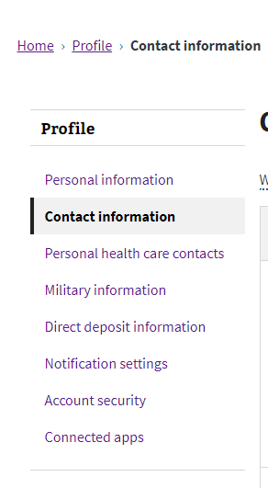

(note on a mobile device this left hand menu is at the top of the page and is labeled “Profile Menu”)

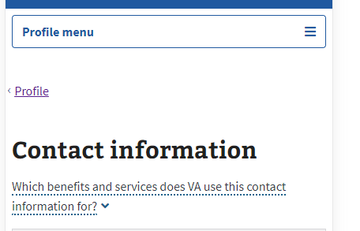

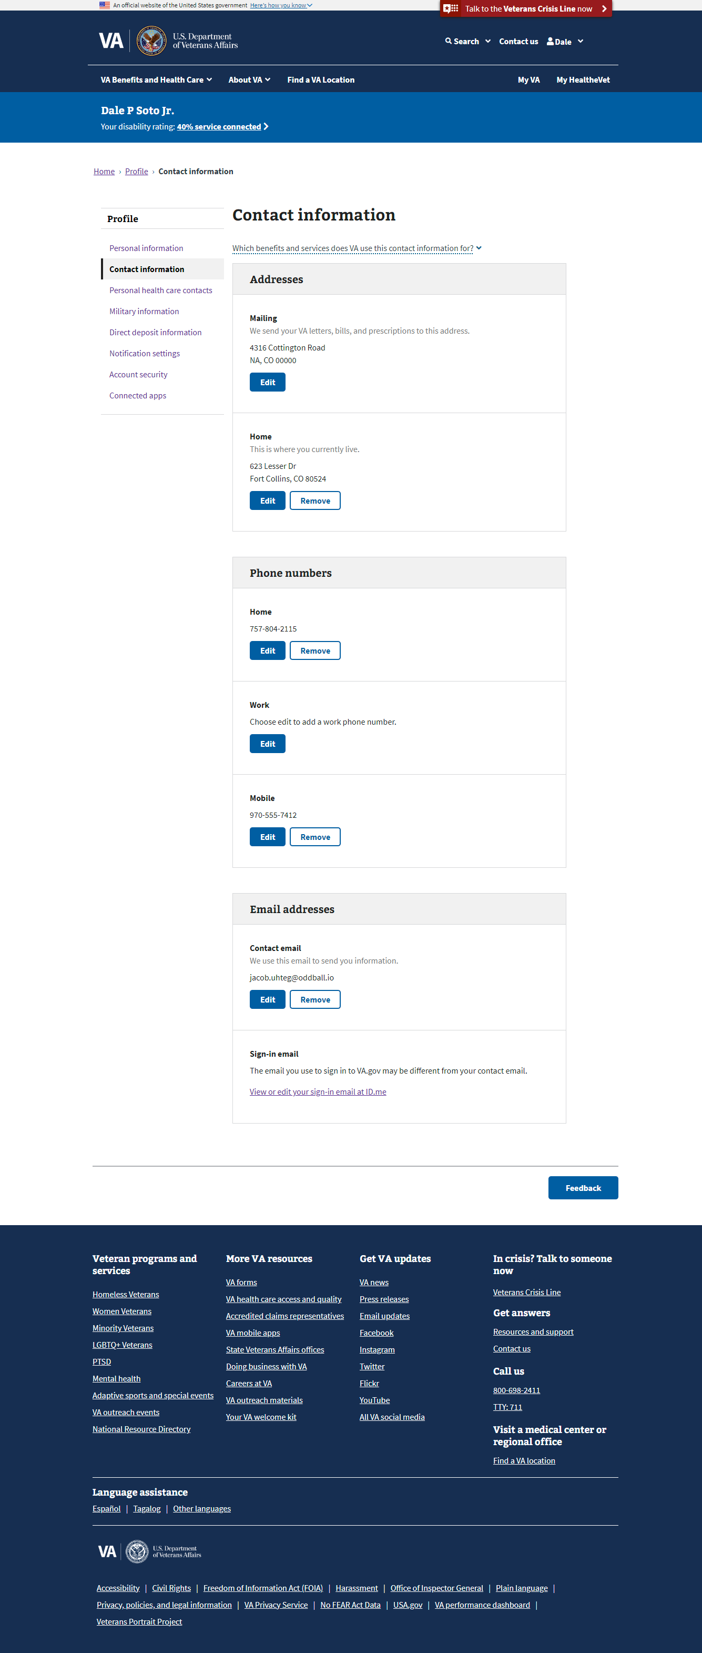

## User Access

### Users who have not verified their identity (LOA1)

As a reminder, users who have not verified their identity on VA.gov, or users who have a block on their account will only see the **Account security** section of the VA.gov profile when they go to www.va.gov/profile/contact-information. They will not see the **Contact Information**.

### Users who have verified their identity (LOA3)

Users who have verified their identities on VA.gov will be able to see **Contact Information** and all the sections of the profile.

### Users who have a blocked account

Users who have verified their identities on VA.gov but have a flagged account (eg. have a fiduciary, are deceased, flagged as incompetent) will not be able to use the **Contact Information** page, they will only see the **Account security** page. If they attempt to navigate to [www.va.gov/profile/contact-information](http://www.va.gov/profile/contact-information) it will redirect them to [www.va.gov/profile/account-security](http://www.va.gov/profile/account-security) and will display a warning message.

## Navigation

Access the **Contact information** section of the profile via the authenticated menu:

1. Sign into VA.gov (<https://www.va.gov/>).
2. Click the authenticated menu in the upper right corner of the screen (the user’s name) and select **Profile**.
3. Select **Contact information** from the Profile Hub.

## Functionality

### Editing Contact Information: Addresses

#### How to edit mailing addresses

From the **Contact information** section of the profile:

1. Go to the **Addresses** box.
2. Select **Edit** for the **Mailing address** field.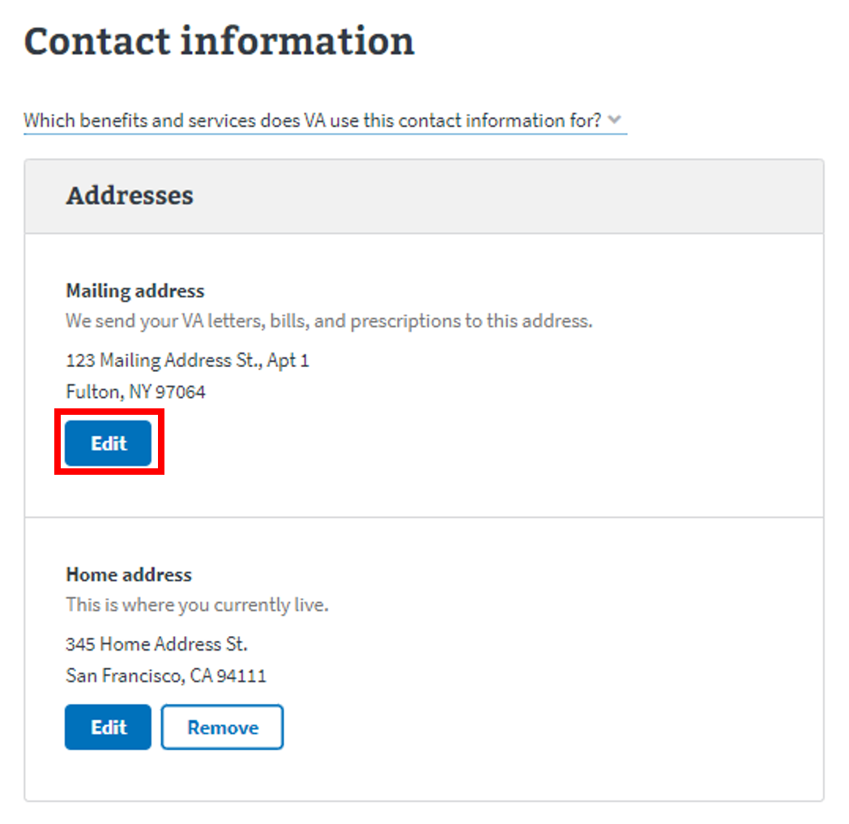
3. Enter the latest information. 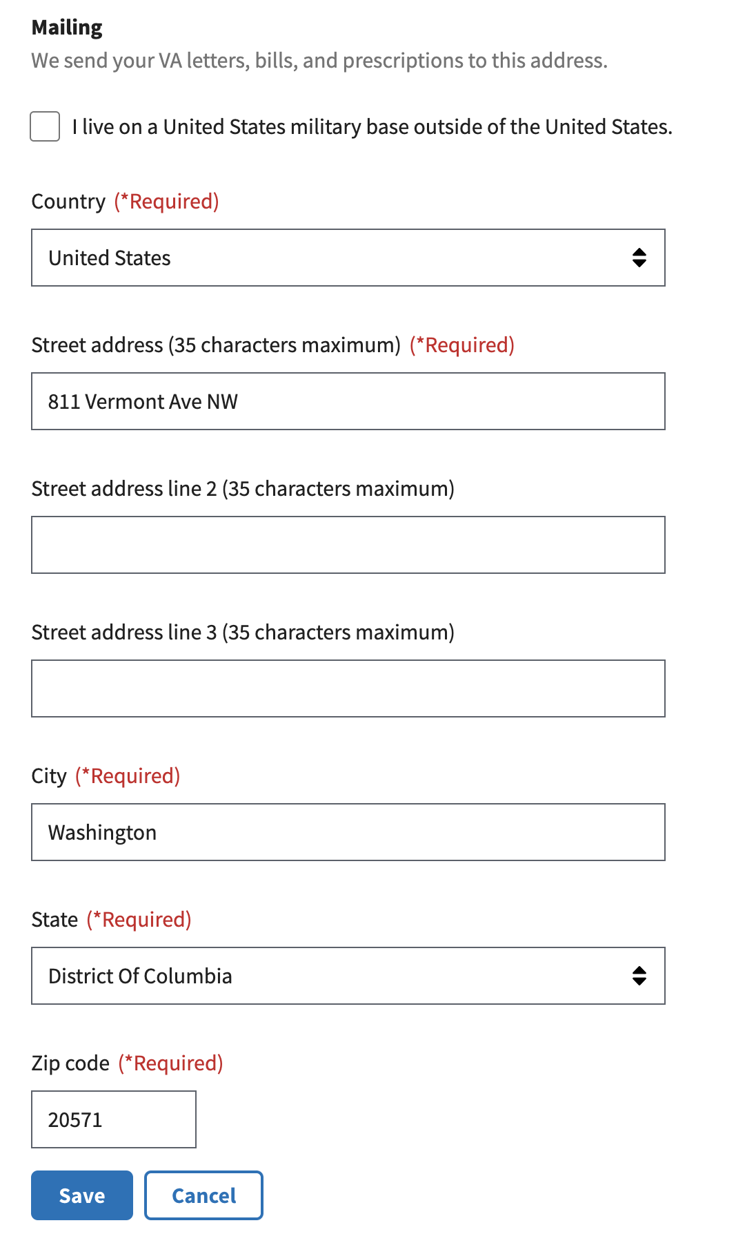
4. If a user lives on a U.S. military base, they can check the box that says **I live on a United States military base outside of the United States.**  
   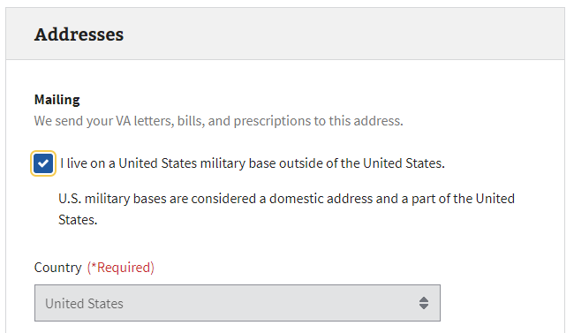
5. Click **Save** to save.

#### How to edit home addresses

From the **Contact information** section of the profile:

1. Go to the **Address** box.
2. Select **Edit** for the **Home address** field.
3. Enter the latest information. (If a user has the same home address as their mailing address, they can check the box that says **My home address is the same as my mailing address**.)  
     
   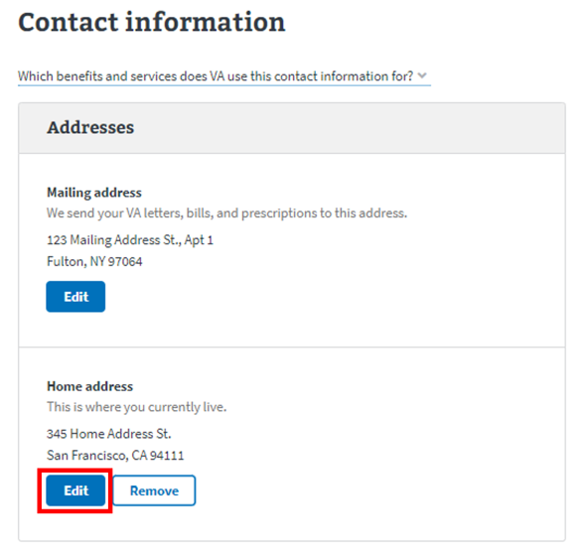  
   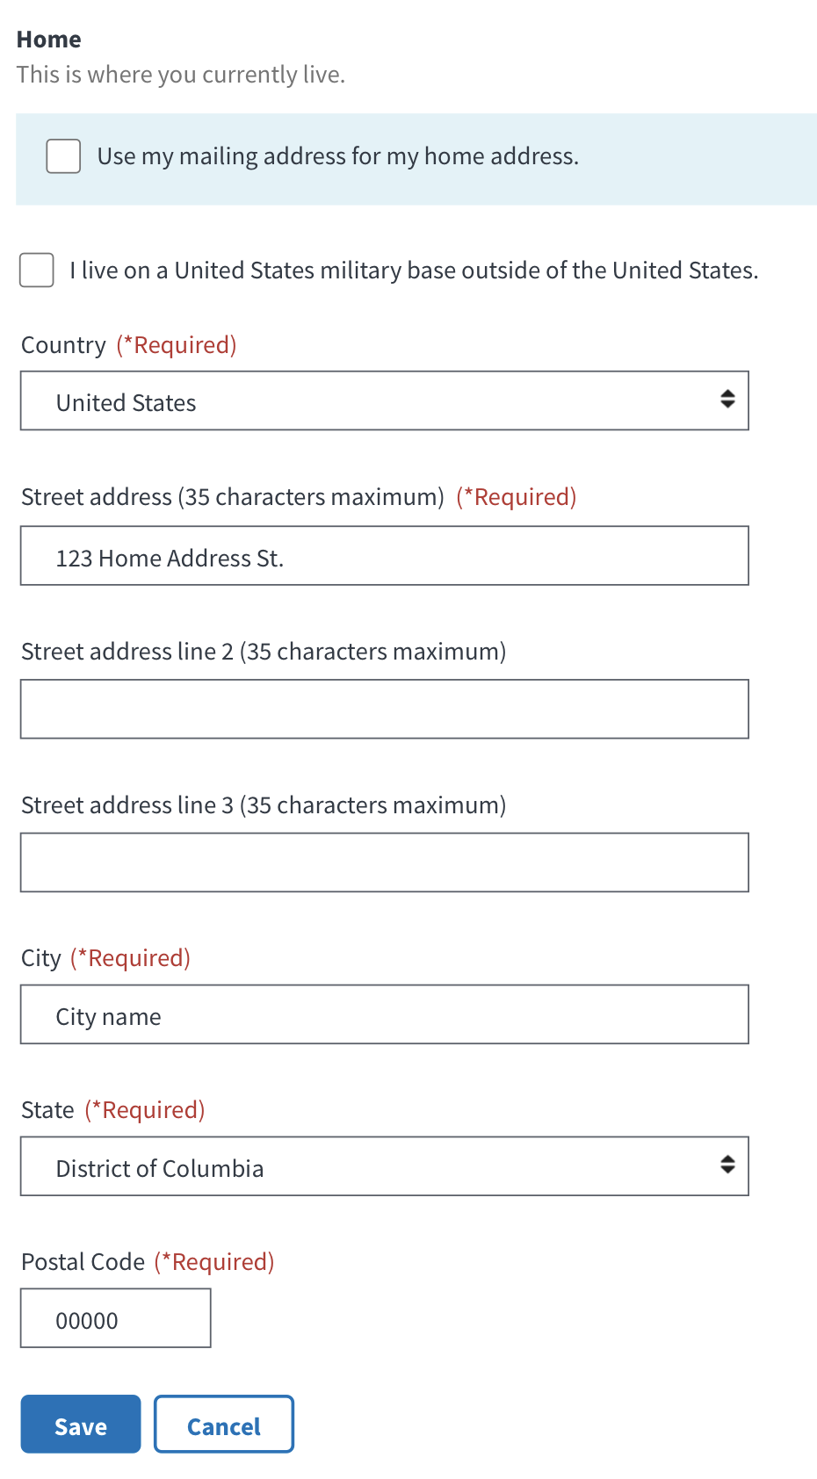  
     
   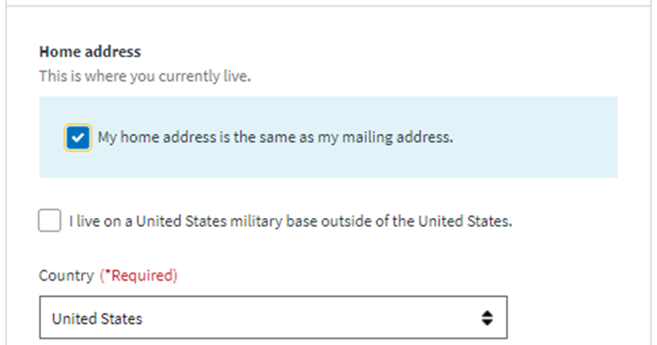
4. **Click** **Save** to save.

#### Address validation

When users update and save their addresses, the VA.gov profile checks the likelihood that the U.S. Postal Service will be able to deliver mail to them. This is called address validation.

In all the scenarios detailed, a person can edit the address they originally entered or choose to override the warning and save the address they entered as-is. If there is an address suggestion, they can select that.

After the user saves an address, the form closes. The new address will be visible in their profile.

If someone tries to save an address that our system flags as problematic, they will see one of the following:

##### A prompt to confirm the address, with potential address suggestions:

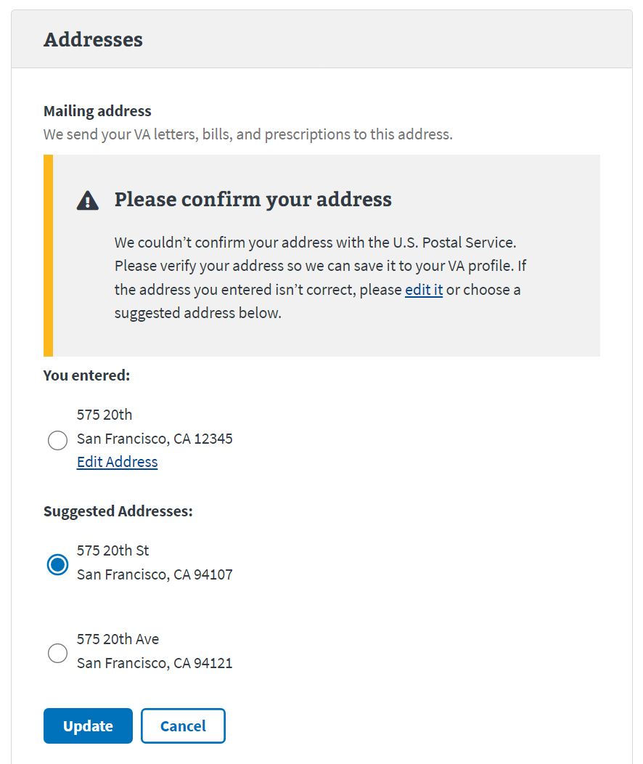

##### A prompt to confirm the address, with no suggestions:

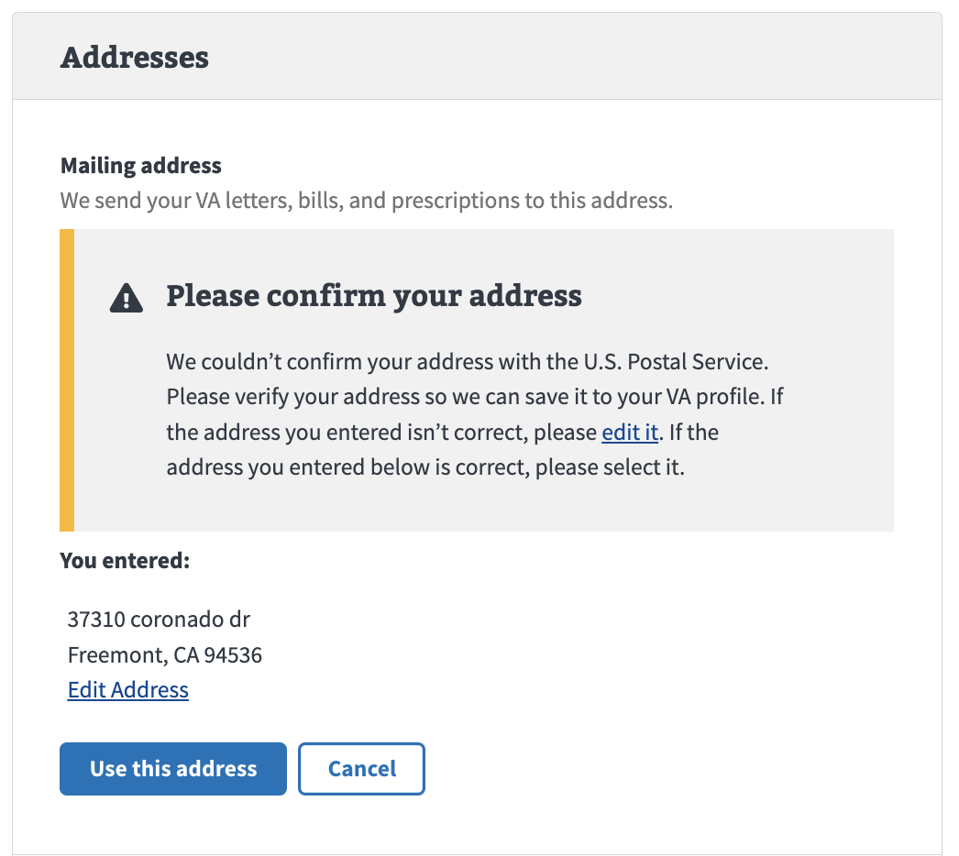

##### A prompt to add a unit number:

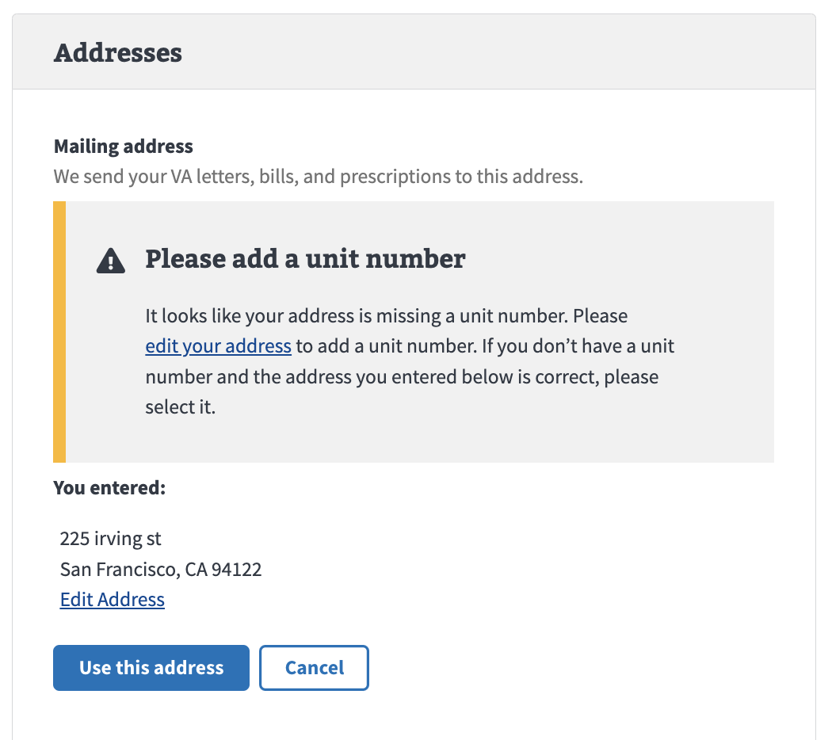

##### A prompt to edit a unit number:

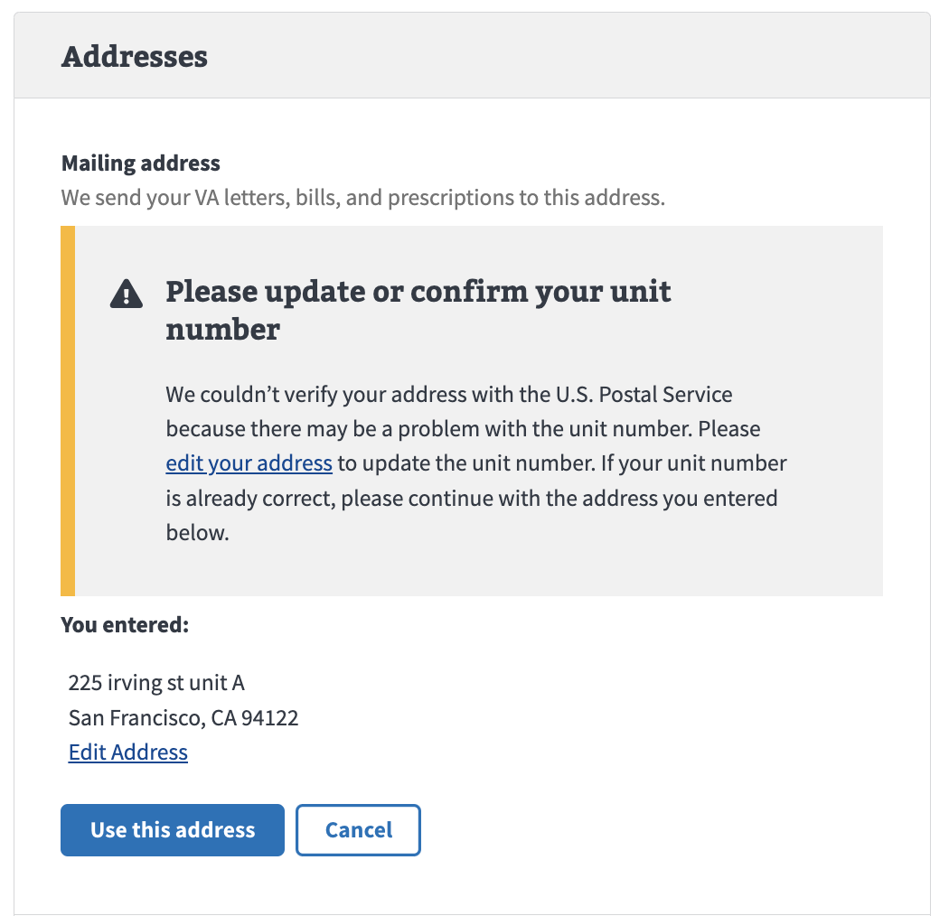

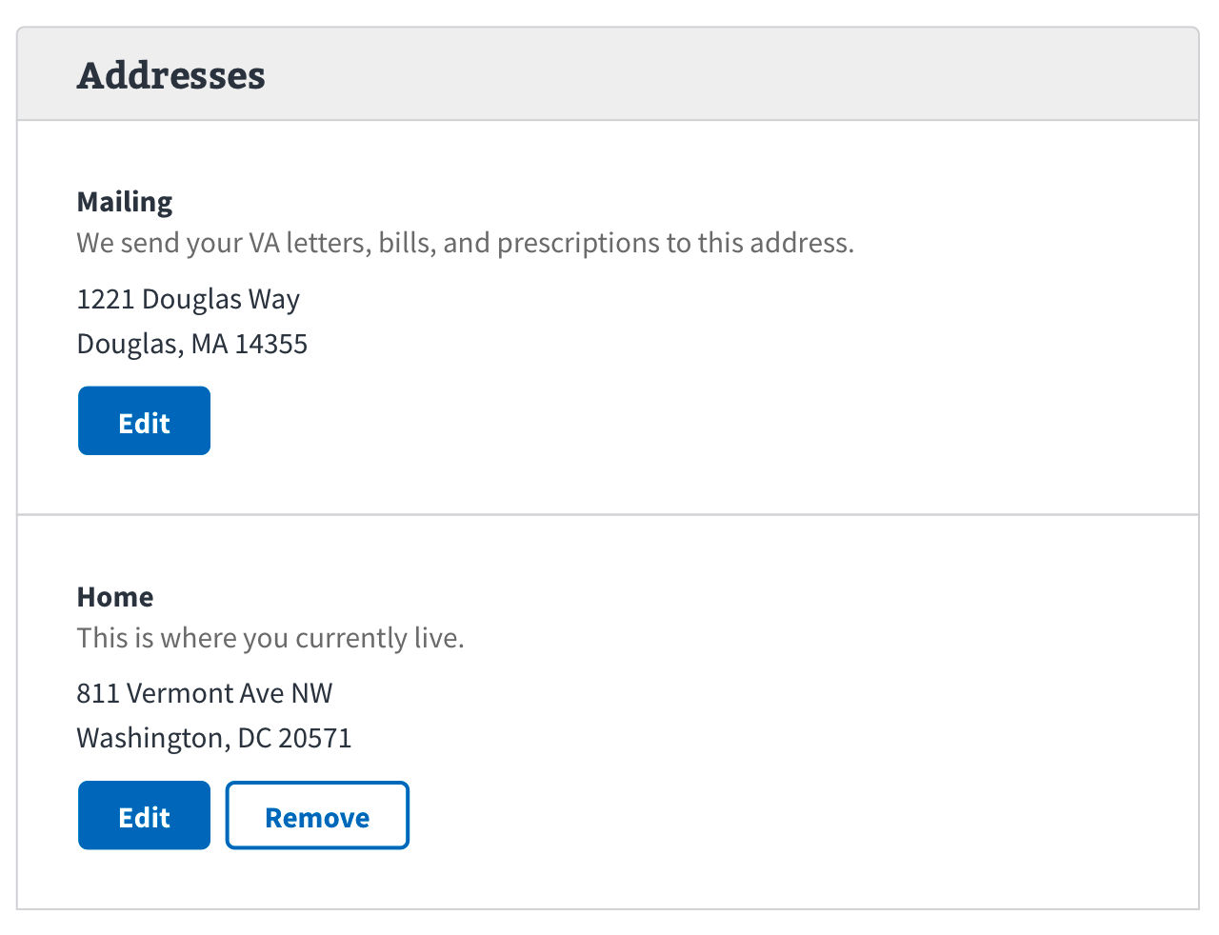

The **Contact info** page will display an alert within the **Mailing address** field:

To update the address:

1. Select edit
2. Make changes and **select Save**:

Additionally, a user's address may mistakenly be flagged as “bad” although the address is correct (e.g., due to returned mail). In this case we want the user to review and ***confirm*** their mailing address.

To confirm address if an address is correct:

1. Select edit:

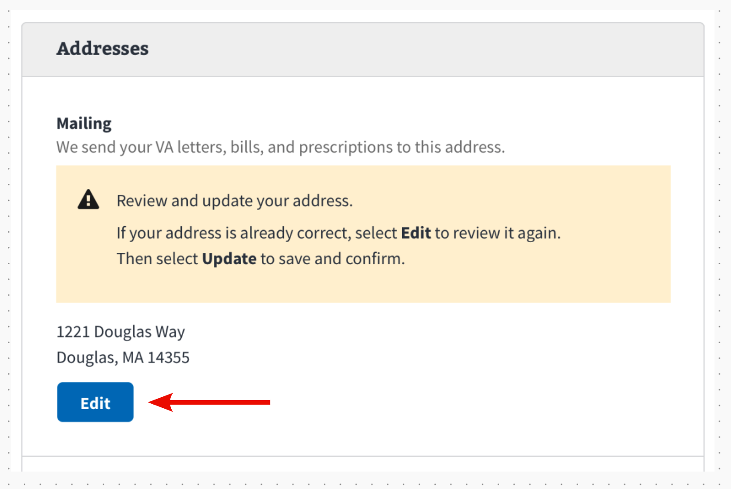

1. Review address without making any changes (if correct)
2. Then **select save**

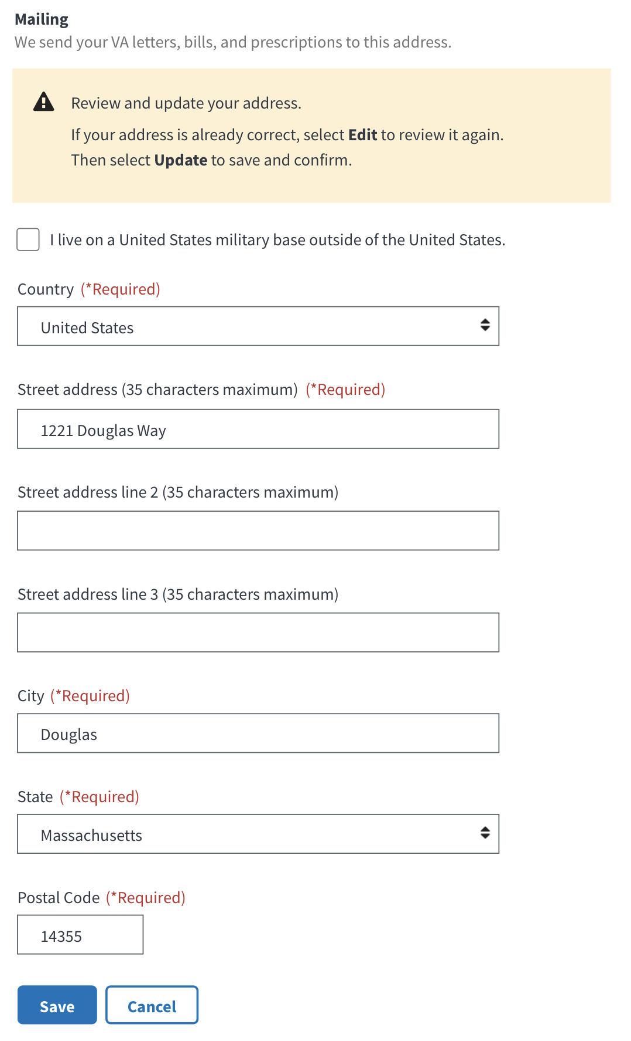

If the address is successfully updated the user will be shown a success alert: 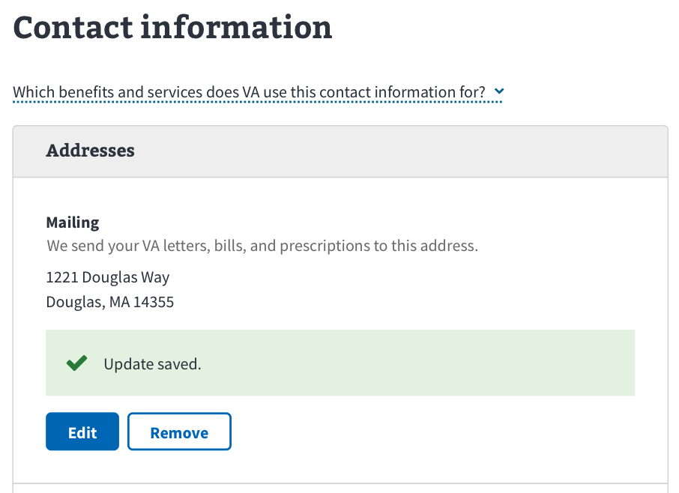

Note: if the user **confirms** their address is correct, they won’t see an “update saved” message since they didn’t make any changes.

The “Review your mailing address” alert will disappear from both the Contact information page and the Personal information page.

If unsuccessful, an error alert will show in the Mailing address field:

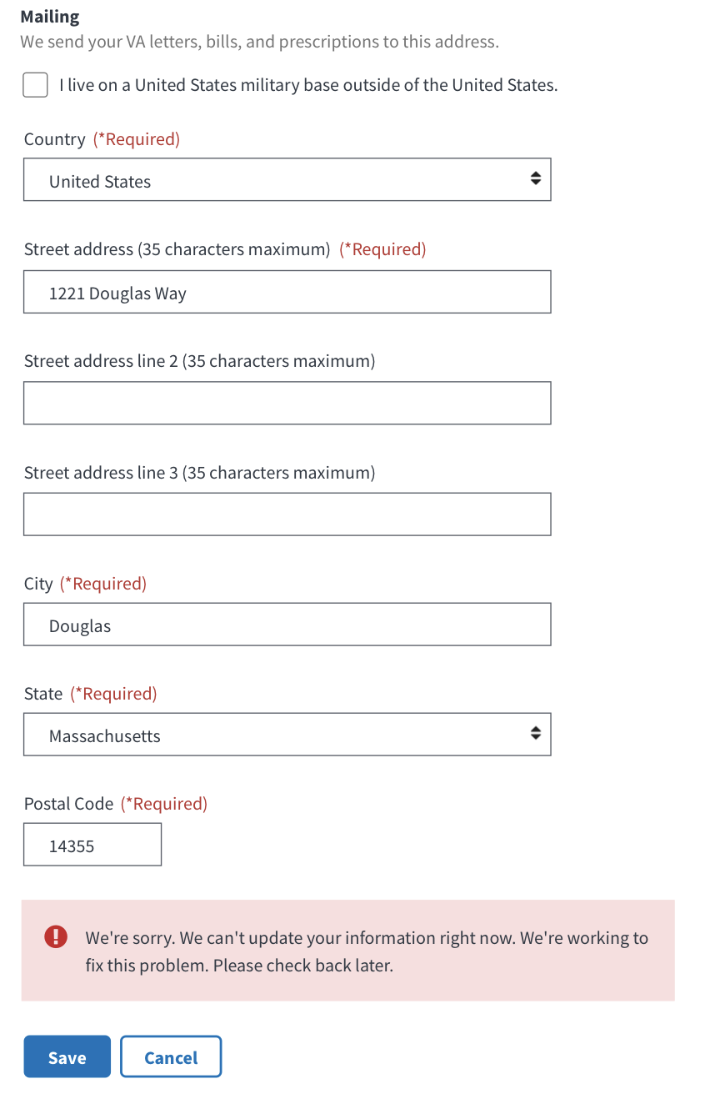

The alert will continue to display on the account until the user confirms the mailing address or updates it successfully.

### Editing Contact Information: Phone numbers

From the **Contact information** section of the profile:

1. Go to the **Phone numbers** field.
2. Select **Edit** for the number you want to edit.  
   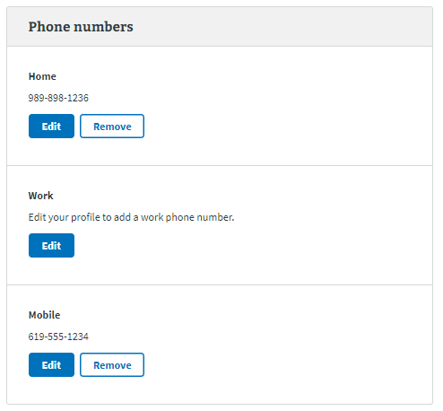
3. Enter the latest information.

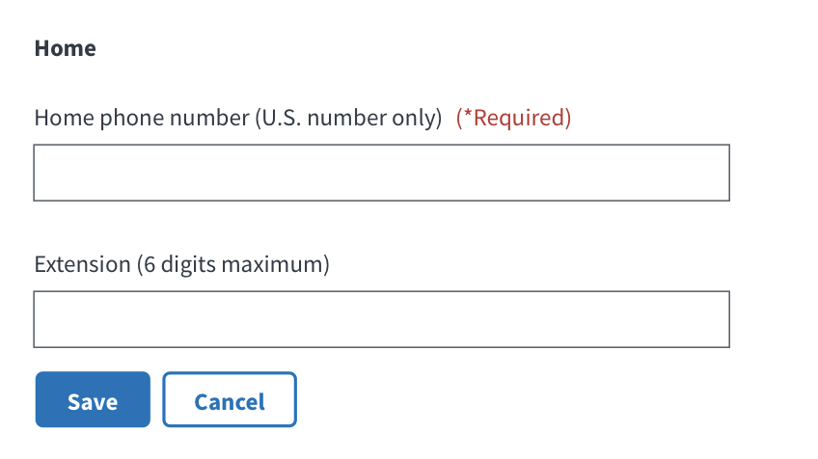

1. Click **Save** to save.

### Editing contact information: Contact email address

The **Contact email address** that is listed in the profile is the email address that VA will use to contact a user.

**Note**: This is not the email address used to sign-in. Updating this email address does not update the email address used to sign in.

To edit a contact email address:

1. Go to the **Contact email address** box.
2. Select **Edit.**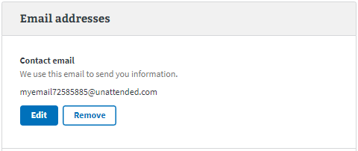
3. Enter the latest information.

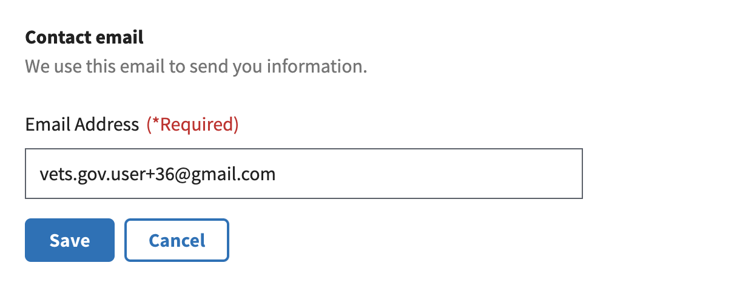

1. Click **Save** to save.

### Editing Contact Information: Sign in email address

If a user would like to update the email used to sign in, they should click on the link to go to the website where they manage their sign in account (either **Login.gov,** **DS Logon, MyHealtheVet, or ID.me**).

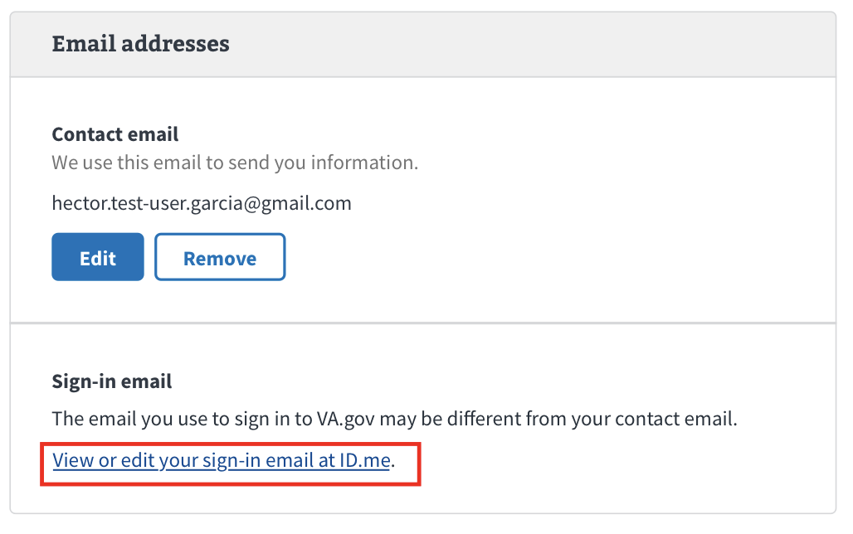

## Major Issues and Error Messages

### Editing errors

There are errors that users may see when a user is editing their information in the personal and contact information section.

#### Invalid phone numbers

If a user tries to enter an invalid phone number into a field, they will not be able to save, resulting in an error. If they receive this error, they should double check that the phone number they entered is valid.

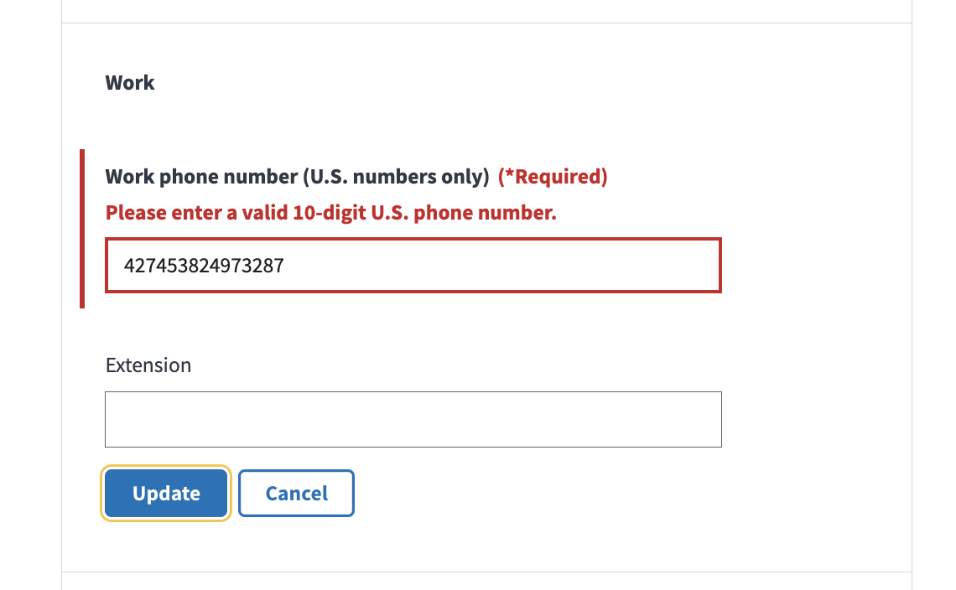

#### Finish editing section before moving to another

If a user tries to edit another section without saving the current section they are editing, they will receive this error message. There is a possibility that a user does not know that they are currently editing a different section. The error message will let them know what section they are editing. If a user decides to move on to a new section without saving, then all progress will be lost.

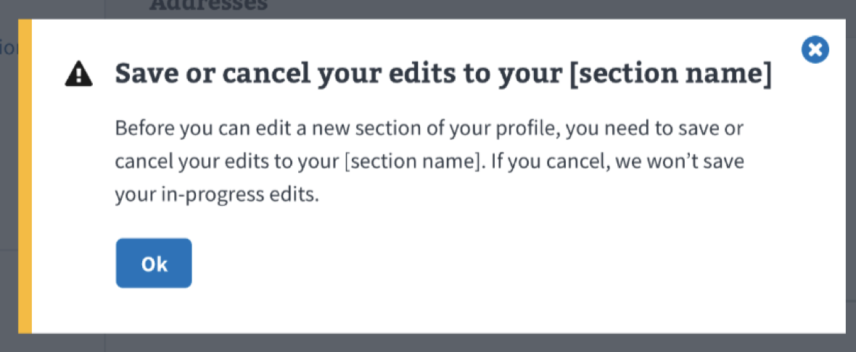

#### Canceling

If a user would like to cancel while in the middle of editing, they can click the **Cancel** button at the bottom of any section while in edit mode. There will be a message confirming they would like to cancel. If they cancel, then all progress will be lost.

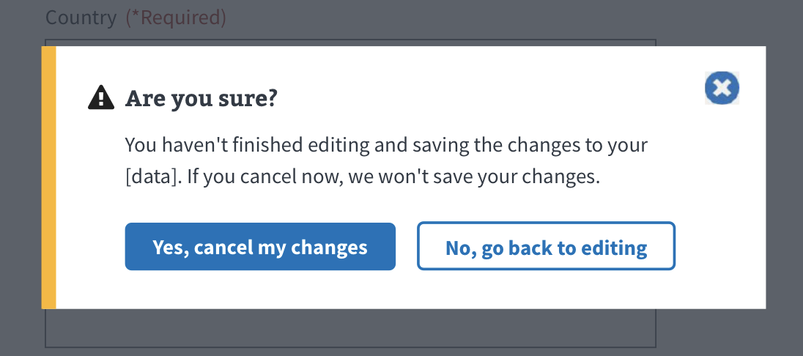

#### Trying to leave a page without saving

If a user tries to exit or leave the page while in the middle of editing a section, there will be a message confirming that they would like to leave the current page. If a user decides to leave the page, then all progress will be lost.

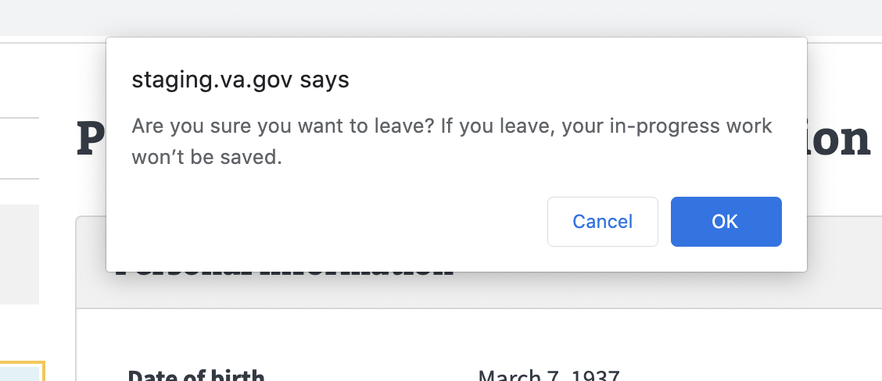

#### Saving error

There is the chance that a problem may occur on our end, and we won’t be able to save a user’s information. If that happens, the user will see one of the messages below and should refresh and try again.

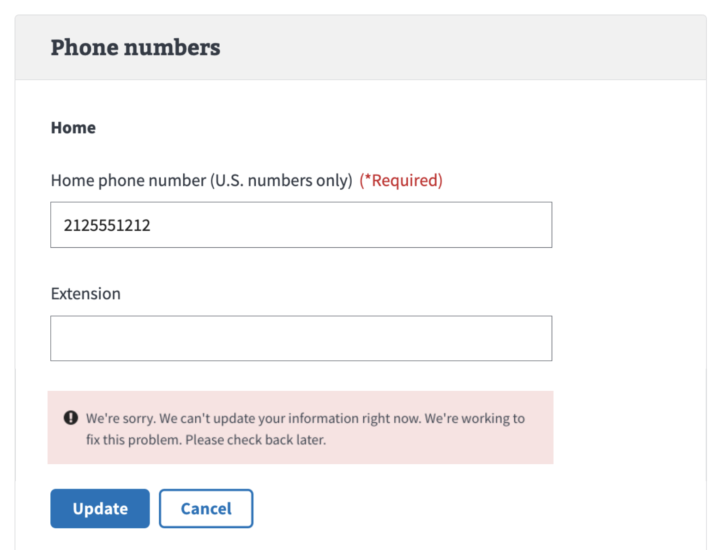

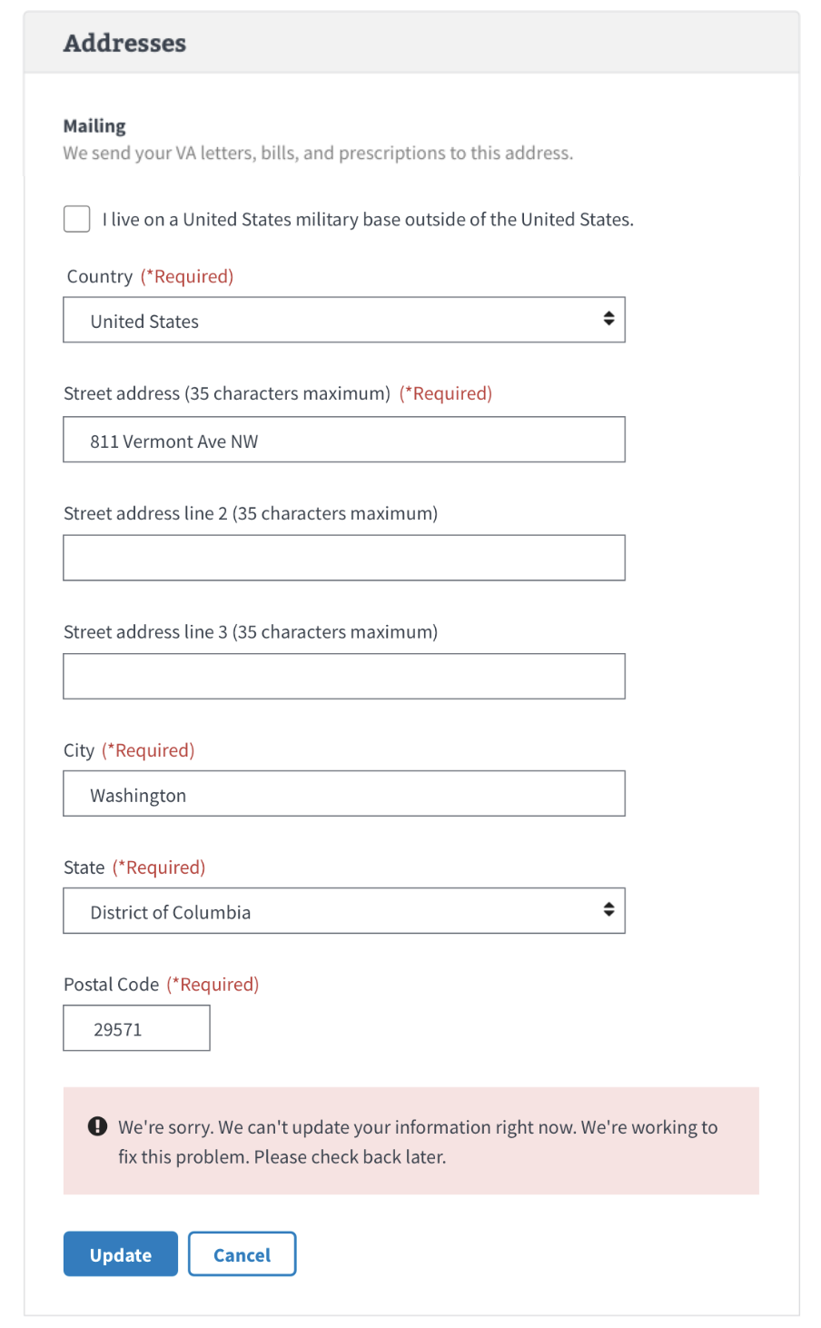

#### Update is delayed

There could be a significant delay when saving new information. If that occurs, the user will see the message below and will be notified when their information has been updated.

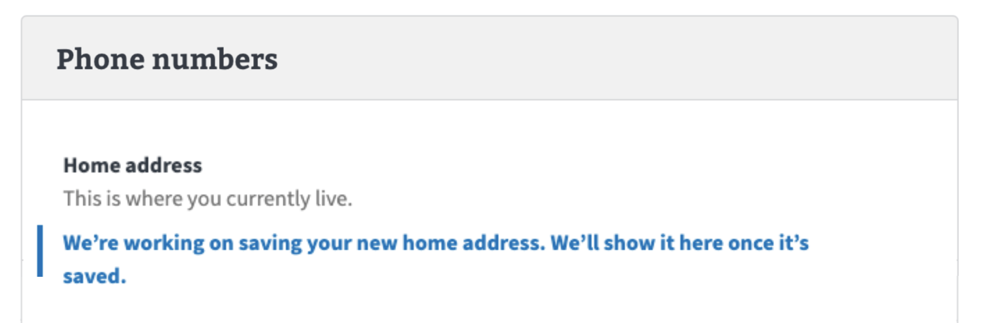

### General errors

There are general errors that users may see when using the **Contact information section**.

#### Can’t access personal information

Sometimes, a problem can occur on our end, and we won’t be able to retrieve a user’s contact information. If that happens, the user should refresh or try again later.

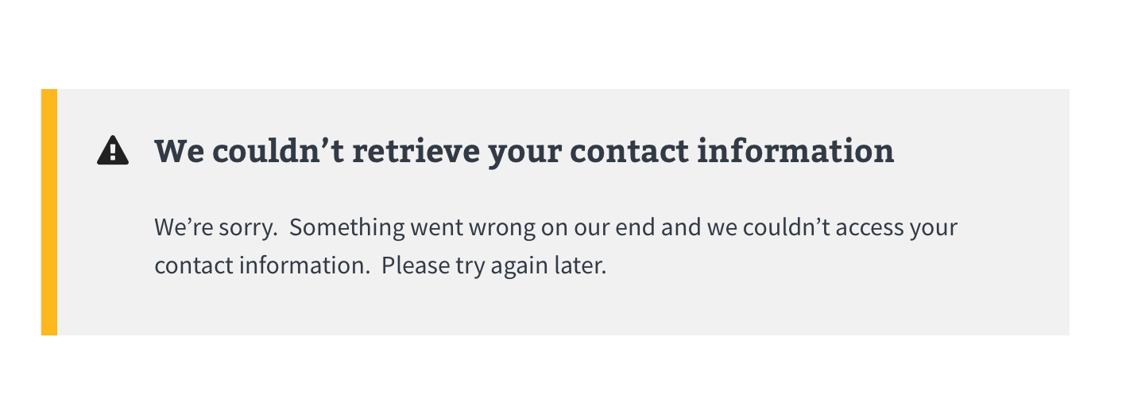

#### Multiple accounts

A scenario sometimes occurs where we can’t load all a user’s information because they have multiple VA IDs or accounts. We won’t know if it is an issue with their MyHealtheVet account or an issue with the Department of Defense. If the user receives this message, then there are a few things they can do:

##### To find out if this is about an account on MyHealtheVet

* They can call 877-327-0022, Monday–Friday, 8 a.m.–8 p.m. ET. If they have hearing loss, they can call 800-877-3399. They can tell the representative that they tried to sign into VA.gov, but got an error message that they may have more than one MyHealtheVet account or ID.
* Fill out a MyHealtheVet online help form to get help signing in. (<https://www.myhealth.va.gov/mhv-portal-web/contact-us>)

##### To find out if this is about an account with Department of Defense

* They can submit a request to get help signing in.

(<https://ask.va.gov/>) 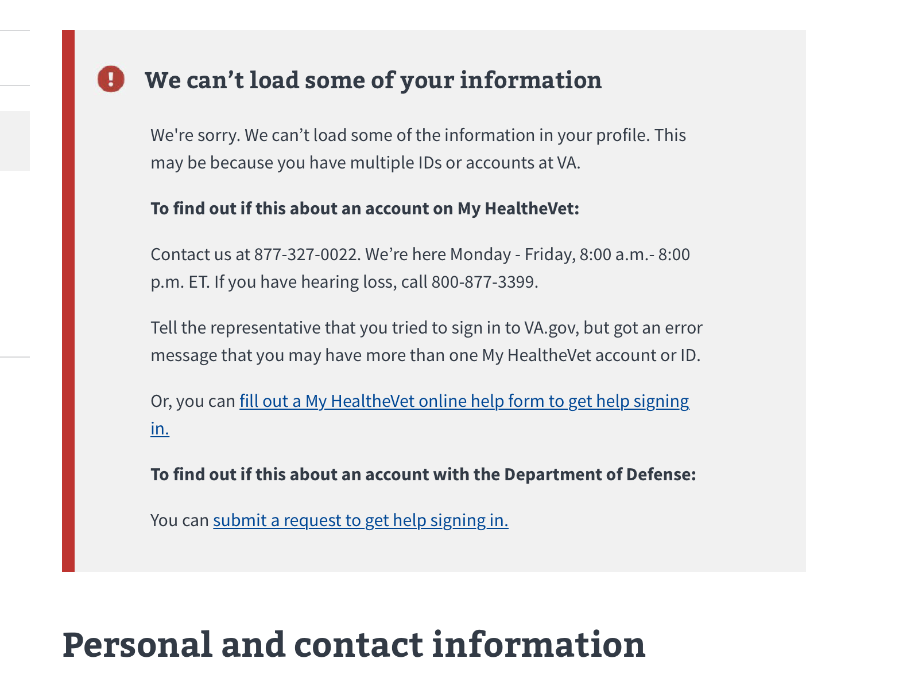

#### User information doesn’t match our Veteran records

There is the chance that we won’t be able to match a user’s information with our Veteran records. In this case, a user will not have access to their profile until they can verify and update their records.

The user will need to contact the nearest VA medical center to verify and update their records. They can find the nearest facility by clicking the link that says **Find your nearest VA medical center.** (<https://va.gov/find-locations/?facilityType=health>).

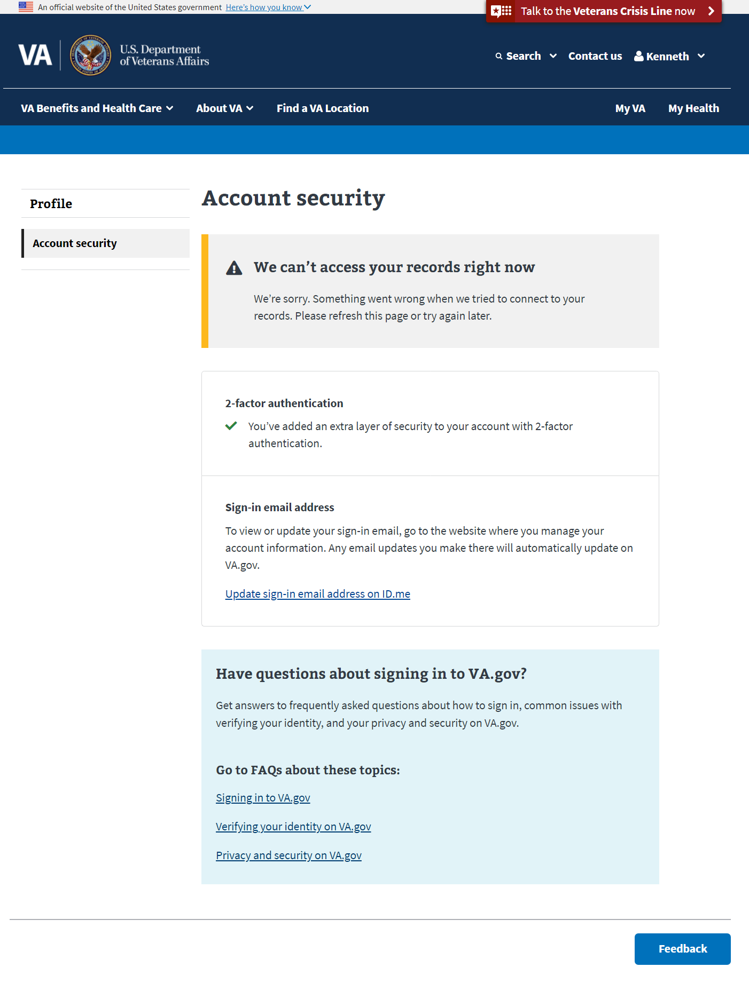

### User Account is Blocked:

If a veteran’s account is flagged for having a fiduciary, being deceased, or is classified as incompetent, the whole profile will be blocked, and at that point the Account Security page is the ONLY page that will load within the profile application.

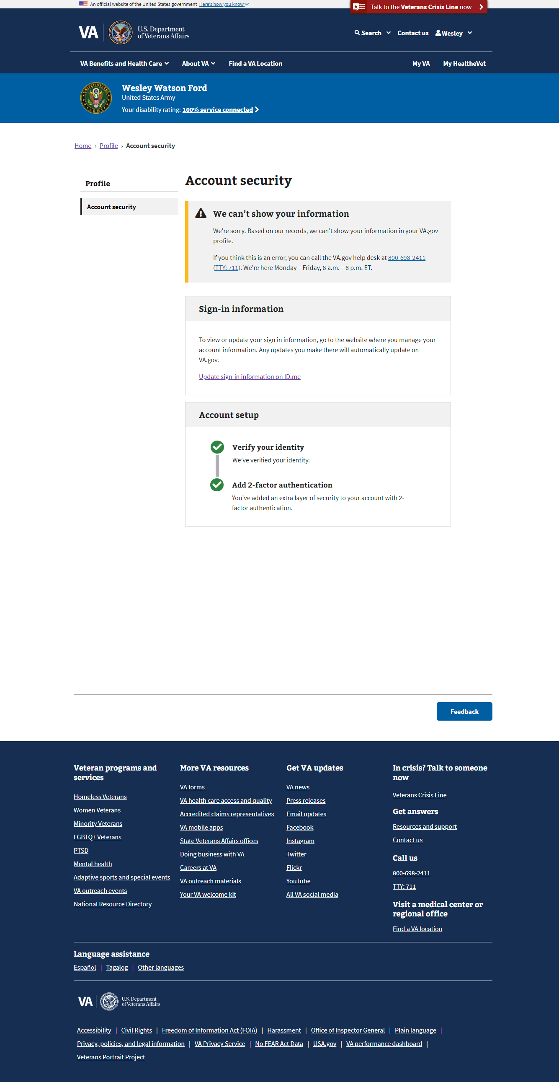

# Section Overview: Military Information

The **Military information** section of the profile displays the specific branch that a user served in and their period(s) of service.

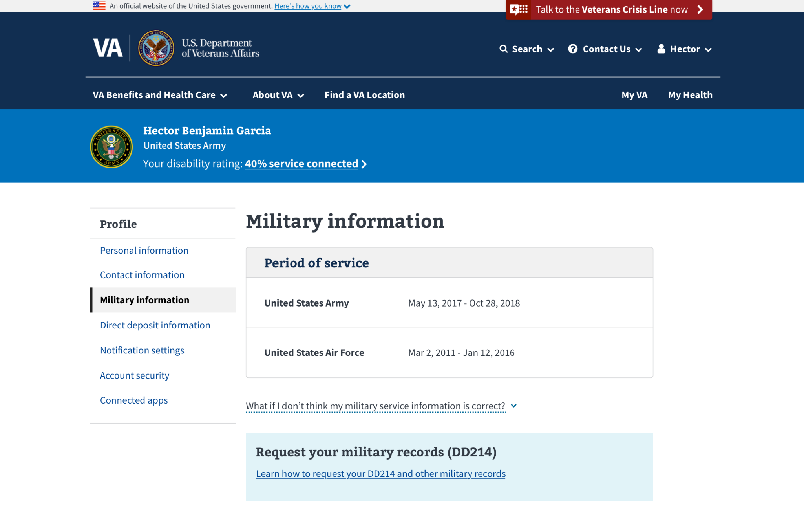

## User Access

### Users who have not verified their identity (LOA1)

As a reminder, users who have not verified their identity on VA.gov, or users who have a block on their account will only see the **Account security** section of the VA.gov profile when they go to www.va.gov/profile/military-information. They will not see the **Military Information**.

### Users who have verified their identity (LOA3)

Users who have verified their identities on VA.gov will be able to see **Military Information** and all the sections of the profile.

### Users who have a blocked account

Users who have verified their identities on VA.gov but have a flagged account (eg. have a fiduciary, are deceased, flagged as incompetent) will not be able to use the **Military Information** page, they will only see the **Account security** page. If they attempt to navigate to [www.va.gov/profile/military-information](http://www.va.gov/profile/military-information) it will redirect them to [www.va.gov/profile/account-security](http://www.va.gov/profile/account-security) and will display a warning message.

## Navigation

1. Sign into VA.gov (<https://www.va.gov>).
2. Click the authenticated menu in the upper right corner of the screen (the user’s name) and select **Profile**.
3. Click on **Military information** in the Profile Hub.



## Functionality

### Editing Military Information

The **Military information** section is not editable from the VA.gov profile.

If the military service information in a user’s profile doesn’t seem correct, the user should call the Defense Manpower Data Center (DMDC). They’ll work with the user to update their information in the Defense Enrollment Eligibility Reporting System (DEERS).

To reach the DMDC, users can call **800-538-9552**, Monday through Friday (except federal holidays), 8 a.m. to 8 p.m. ET. If a user has hearing loss, they should call TTY: +**711**.

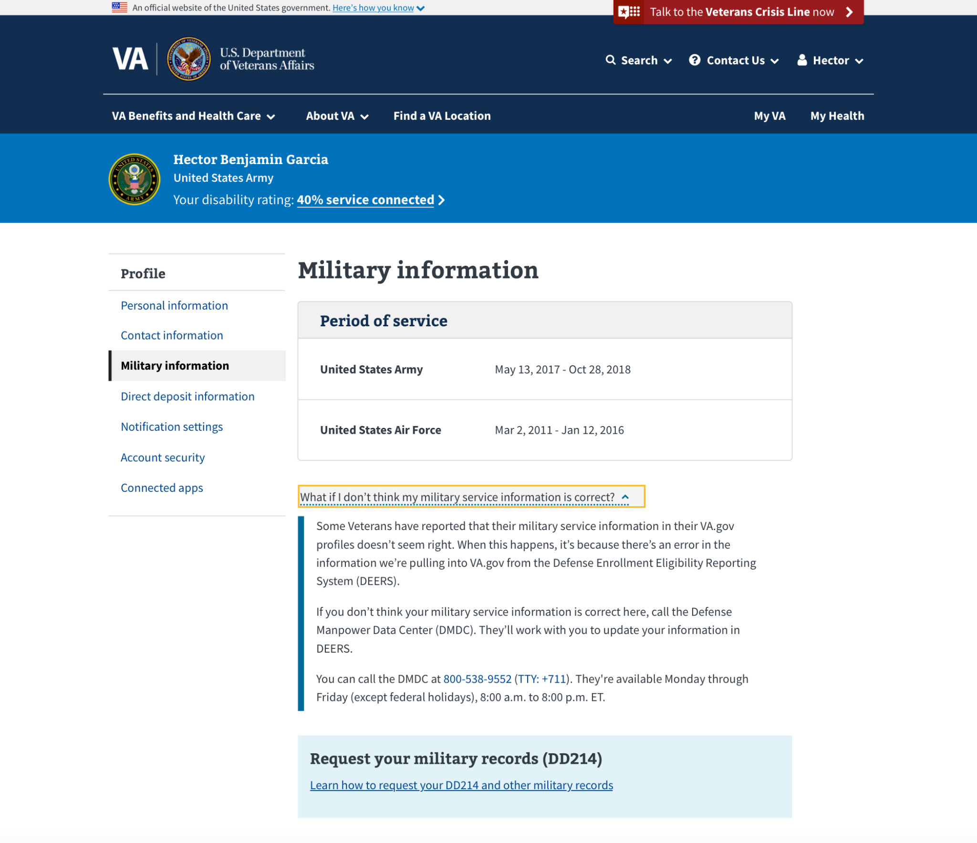

## Major Issues and Error Messages

### Can’t access military information

Occasionally, a problem can occur on our end and we won’t be able to retrieve a user’s military information. If that happens, the user should refresh the page or try again later.

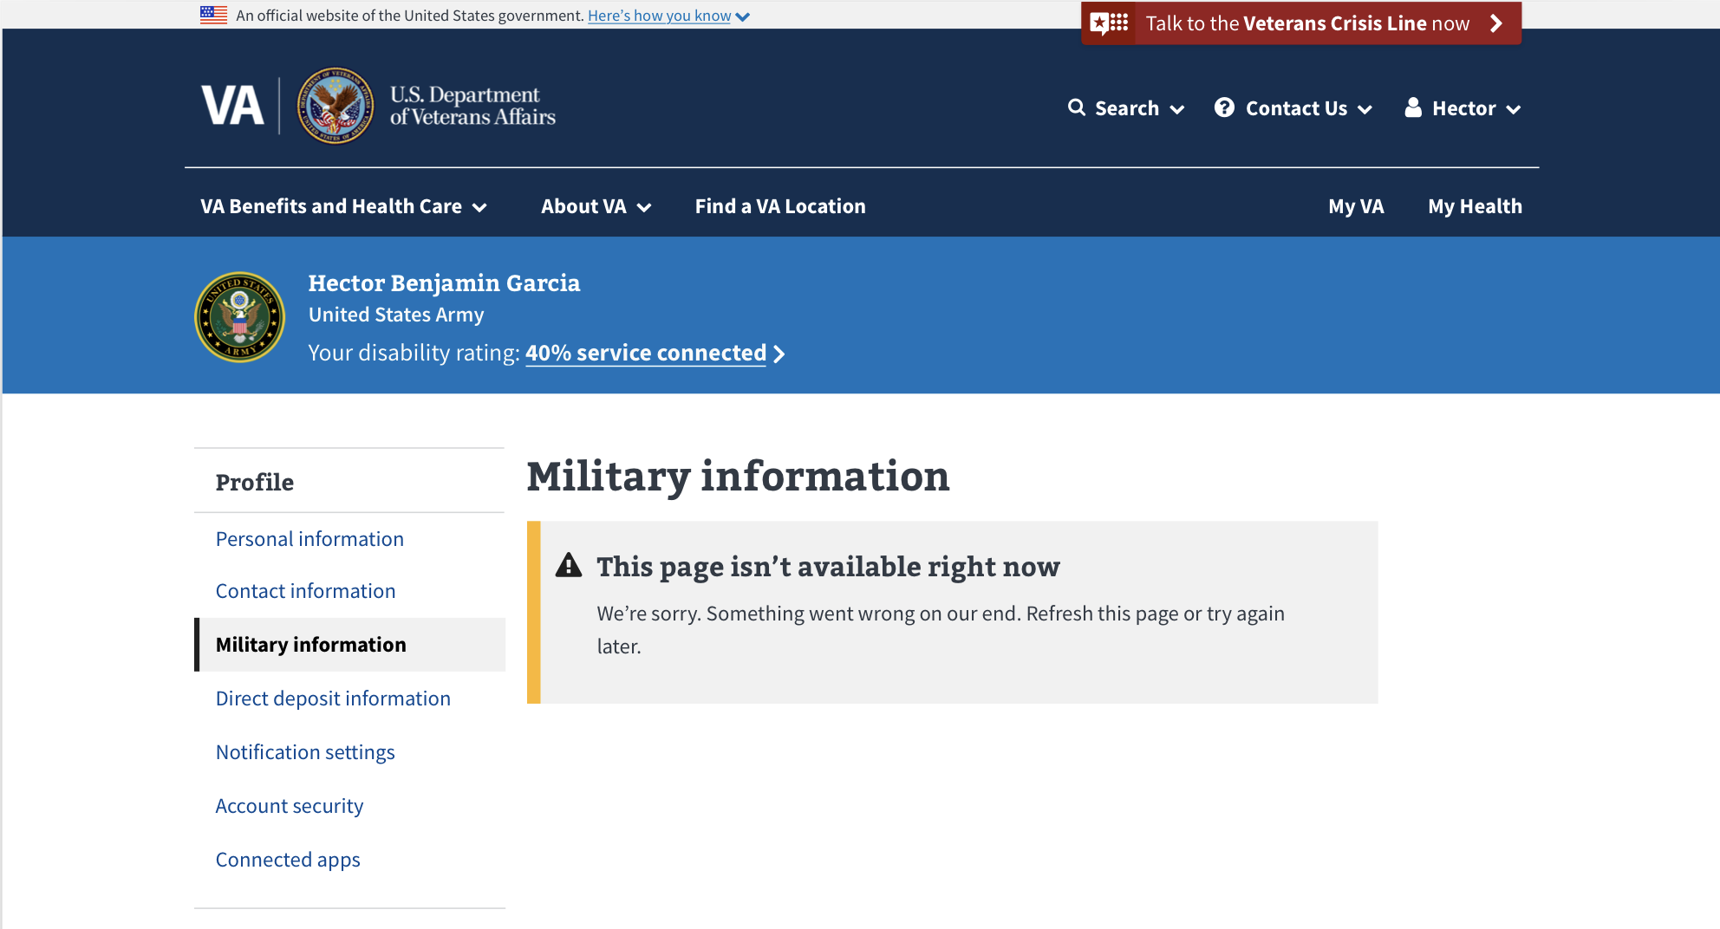

For users who are not veterans, they will automatically see the message below when they go to the **Military information** section.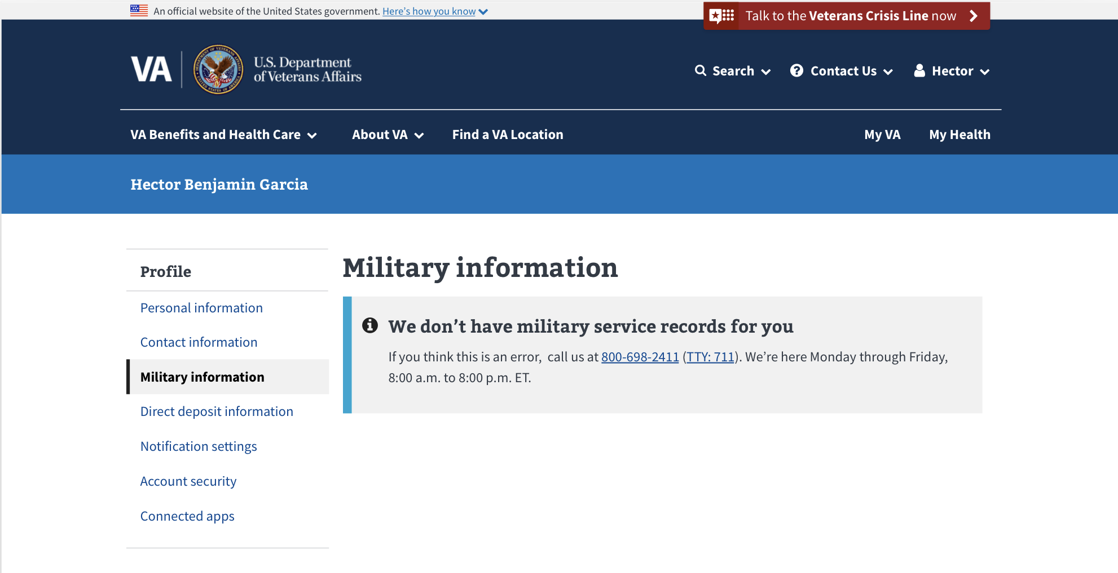

### Can’t show military information

If we can’t find a user’s Department of Defense DoD ID or the user has no military service, we will not be able to access their military records. If the user receives this message, they can call **800-538-9552 (TTY: 711)** to learn what military service records may be on file for them.

If they think there might be a problem with their military service records, they can apply for a correction by clicking the link that says **Learn how to correct your military service records on the National Archives website**. (<https://www.archives.gov/veterans/military-service-records/correct-service-records.html>)

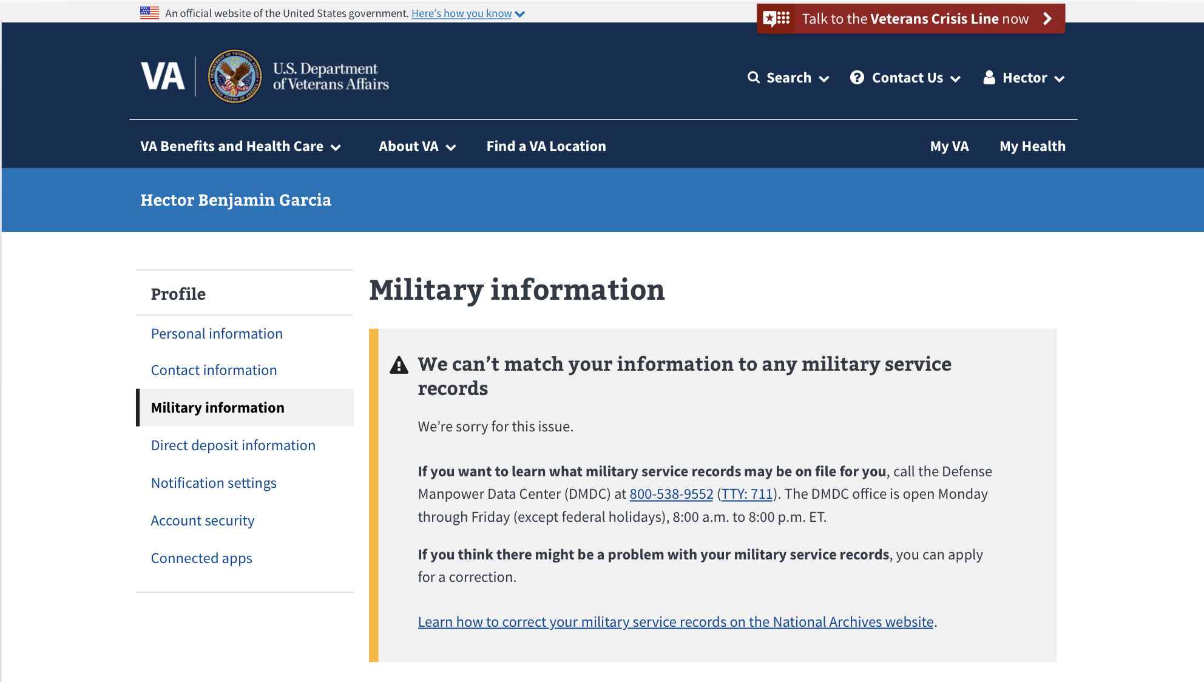

# Section Overview: Direct Deposit

The Direct Deposit feature on VA.gov allows users to see and change their bank information for benefits payments made by VA. There are two categories of benefits: compensation and pension (C&P) and education (EDU).

## User Access

### Users who have not verified their identity (LOA1)

As a reminder, users who have not verified their identity on VA.gov, or users who have a block on their account will only see the **Account security** section of the VA.gov profile when they go to www.va.gov/profile/direct-deposit. They will not see the **Direct deposit Information**.

For a user to see **Direct deposit**, they must have verified their identity (LOA3). 2-factor authentication (2FA) is not required.

If we do not detect that a user is receiving compensation, pension, or education benefit payments, they will see the section, but will not have the option to add or edit direct deposit information

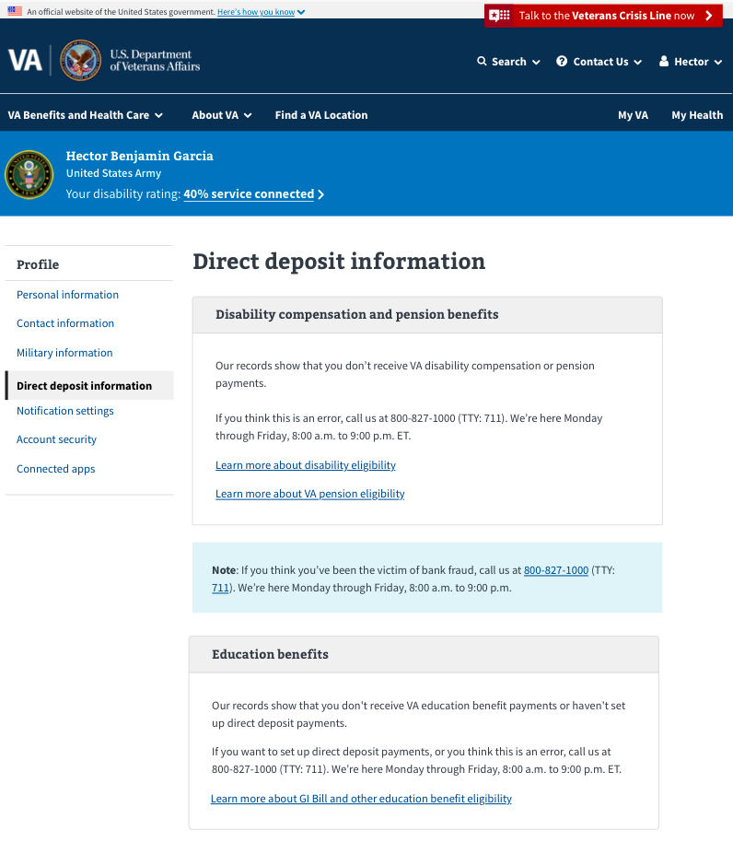

### Users who have verified their identity (LOA3)

Users who have verified their identities on VA.gov will be able to see **Direct deposit information** and all the sections of the profile.

### Users who have a blocked account

Users who have verified their identities on VA.gov but have a flagged account (eg. have a fiduciary, are deceased, flagged as incompetent) will not be able to use the **Direct deposit information** page, they will only see the **Account security** page. If they attempt to navigate to [www.va.gov/profile/direct-deposit](http://www.va.gov/profile/direct-deposit) it will redirect them to [www.va.gov/profile/account-security](http://www.va.gov/profile/account-security) and will display a warning message.

## Navigation

1. Sign into VA.gov (<https://www.va.gov/>).
2. Click the authenticated menu in the upper right corner of the screen (the user’s name) and select **Profile**.
3. Click on **Direct Deposit** in the hub.

## Functionality

### Direct deposit information for disability compensation and pension (C&P) payments

#### How to add direct deposit information for compensation and pension

**Note:** Adding direct deposit information online is only available for C&P payments. Education benefit direct deposit needs to be set up over the phone.

From the **Direct deposit information** section of the profile:

1. Click **Edit** to add bank information.

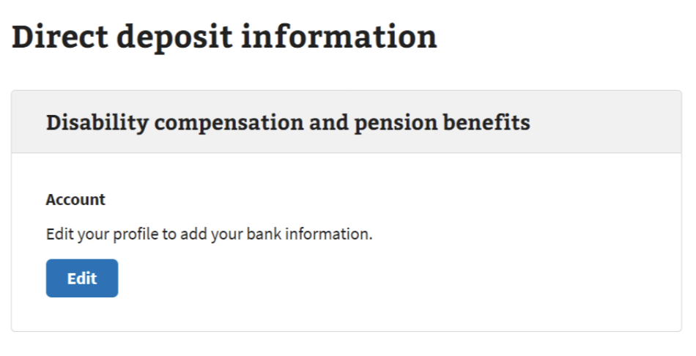

If a user has questions related to finding their account number or routing number, they can click the **Where can I find these numbers?** dropdown.

1. Enter the new bank account information.
2. Click **Save** to save. Once they click **Save,** they should see a message letting them know their information was saved:

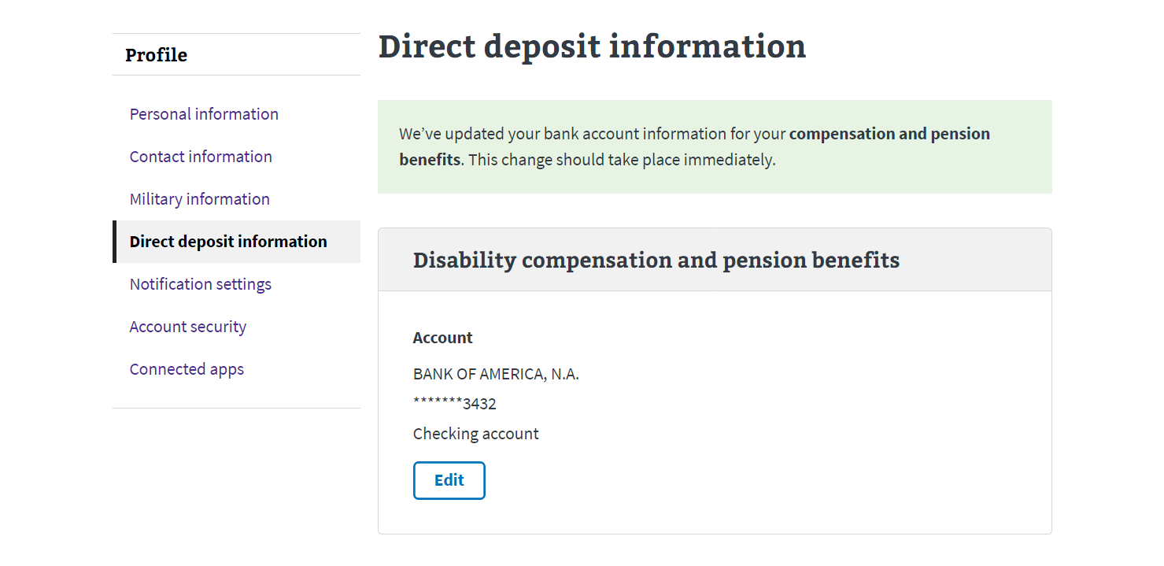

After a user’s direct deposit information has been updated, they should receive an automatically generated confirmation email from VA.gov. This is a no-reply address and any emails sent to this address will not be received by our team or anyone else.

#### How to edit direct deposit information for disability and compensation payments

From the **Direct deposit information** section of the profile:

1. Click the **Edit** button within the **Disability compensation and pension benefits** box.

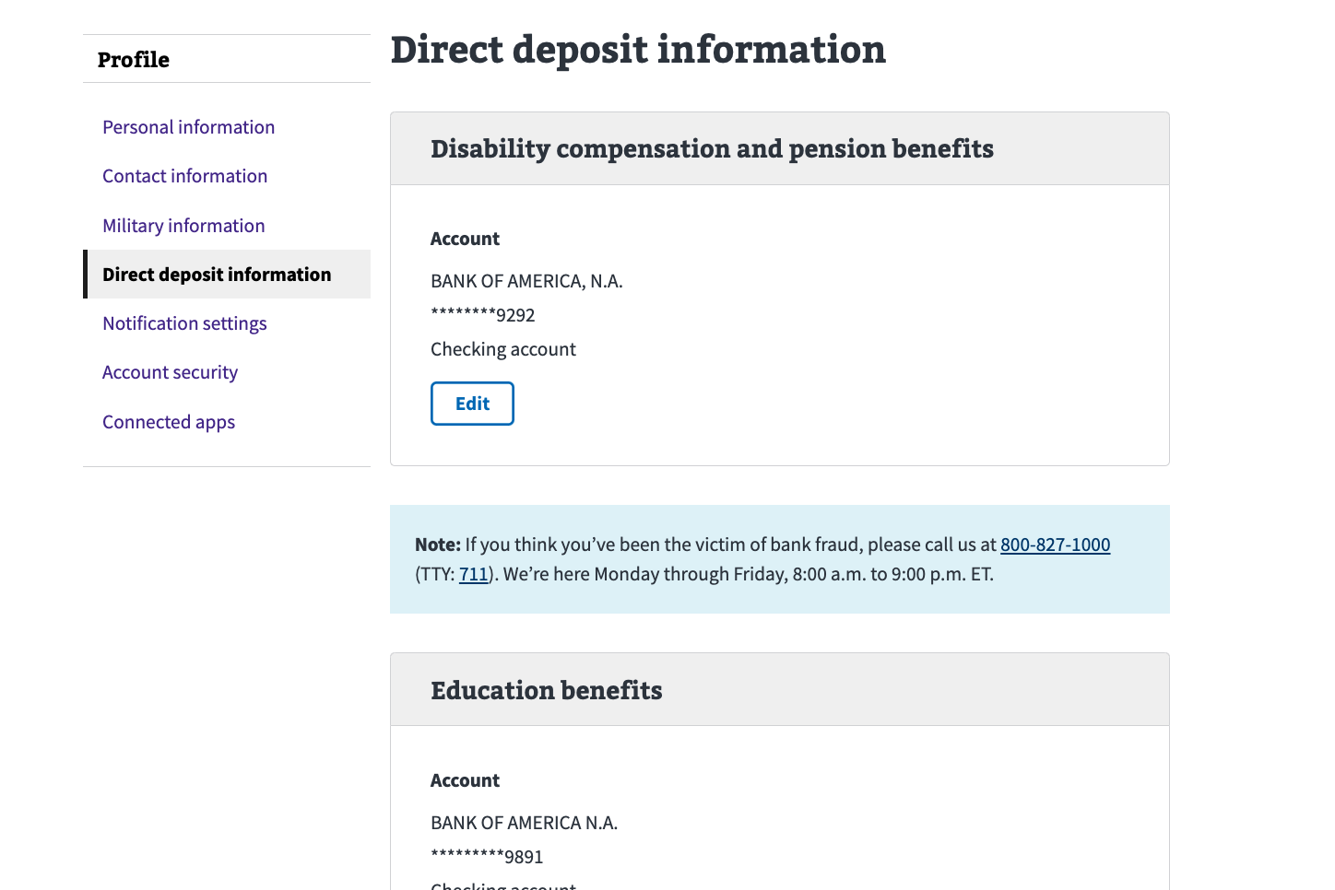

1. Once the form opens, update the **Routing number**, **Account number**, and **Account type**.
2. Click **Save** to save.

### Direct Deposit for Education Benefits

#### How to edit direct deposit information for Education payments

**Note:** Users can’t add direct deposit for education payments online; the functionality allows for editing *after* direct deposit is set up over the phone.

From the **Direct deposit information** section of the profile:

1. Click **Edit** to the right of **Account** within the **Education benefits** box.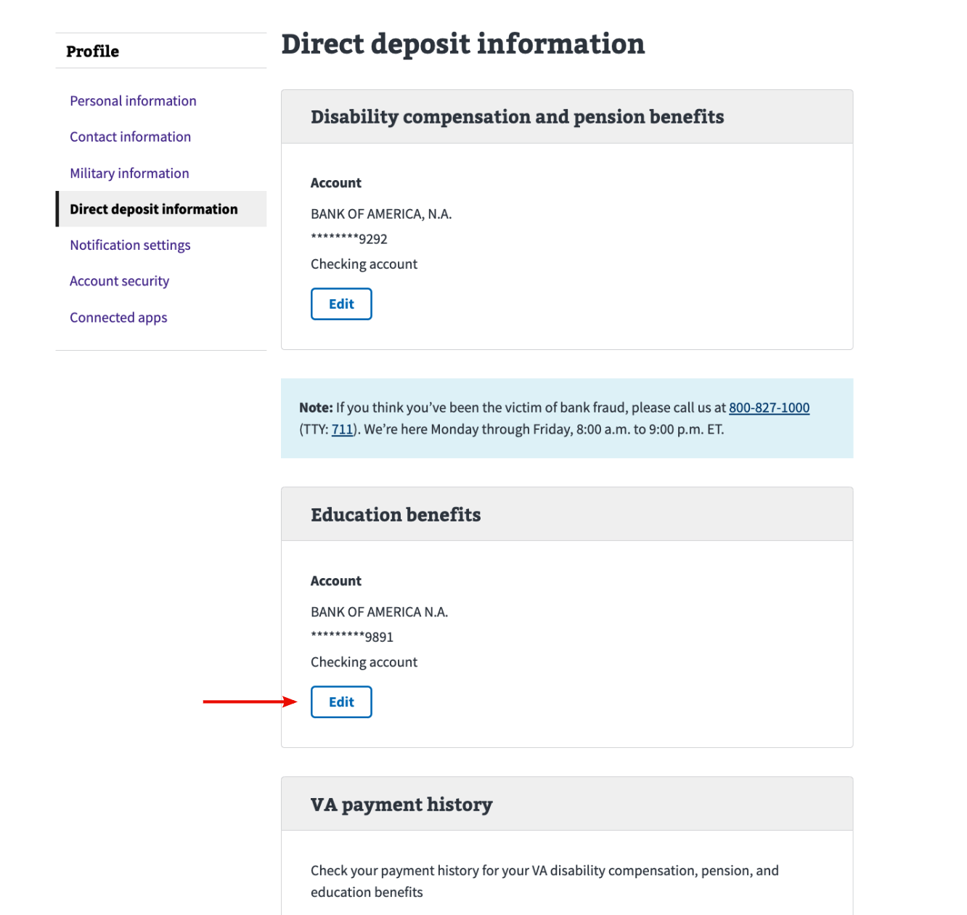
2. Once the form opens , update the **Routing number**, **Account number**, and **Account type**.

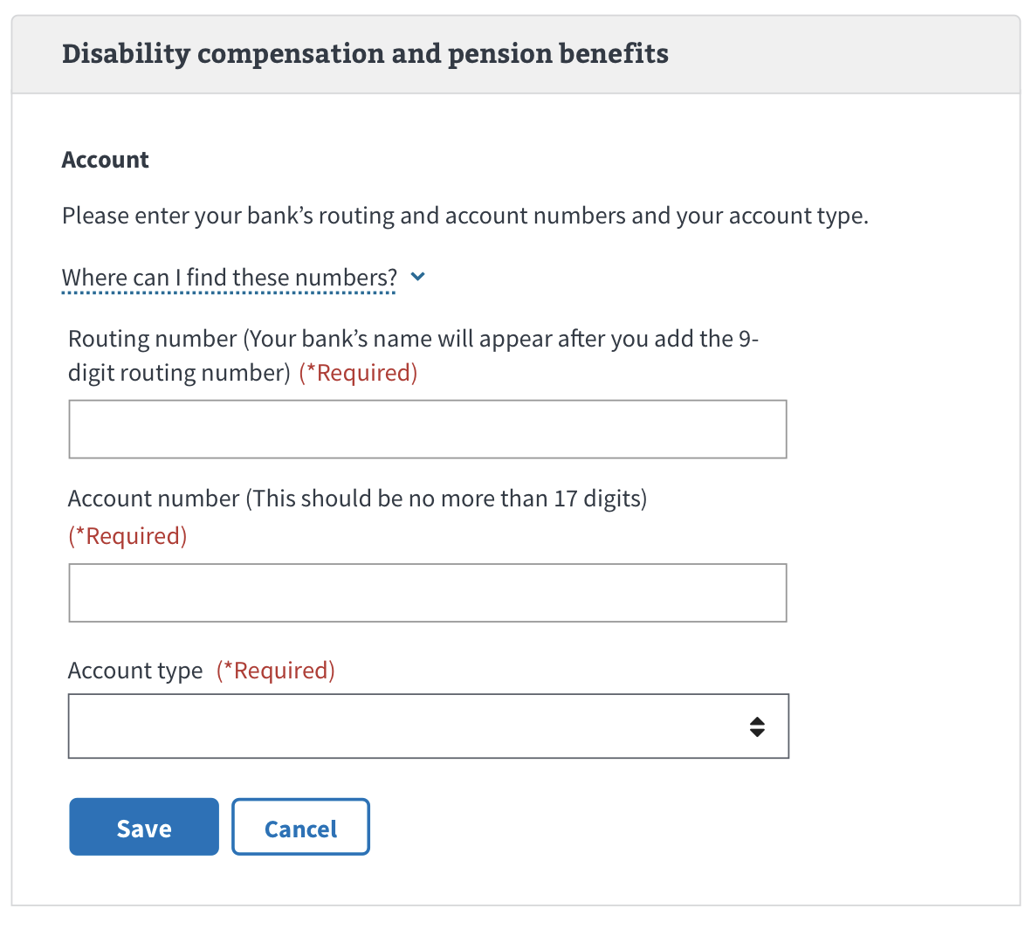

1. Click **Save** to save.

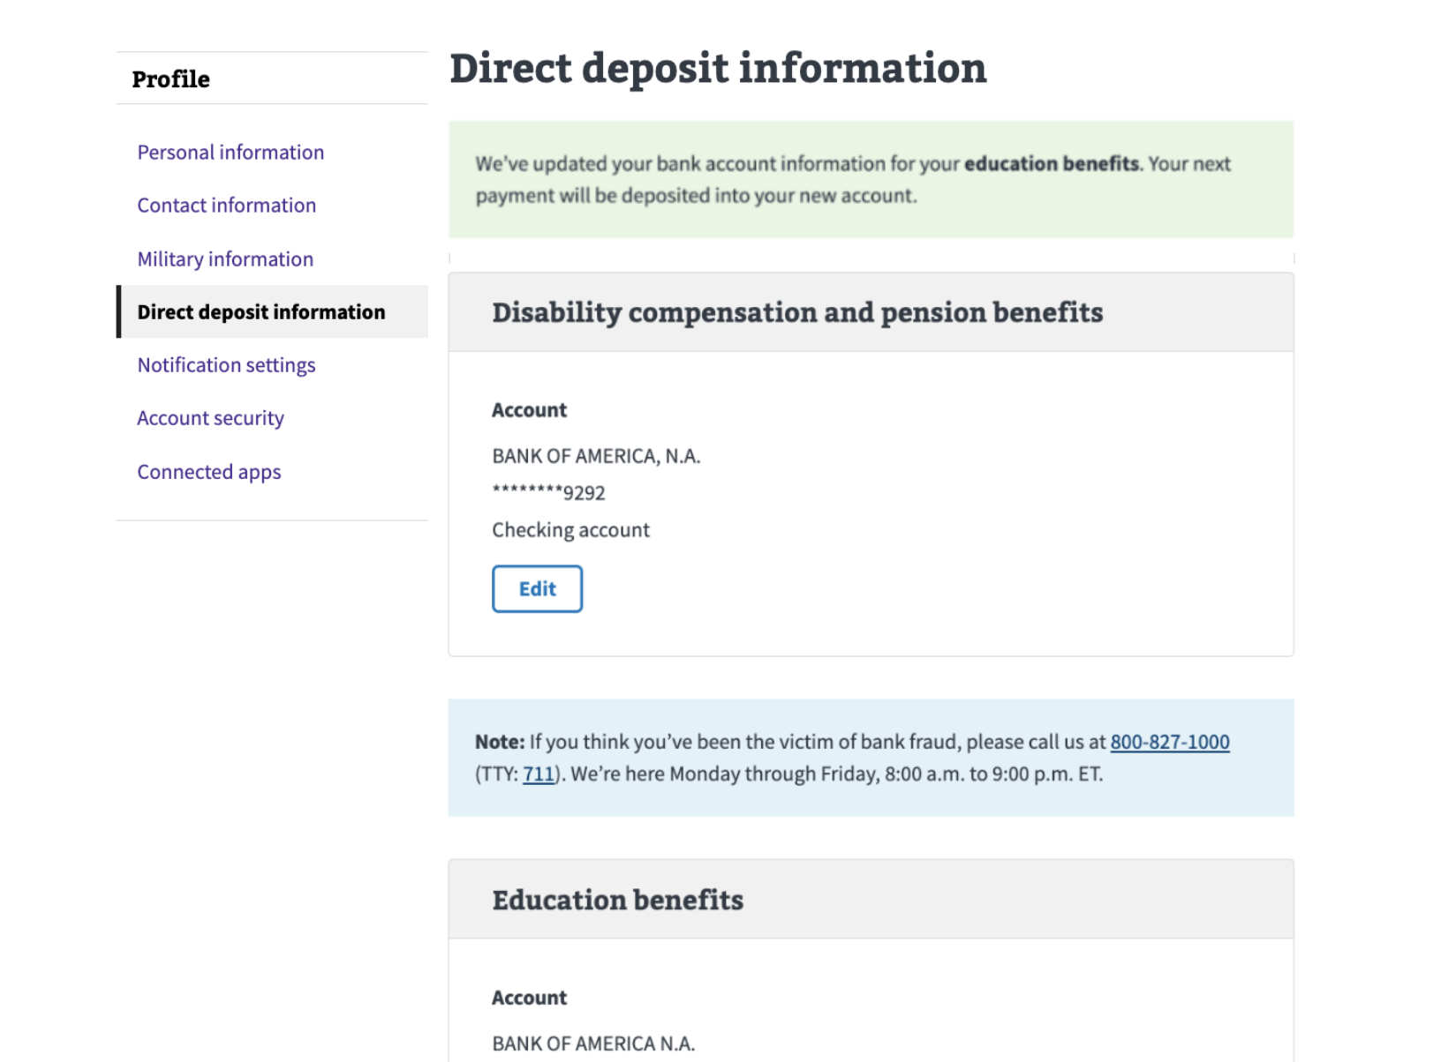

### How to view payment history

From the **Direct deposit information** section of the profile:

1. Click the **View your payment history** link. This will take them to the View Payments page on VA.gov.

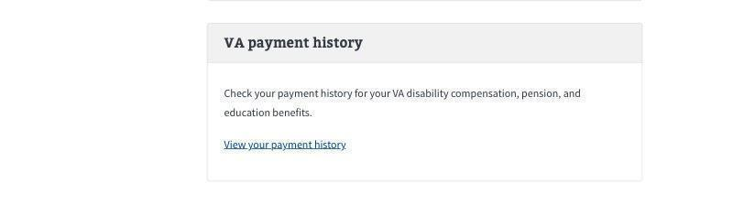

## Major Issues and Error Messages

### User needs to verify their identity with Login.gov or ID.me

If a user is logged in with a My HealtheVet or DS Logon credential, they will see an alert instructing them to log in with Login.gov or ID.me to manage direct deposit information online:

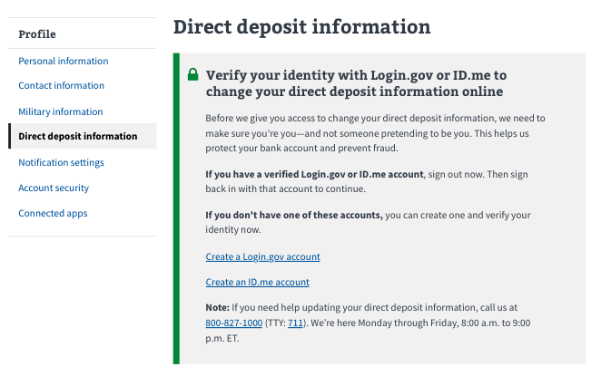

There are a few errors that users may see when they are interacting with the direct deposit feature:

### Direct Deposit Form Validation Errors

#### Required Field Errors

If a user tries to submit the direct deposit form without filling out any/all the fields, they will receive “required” errors that correspond with the fields they have left blank. Below is an image of what this would look like if all the fields were left blank:

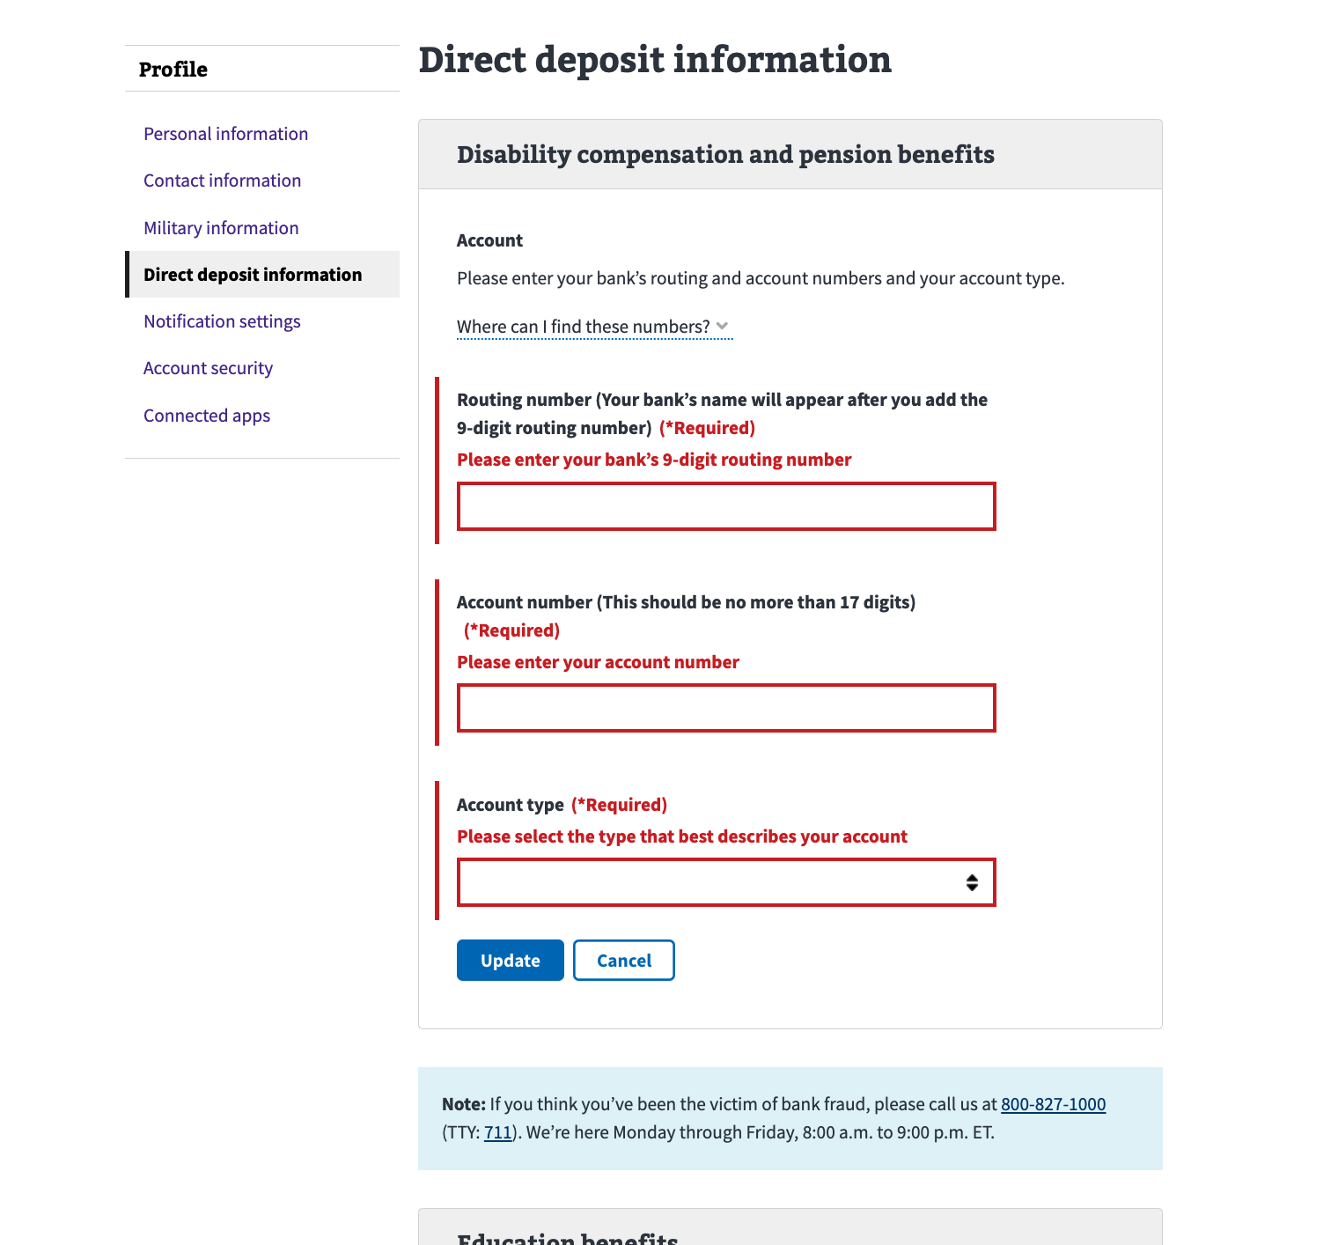

#### Routing number can’t be found

If a user submits an invalid bank routing number, we will return the error below. This error would occur if someone accidentally mistyped their bank’s routing number:

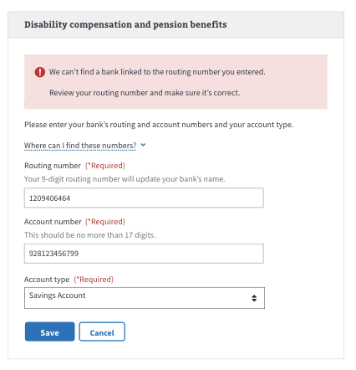

### Backend system is down/generic error

If someone tries to update their direct deposit information and the backend system is down, they will see this error in the Direct deposit section. There may be other scenarios in which a user sees this error, but they would all be caused by issues with the backend system. There isn’t anything the user can do to resolve this. They should try again later:

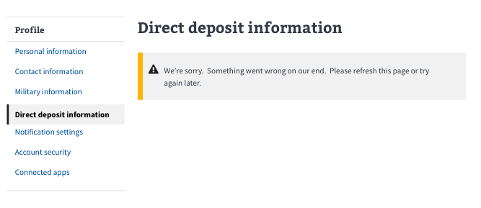

### Backend System Error - information fails to load

If we can’t retrieve someone’s direct deposit information, they will see this error. This is caused by issues with the backend system, and there isn’t anything the user can do to resolve it. They should try again later:



### Fraud Alert Error

If someone reports suspicion of fraud to the VA and the VA finds that there is a credible threat, they will suspend the ability for the associated account to update their direct deposit information until the fraud issue is resolved. This is an extremely rare use case, but if it happens, a user will see this if they try to update their direct deposit information:

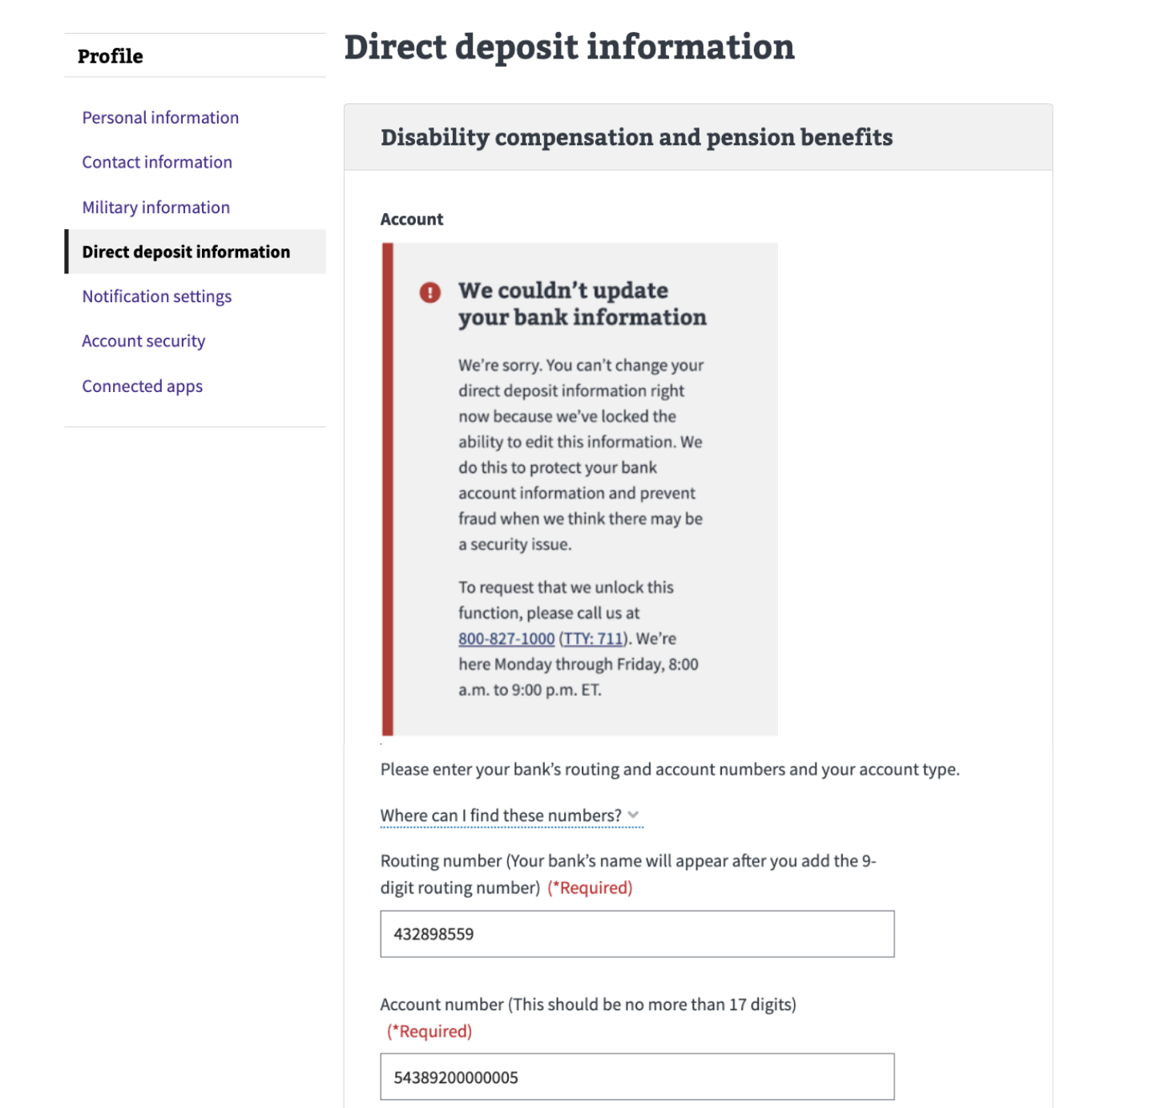

### Mailing address errors

Some people may not be able to update their direct deposit information because of an issue with the mailing address on file. If we detect that their mailing address is “invalid”—either incomplete or an address which the U.S. Postal system may not recognize—the update of the direct deposit information will fail. The technical specifics are not important to convey to the end user, just that this has something to do with how direct deposit data and mailing addresses are coupled in the backend database.

If someone sees this error, they should update their mailing address in the VA.gov profile, and then try to update their direct deposit again. Once they are successfully able to save a new and valid mailing address, then their direct deposit information should be able to be saved **unless** there are issues with their phone numbers on file (see the next section for more information on phone number errors).

The flow will look like this:

1. A user tries to update their direct deposit information in the VA.gov profile. They may get this error saying their mailing address is invalid.
2. From here, they should leave the **Direct deposit** section and go to the **Contact information** section of the profile. Under there, they will see an option to update their mailing address. They should click **Edit** to update their mailing address.

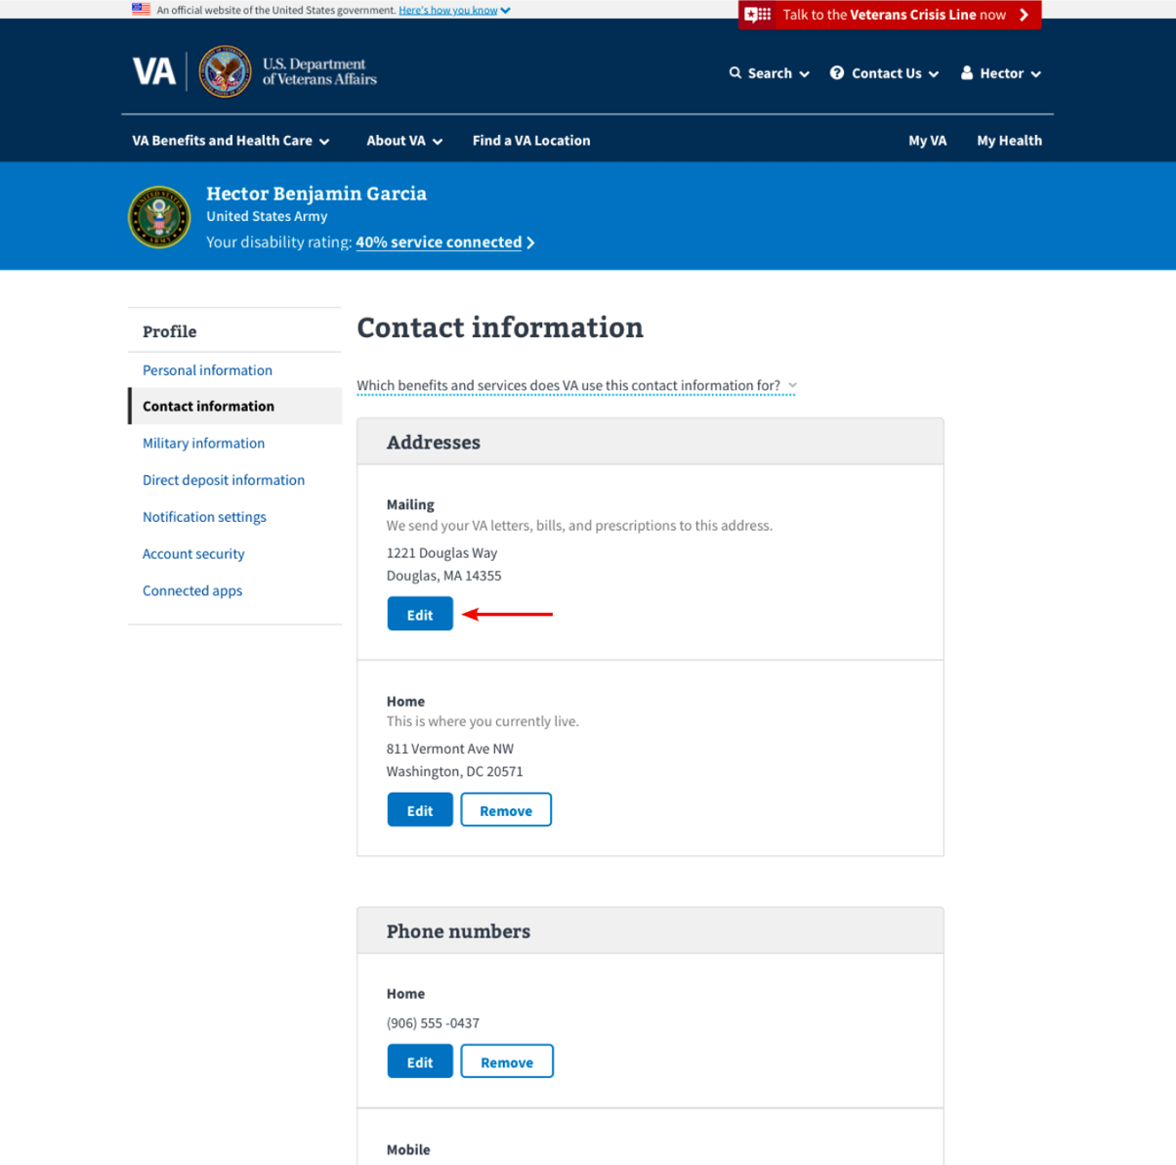

1. In the mailing address form, they will enter their current mailing address and click **Save**.

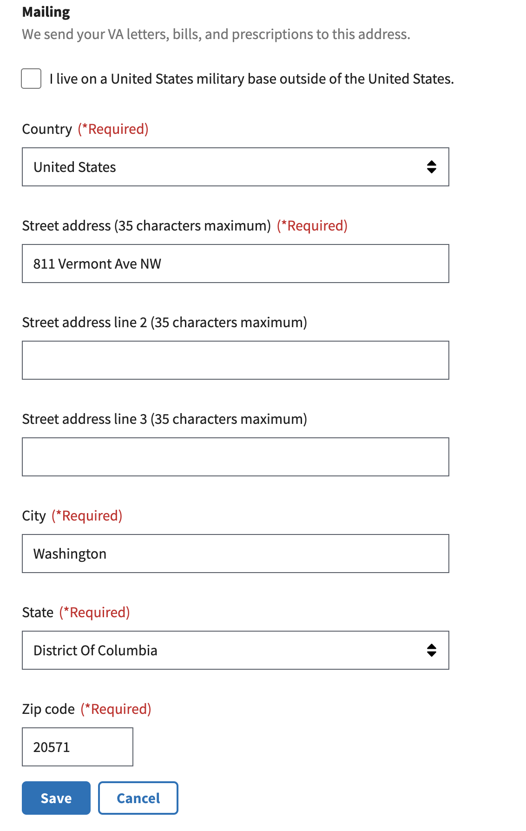

1. Once they update their mailing address, they should try to update their direct deposit information again. It should work this time.

**Note**: This is unlikely, but it is possible that someone will get another error related to changing their phone number after they’ve fixed their mailing address (see the next section below for more information). This is unlikely but it is possible. Once they fix their phone number(s), they should be all set to update their direct deposit information.

### Phone number errors

Like the error above, some people may not be able to update their direct deposit information because of an issue with the home or work phone number that is on file for them. If we detect that their home or work phone number is invalid, the update of the direct deposit information will fail. Note to the user that this has something to do with how direct deposit data and home or work phone numbers are coupled in the backend database.

If someone sees this error, they should update their home or phone number in the VA.gov profile, then try to update their direct deposit again. Pleasenote that the error message will specify whether they need to update the home OR work phone number.

Once they are successfully able to save a new home or work phone number, then their direct deposit information should be able to be saved **unless** there are issues with their mailing address on file (see the previous section for more information on mailing address errors) **or** there are issues with a different phone number (e.g., they had to fix their home number and then got a different error that they need to fix their work phone number).

For the end user, the flow will look like this:

1. A user tries to update their direct deposit information in the VA.gov profile. They may get an error saying their home or work phone number is invalid (**Note**: the error will specify which phone number they need to update).
2. From here, they should leave the **Direct deposit** section and go to the **Contact Information** section of the profile. Under there, they will see an option to update their home or work phone number. They should click **Edit** next to whichever phone number they need to update.

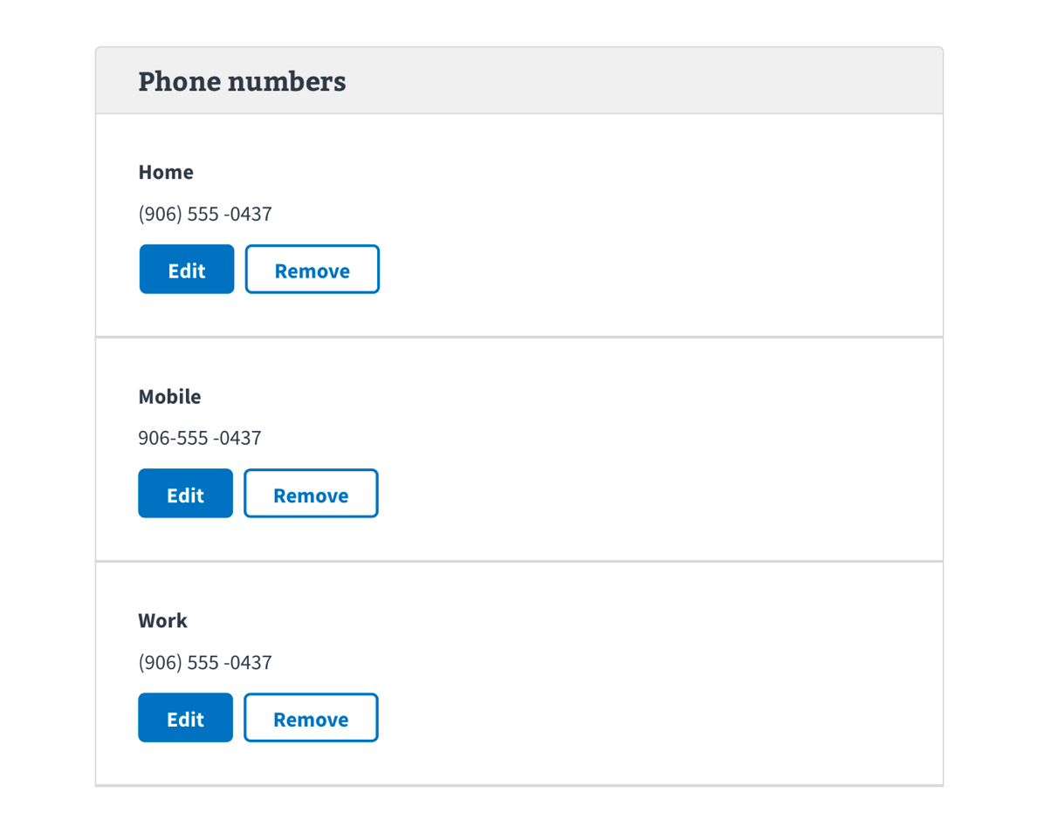

1. In the phone number form, have them enter their current home or work phone number and click **Save**.

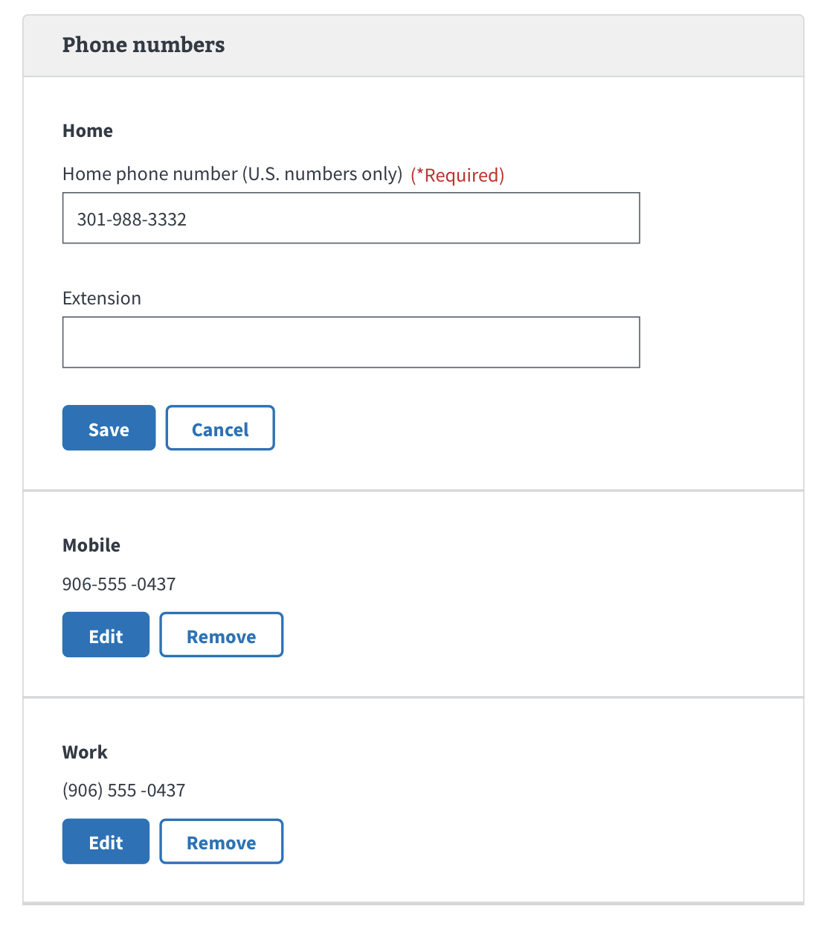

1. Once they update their home or work phone number, they should try again to update their direct deposit information. It should work this time.

**Note**: This is unlikely, but it is possible that someone will get another error related to changing a different phone number orto changing their mailing address (see Mailing Address section above) after they’ve fixed their phone number. Once they fix their phone number(s) and/or mailing address, they should be able to update their direct deposit information.

## Additional Information

### Additional Information on Direct Deposit

There is additional content that users can read and bookmark on direct deposit. This content can be found at<https://www.va.gov/change-direct-deposit/>.

### Switching from paper checks and direct deposit

On this page, we address how recipients can opt-in to direct deposit after receiving paper checks.

On VA.gov, we tell people to do the following:

**For people who want to switch from paper checks to direct deposit**:

* Fill out VA Form SF-1199a and submit this to a regional office <https://www.va.gov/find-forms/about-form-sf-1199a/>.
* **Or** this change can be done over the phone by the National Call Center.
* **Or** they can make this change in person at their regional office.

# Section Overview: Notification Settings

The **Notification settings** feature on VA.gov allows users to proactively establish the way in which the VA communicates with them. Over time, this section will expand to include additional notification items and channels (i.e., text message versus email).

## User Access

### Users who have not verified their identity (LOA1)

As a reminder, users who have not verified their identity on VA.gov, or users who have a block on their account will only see the **Account security** section of the VA.gov profile when they go to www.va.gov/profile/notifications. They will not see the **Notification settings**.

### Users who have verified their identity (LOA3)

Users who have verified their identities on VA.gov will be able to see **Notification settings** and all the sections of the profile.

### Users who have a blocked account

Users who have verified their identities on VA.gov but have a flagged account (eg. have a fiduciary, are deceased, flagged as incompetent) will not be able to use the **Notification settings** page, they will only see the **Account security** page. If they attempt to navigate to [www.va.gov/profile/notifications](http://www.va.gov/profile/notifications) it will redirect them to [www.va.gov/profile/account-security](http://www.va.gov/profile/account-security) and will display a warning message.

## Navigation

Users access the notification settings feature via the authenticated menu in the upper right corner of the screen (the user’s name).

1. Sign into VA.gov (<https://www.va.gov/>).
2. Click the authenticated menu in the upper right corner of the screen (the user’s name) and select **Profile**.
3. A user can select **Notification settings** from the hub.
4. Alternatively, if the user has already opened another page of the profile they can select **Notification settings** from the list on the left navigation menu. 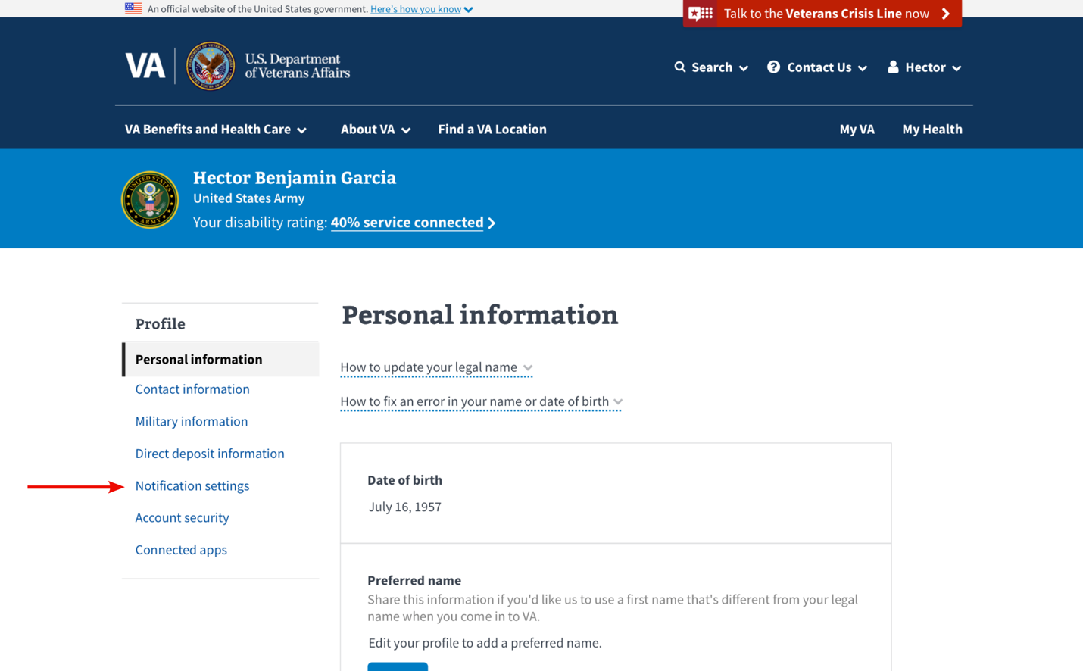

## Functionality

### Selecting notification options

LOA3 verified users who have already added their mobile phone number to their profile will immediately be able to make notification settings selections.

1. Users will see the notifications they have available to them on the page. The options available to them will depend on the benefits and services they receive from VA. They can check a checkbox to be notified, or uncheck it to not be notified.

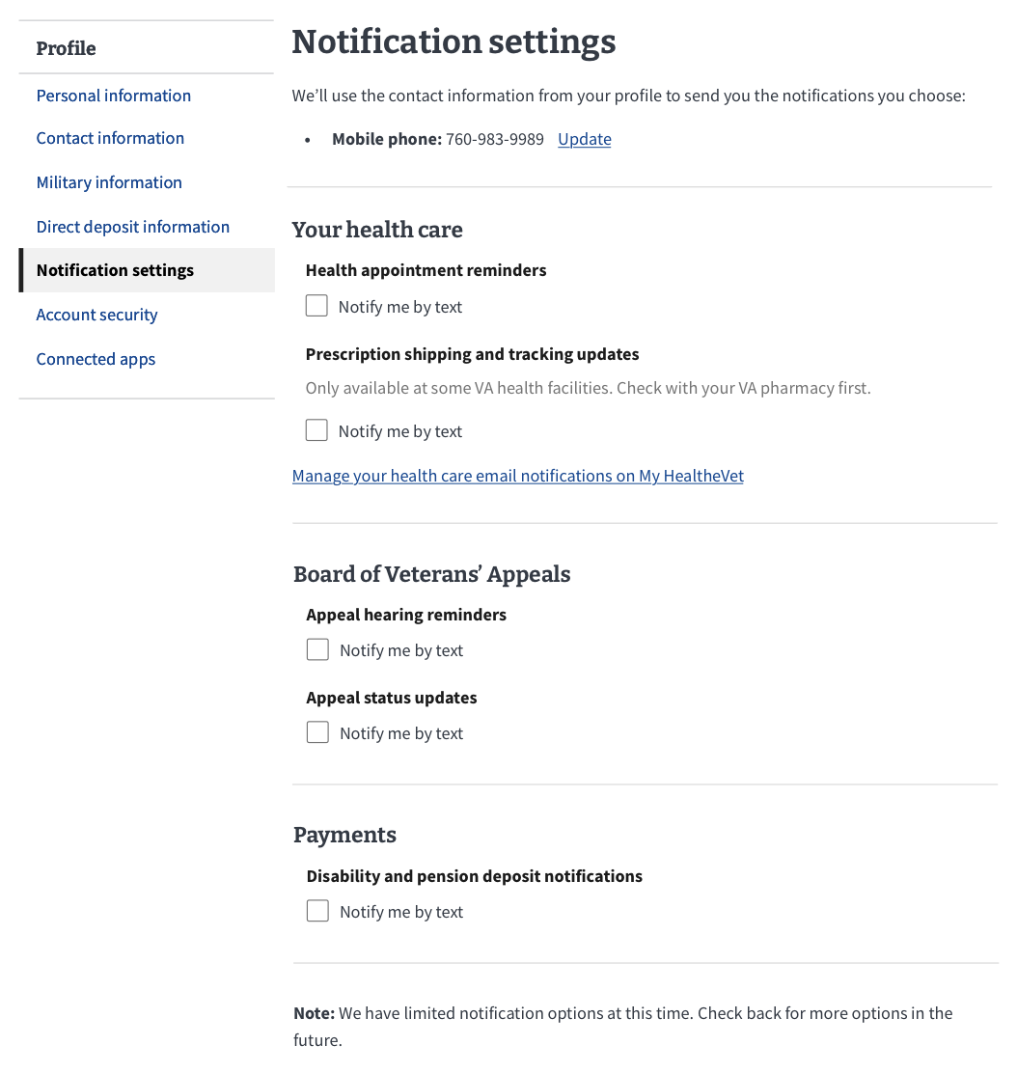

1. When a user selects or unselects a notification item, they will see a success message letting them know that their update has been saved.

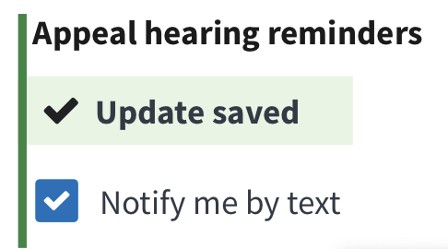

### Editing-as-a-subtask: Adding mobile phone number

LOA3 verified users who have not added their mobile number to their profile will not be able to see any notification items until they have added their phone number. When the notification settings page loads, the user will be prompted to add a phone number to their profile:

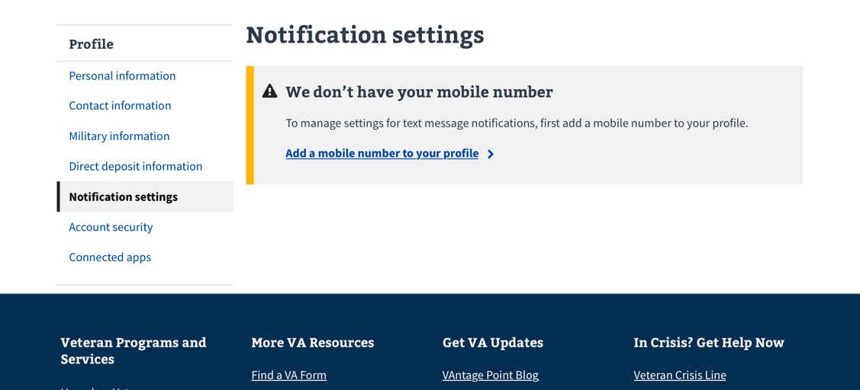

1. To add their mobile phone number to their profile, the user can click the link that says, “Add a mobile phone number to your profile.”

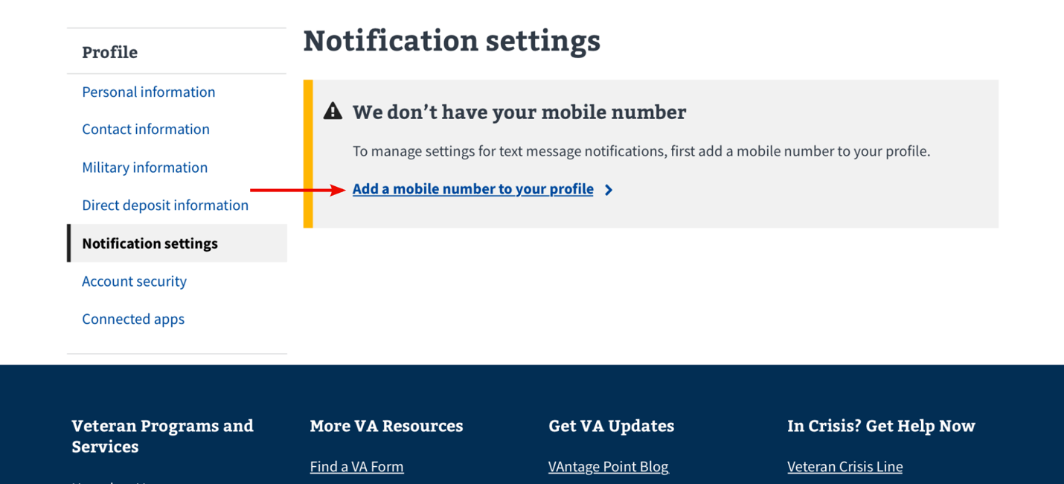

Clicking this link will send the user to a new page where they can add their phone number:

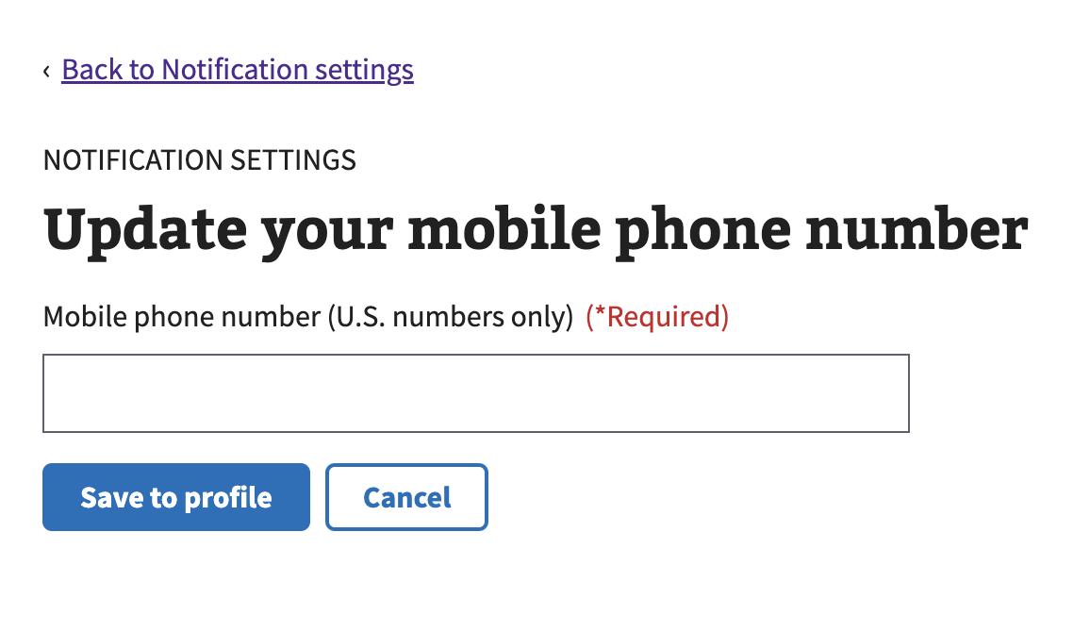

The user can then add their mobile phone number and save it.

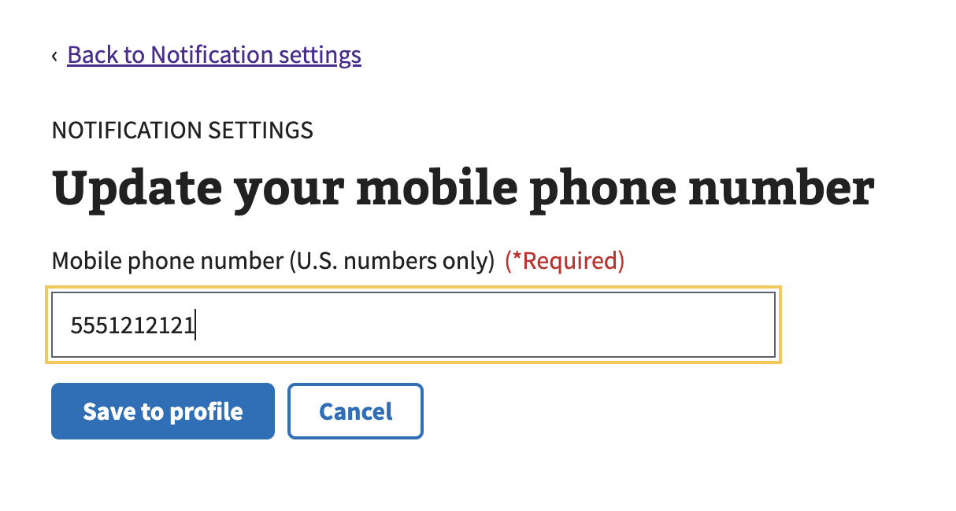

The user will know their mobile phone number has been saved to their Profile because they will be returned to the notification settings page and will see a success message. They will also see a link to update their information. 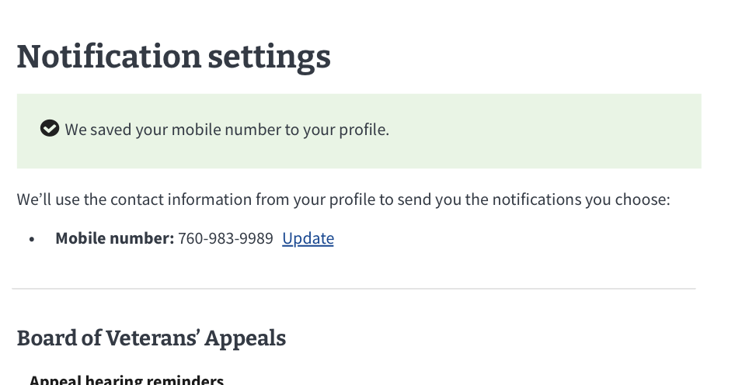

## Major Issues and Error Messages

### Notification settings feature is unavailable

If the API that powers the notification settings feature is unresponsive, then the user will see this message:

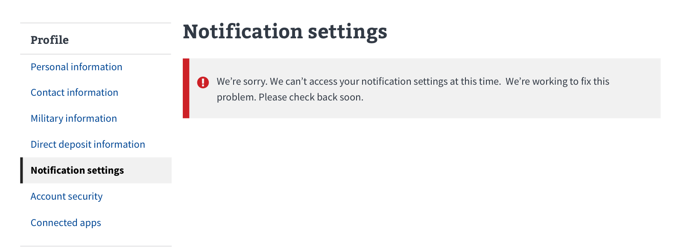

### Save failure

If a user’s selection within a notification item fails, they will see this message:

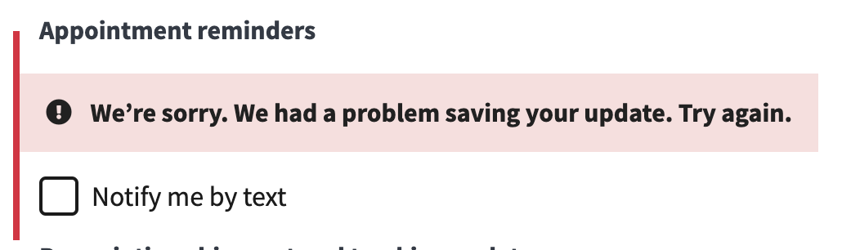

# Section Overview: Account Security

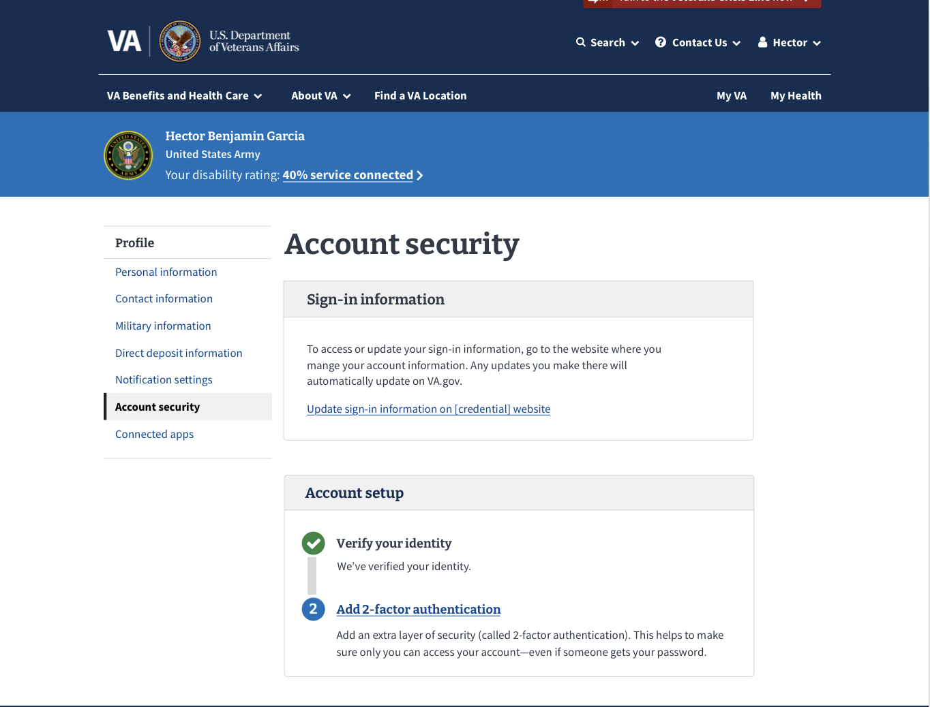

The **Account Security** section will let a user update and view their account security information. This includes the following:

* Identity Verification
* 2-factor authentication
* Terms and Conditions
* Information on how to update a sign in email address

## User Access

### Users who have not verified their identity (LOA1)

**Account security** is the one section of the profile where users can see if they have not verified their identity. On this page, they will see a prompt to confirm their identity so they can view the full profile.

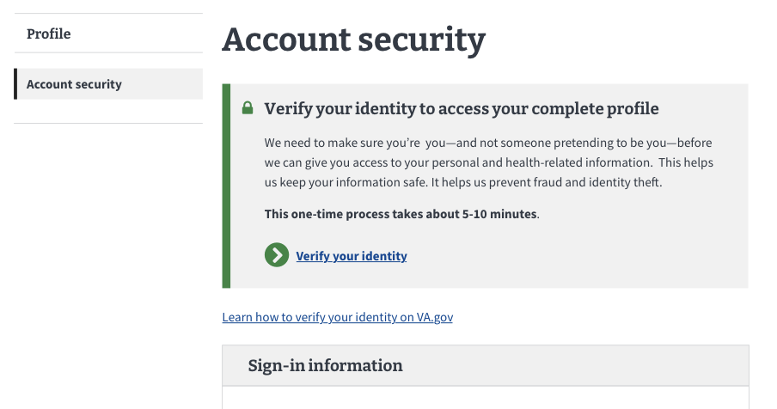

### Users who have verified their identity (LOA3)

People who have verified their identities on VA.gov will be able to see **Account settings** and all the sections of the profile.



### Users who have a block on their account:

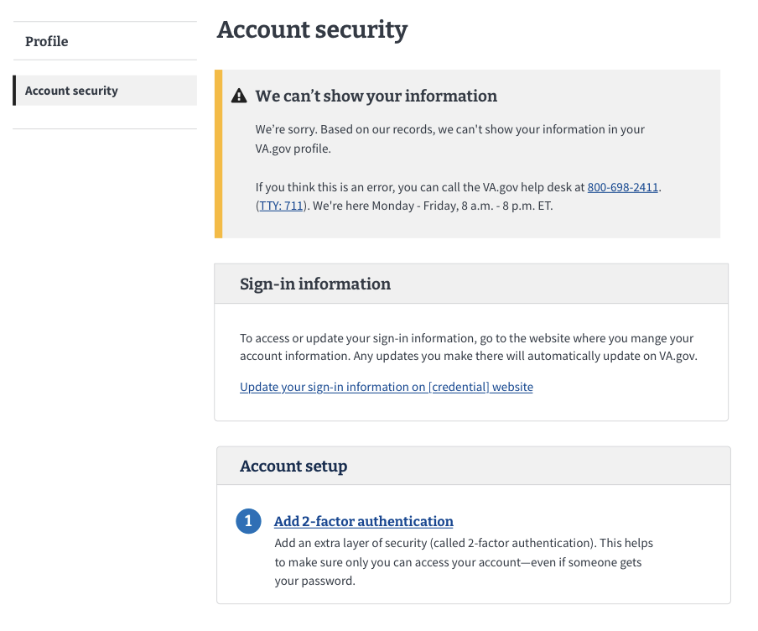

## Navigation

1. Sign into VA.gov (<https://www.va.gov/>).
2. Click the authenticated menu in the upper right corner of the screen (the user’s name) and select **Profile**.
3. A user can select **Account security** from the hub.
4. Alternatively, if the user has already opened another page of the profile they can select **Account security** from the list on the left navigation menu.



### 

## Functionality

### Verifying identity

If a user has not verified their identity (LOA1), they will only have access to a limited version of the **Account Security** page. For a user to have access to the rest of the profile, they must verify their identity.

To do so, they will need to click on the green button, “**Verify your identity.”** ([https://va.gov/verify/](https://staging.va.gov/verify/))**.** This will take them through a flow to verify their identity. This is a one-time process that should only take about 5–10 minutes.

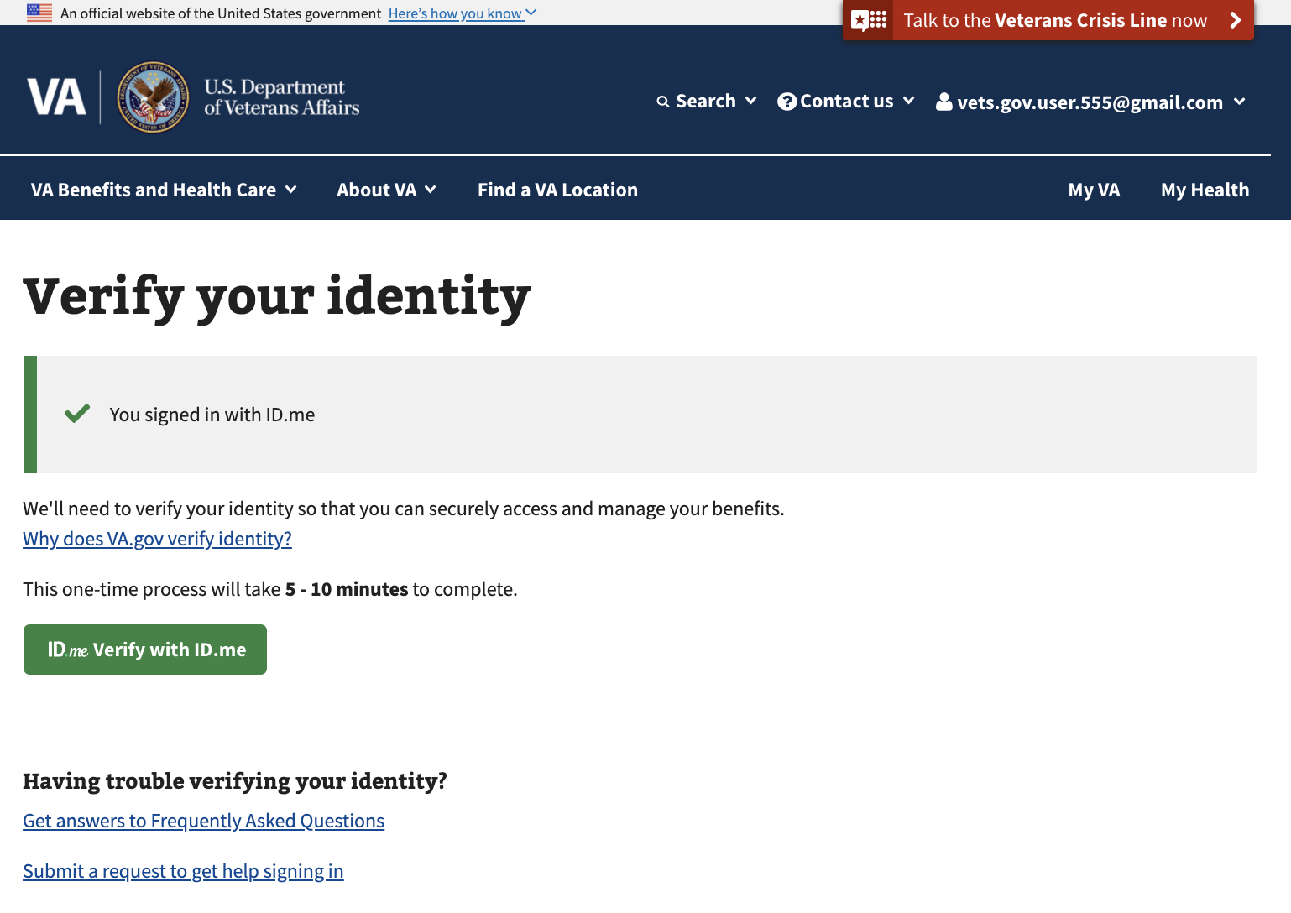

**Note**: To go through the identity verification process, a user must have the following:

* A smartphone (or a landline or mobile phone and a computer with an Internet connection)
* Their Social Security number
* A digital image of their driver’s license or passport

If a user does not have an image of their driver’s license or passport, they must have the ability to answer certain questions based on private and public data (like their credit report or mortgage history).

If a user has already verified their identity, they will see the following message and no further action is required.



### 2-factor authentication (2FA)

2-factor authentication adds an extra layer of security to help make sure only a user can access their account—even if someone else gets their password. If a user has not set up 2-factor authentication, they will need to click on the link that says **Set up 2-factor authentication** and go through the flow. A user does not need to have 2FA set up to see the rest of the profile.

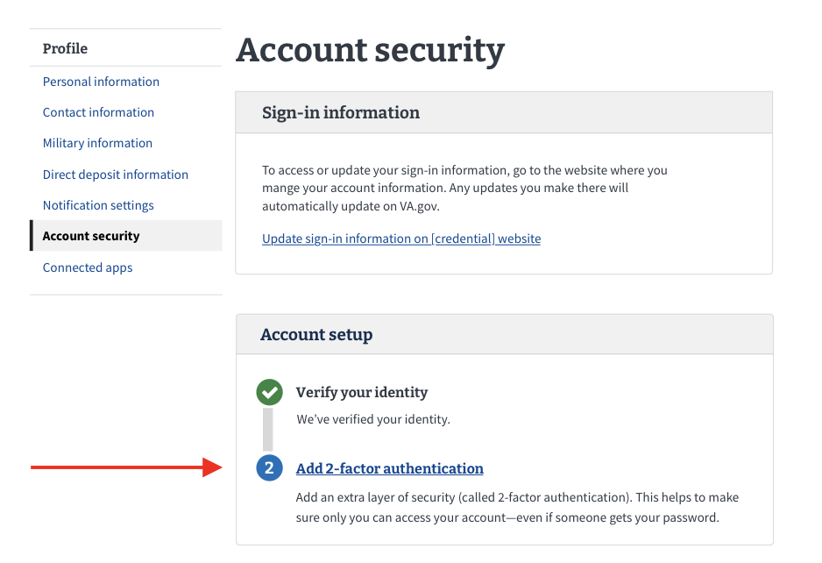

If a user has already set up 2FA, they will see the following message. No further action is required.

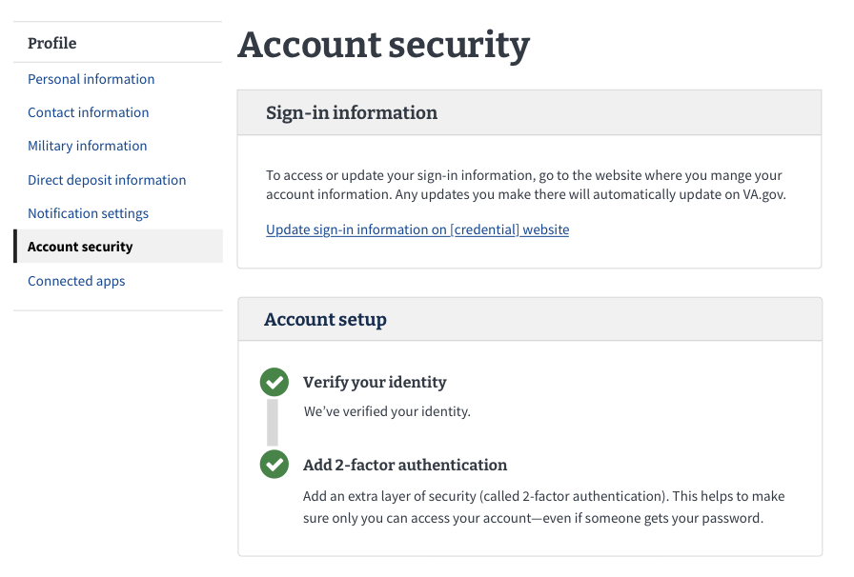

### Sign in email address

The email used to sign in cannot be changed from the profile. If a user would like to update the email they use to sign in, they should click on the link to go to the website where they manage their account (either **Login.gov, DS Logon, MyHealtheVet, or ID.me**).

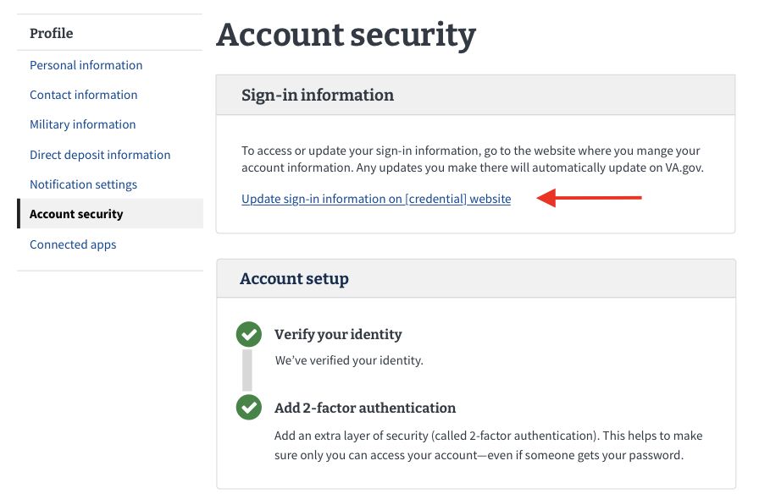

## Major Issues and Error Messages

### User has not verified their identity (LOA1)

If a user is signed in but has not verified their identity (LOA1), they will see this screen. To have full access to the profile, a user must verify their identity.

Click on the link that says **Verify your identity** ([https://va.gov/verify/](https://staging.va.gov/verify/))**.** The user will need to verify their identity before they can access their profile.

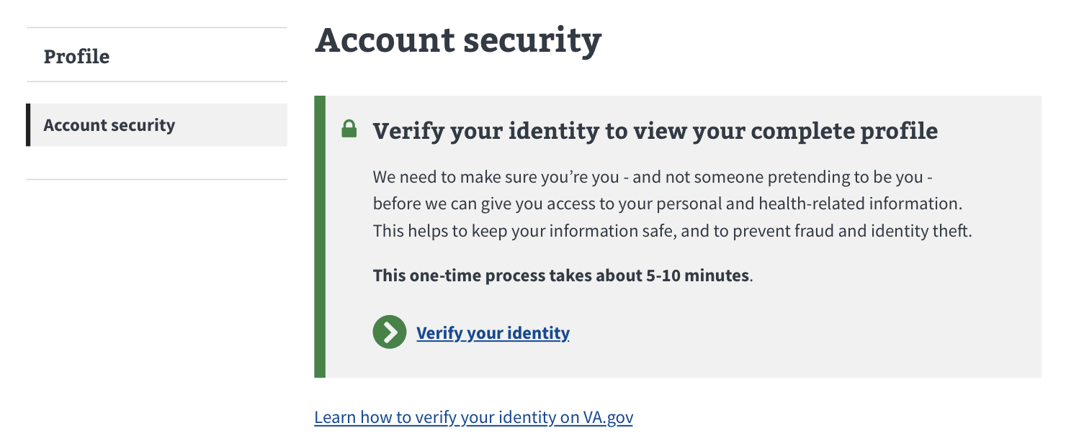

### User information doesn’t match our Veteran records

There is the chance that we won’t be able to match a user’s information with our Veteran records. In this case, a user will not have access to their profile until their records can be matched or updated.

The user does not need to do anything to resolve this. They can return to the page later to check this status.

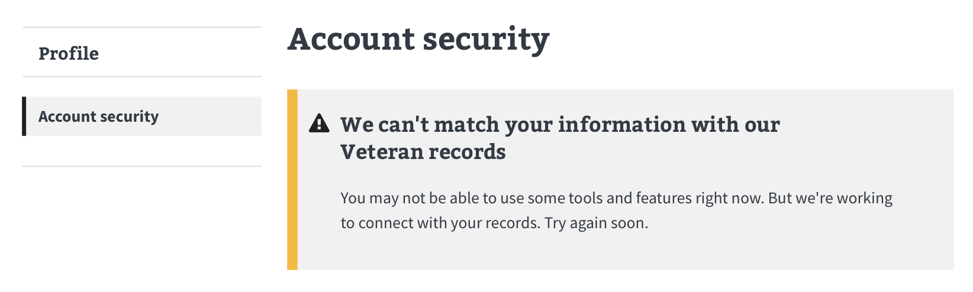

### User information cannot be accessed

There is a chance that a general error will occur and we temporarily won’t be able to access records.

The user does not need to do anything to resolve this and can check back later.

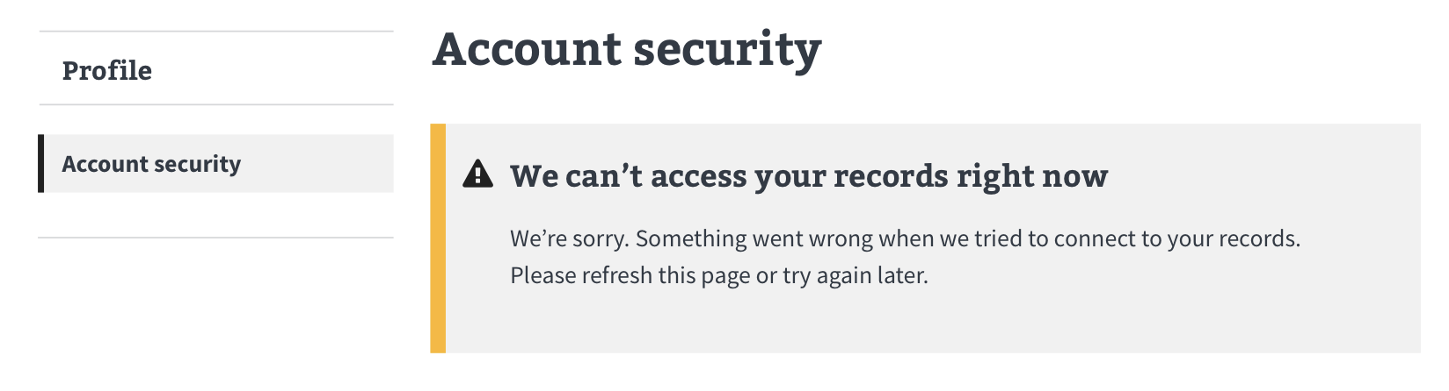

# Section Overview: Connected Apps

The Connected Apps section allows users to connect third-party (non-VA) applications or websites that can share certain information from their VA.gov profile. For example, they can connect information from their VA health record to an app that helps them track their health.

## User Access

### Users who have not verified their identity (LOA1)

As a reminder, users who have not verified their identity on VA.gov, or users who have a block on their account will only see the **Account security** section of the VA.gov profile when they go to www.va.gov/profile/connected-applications. They will not see the **Connected apps**.

### Users who have verified their identity (LOA3)

Users who have verified their identities on VA.gov will be able to see **Connected apps** and all the sections of the profile.

### Users who have a blocked account

Users who have verified their identities on VA.gov but have a flagged account (eg. have a fiduciary, are deceased, flagged as incompetent) will not be able to use the **Connected apps** page, they will only see the **Account security** page. If they attempt to navigate to [www.va.gov/profile/connected-applications](http://www.va.gov/profile/connected-applications) it will redirect them to [www.va.gov/profile/account-security](http://www.va.gov/profile/account-security) and will display a warning message.

## Navigation

1. Sign into VA.gov (<https://www.va.gov/>).
2. Click the authenticated menu in the upper right corner of the screen (the user’s name) and select **Profile**.
3. Click on **Connected apps** from the Hub.

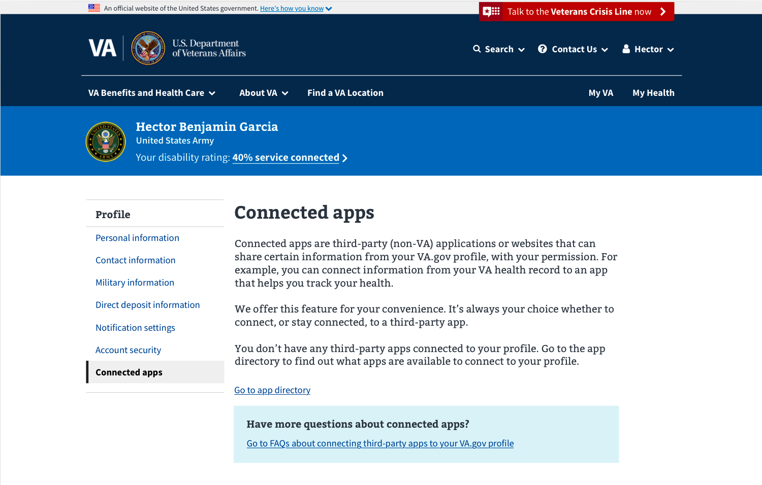

## Functionality

### Connecting and disconnecting an app

To see a list of apps to which a user can connect, click on the link that says **Go to app directory**. Clicking the link will take you to a page called **Find apps you can use**.

Clicking the app link will take you to that app’s webpage. A user will have to connect through the third-party app, not through VA.gov.

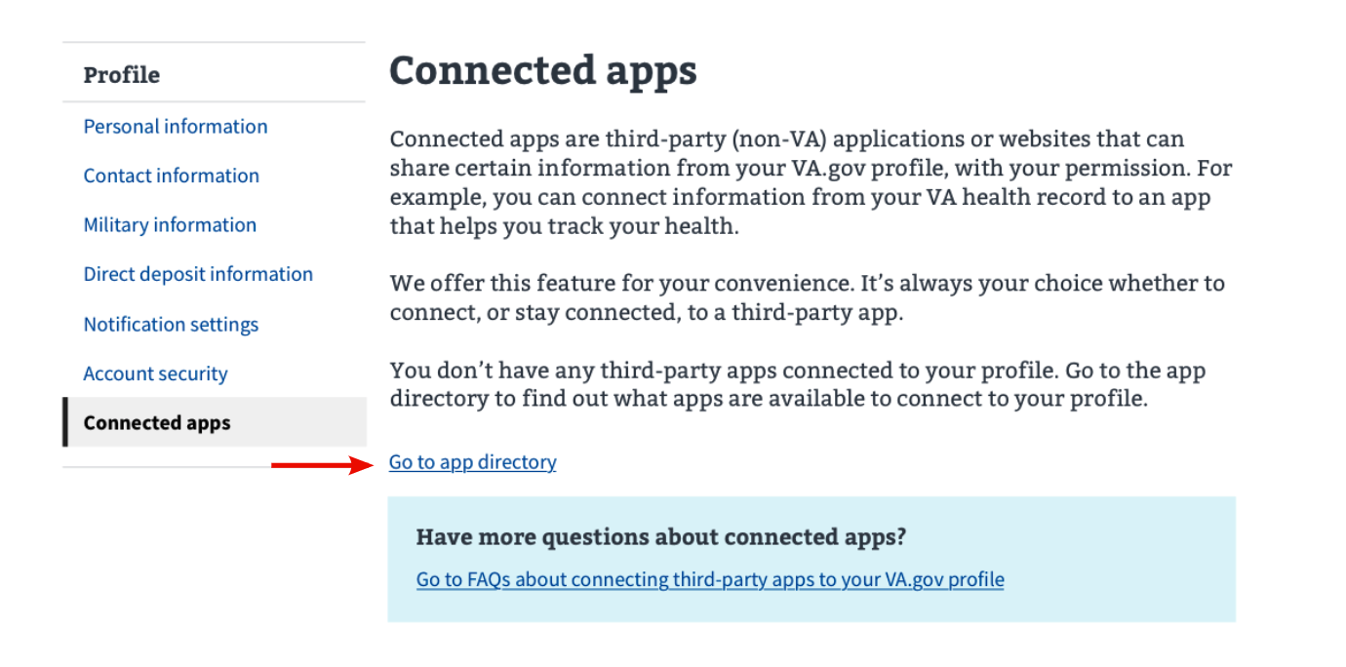

#### How to connect an app to your VA.gov profile

When a VA.gov user goes to a third-party app or website that they are interested in connecting to their VA.gov profile, they should:

1. Sign into the website with their preferred VA.gov account: **Login.gov,** **DS Logon**, **MyHealtheVet**, or **ID.me**.
2. Review the information the app is asking to access.
3. Allow the app or website to access their VA.gov account.

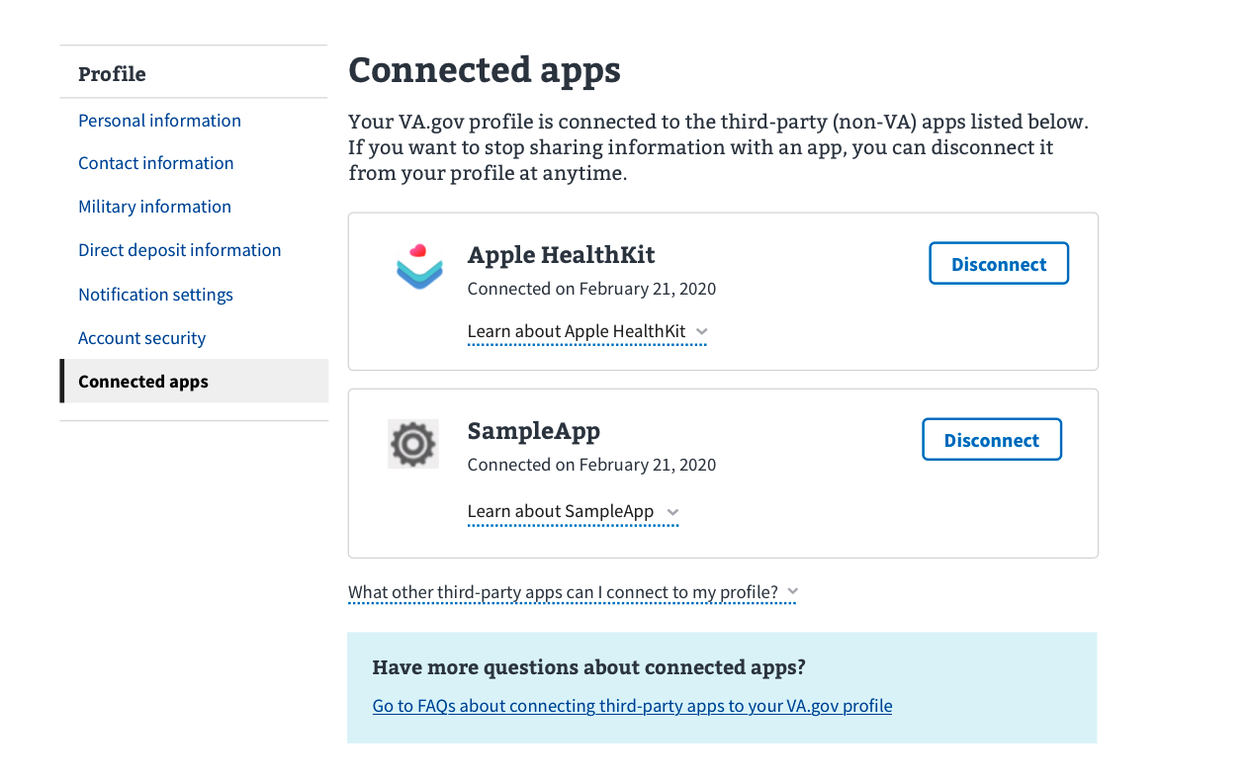

#### How to disconnect an app from your VA.gov profile

From the **Connected apps** section of the profile:

1. Find the app you want to disconnect and click the **Disconnect** button next to it.

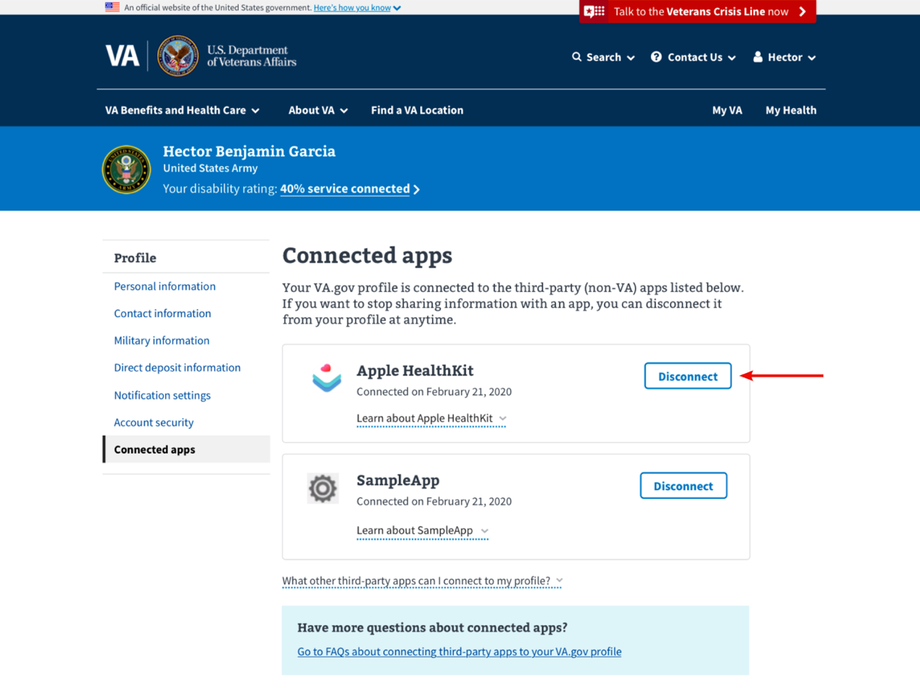

1. Confirm that you would like to disconnect the app by clicking **Disconnect**.

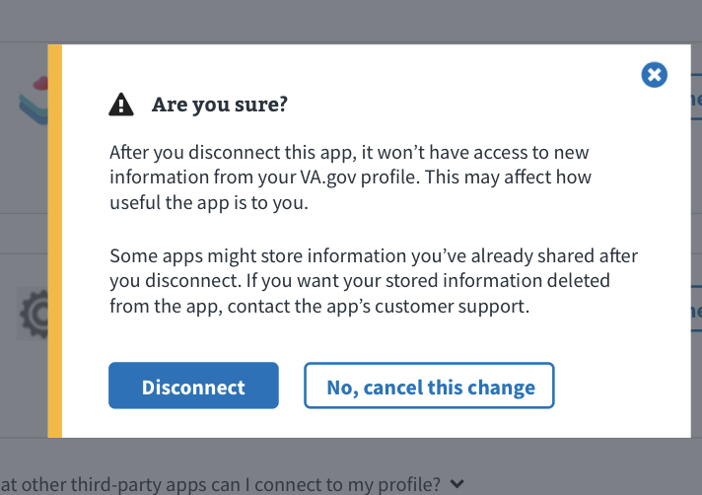

Once the app is disconnected there will be a message showing that it was successfully removed.

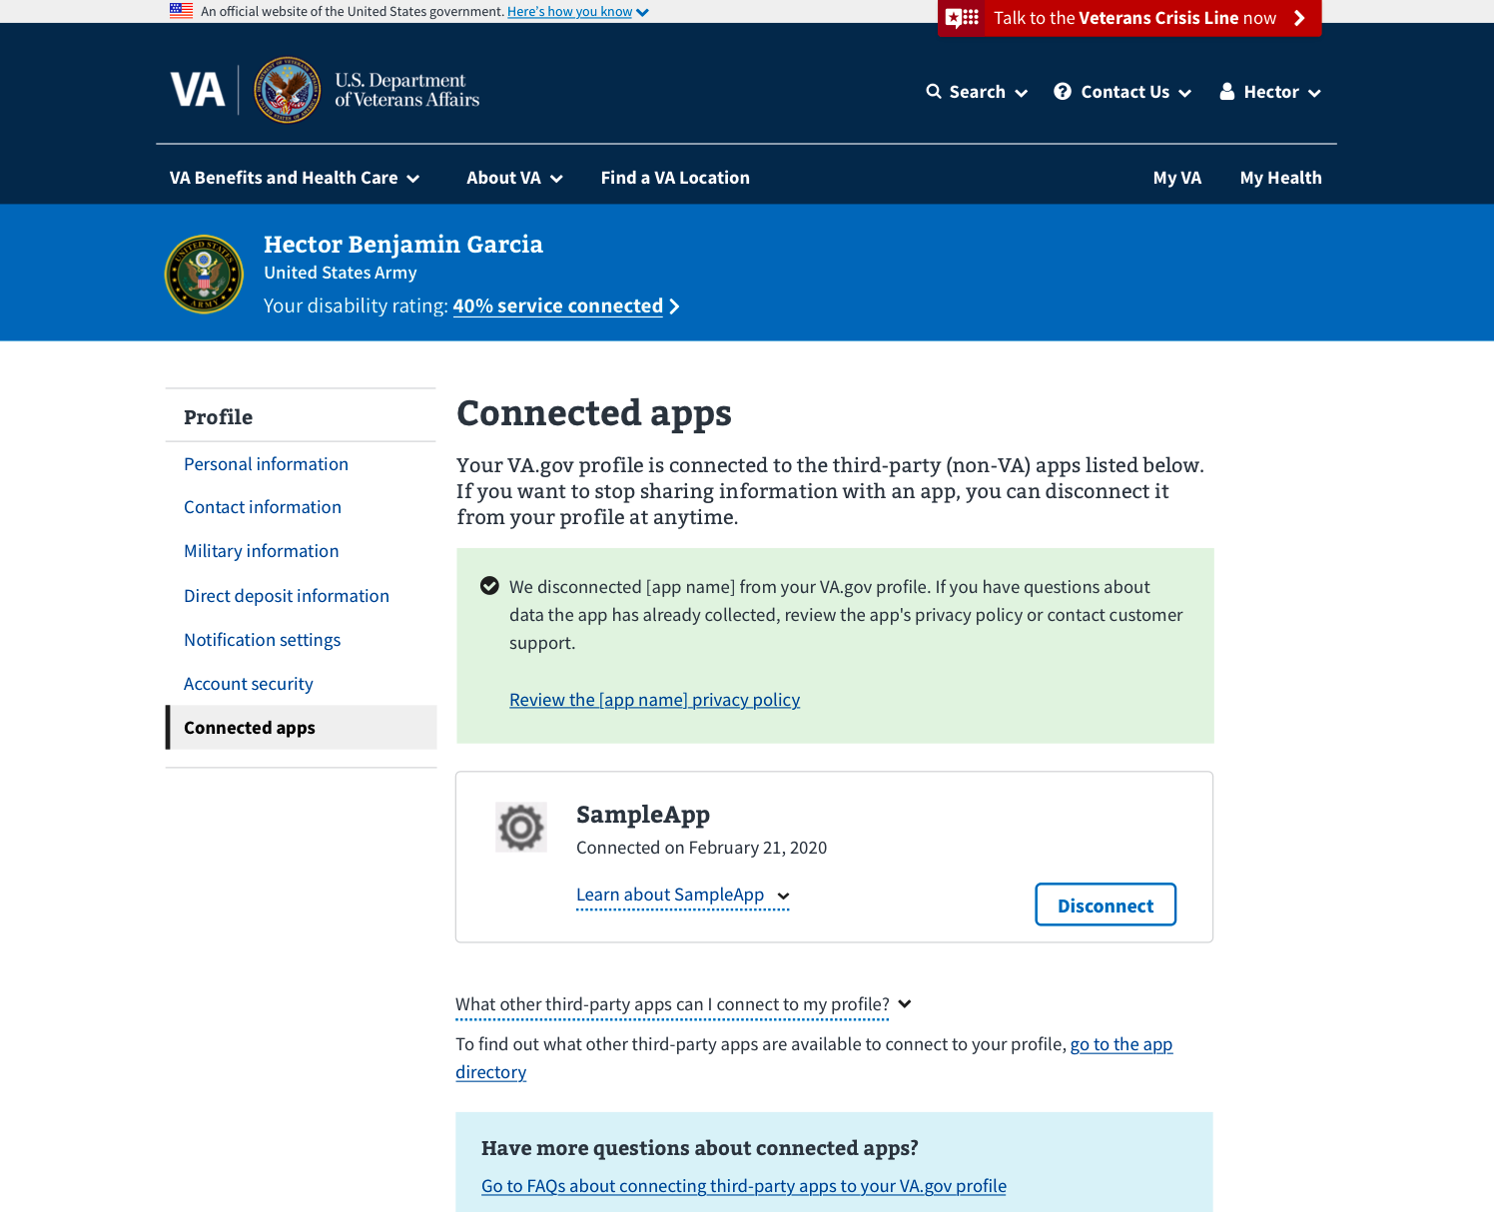

#### How to find additional information on connected apps

For more information about connected apps and how user information is used, click the **Frequently asked questions** link at the bottom of the page.

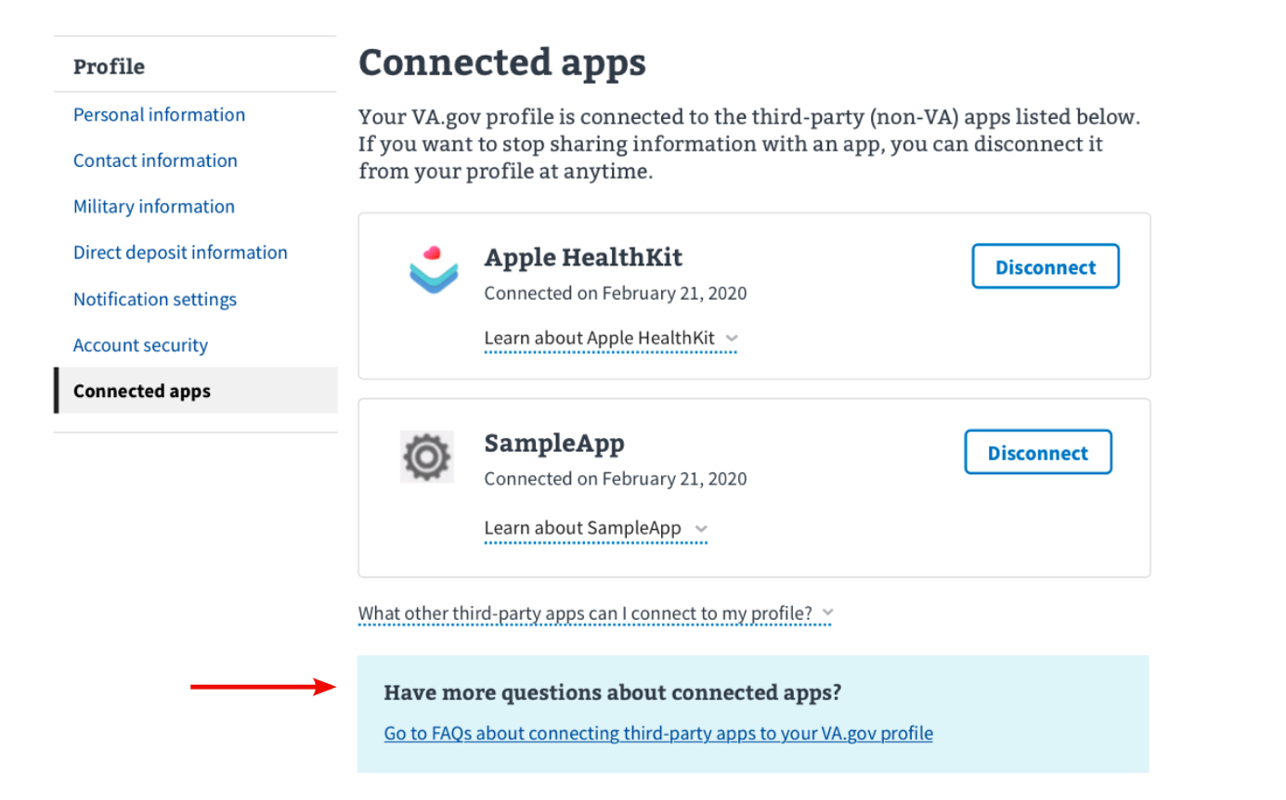

## Major Issues and Error Messages

### Can’t retrieve connected apps:

If this occurs, the user can either refresh the page or try again later.

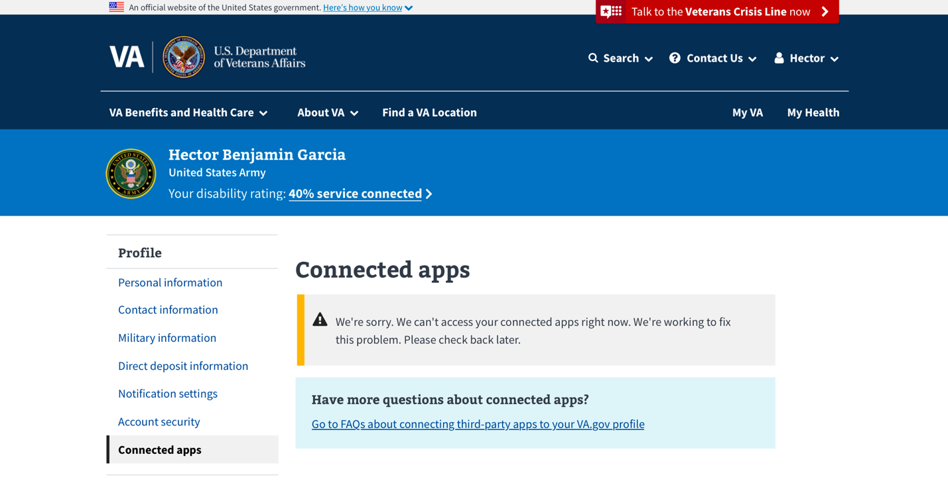

### Can’t disconnect an app:

There is a possibility that we will not be able to delete an app after a user has requested to delete it. If this happens a user can refresh the page or try again later.

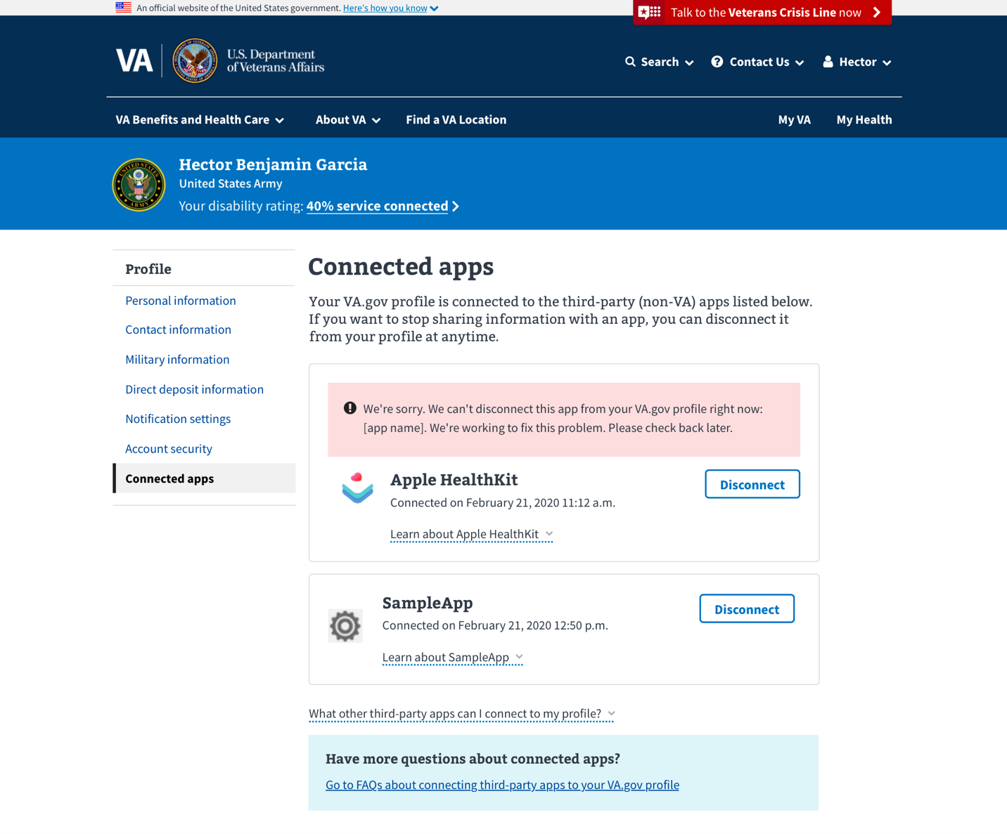

# Table of Figures

Figure 1 profile account security page for LOA1 User 6

Figure 2 profile hub, main landing page for most users 7

Figure 3 account security page for blocked users 8

Figure 4 sign in redirect modal 9

Figure 5 the My VA logged in landing page with the Authenticated Menu expanded 10